
Version 11 ~ 2025
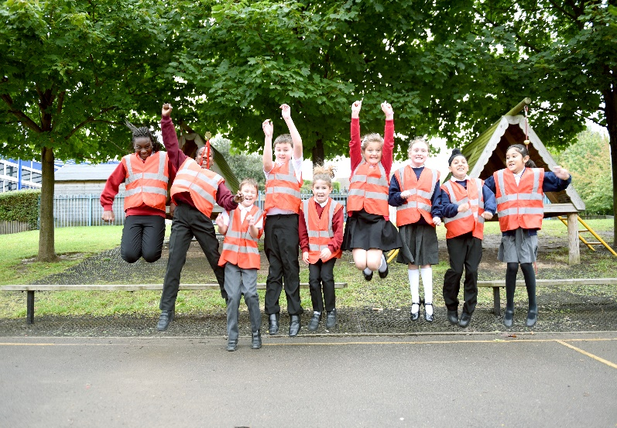
Behaviour Policy
Policy reviewed: September 2025
Next review: September 2026

Teagues Bridge Primary School
Behaviour Policy

Written on: | June 2019
Reviewed on: | September 2025
Next review | September2026
Staff Responsibility | Mrs S. Abdulla
Governor responsibility | Sharron Jones

‘If you treat people as they are, you will be instrumental in keeping them as they are. If you treat them as they could be, you will help them become what they ought to be.’
(GOETHE)

Aims:

- To create an atmosphere of mutual trust and respect.
- To treat everyone with respect and kindness
- To develop concern for others.
- To develop an atmosphere where moral, social, spiritual and cultural values are learnt and understood.
- To establish a calm working environment where children can learn.
- To ensure that children develop skills to be able to self regulate.

Principles:

- At Teagues Bridge we believe that rules are necessary for the safety, consideration and wellbeing of all.
- A consistent behaviour policy will provide a calm environment where teachers can teach.
- Children should know the rewards that good behaviour brings.
- Children should know the school rules and the reasons for them.
- Parents should know what the school expects and what will happen when behaviour falls below the expected level.
- A good behaviour policy is the shared responsibility of all staff. Everyone is responsible for making our school a happy and successful place.
- Everyone is of equal value and will be valued equally regardless of whether or not they have a disability, whatever their ethnicity, culture, religious affiliation, national origin or national status, whatever their gender and gender identity and whatever their sexual identity.
- The school recognises the need to teach the children good behaviour within the curriculum.
- Children deserve to be rewarded for good behaviour.
- Everyone has a right to feel safe at school. The staff at Teagues Bridge are committed to ensuring that every child is protected from harm.
- Teachers to be applying trauma informed practise.
- Practise self-regulation.

Behaviours and Attitude:
- We put the quality of learning experiences for pupils before everything else.
- We do what we need to do to help each child to learn and improve rather than making pupils fit in with an inflexible teacher-led style of teaching.
- We enjoy and contribute to a culture which promotes creative ideas and innovation.
- We want to do our best for our pupils.
- We expect children to take pride in themselves.
- We insist on a smart dress code; no trainers and shirts are always tucked in.
- We promote feeling good about ourselves.
- We insist on good behaviour at all times, ensuring that all children can work in the learning environment, safely and effectively.
- Poor behaviour and bullying will not be tolerated here.

What we hope to achieve at Teagues Bridge:
- Ensure that all children are treated with respect.
- Encourage children to respect and have respect.
- Recognise and develop individuality.
- Make Teagues Bridge a stepping-stone to a positive future for all.
- Raise children’s confidence and self-worth.
- Ensure that quality teaching and learning takes place.
- Assist children to value each other and have self-belief.
- Enable children to face new challenges.
- Create a safe and secure environment where mistakes are a part of learning.
- Encourage critical awareness, tempered with sensitivity.
- Support children to solve problems and learn to make negotiations.
- Celebrate as they become more co-operative, courteous, tolerant, decisive and determined individuals.
- Ensure laughter rings through our place of learning.
- Respect is at the heart of everything we do and say.

To achieve our aims we will have the following Whale Award displayed around the school and in classrooms.

- Work sensibly and calmly at all times.
- Help others.
- Always be polite and show respect to others.
- Listen carefully to all adults and peers.
- Everyone has the right to feel safe.

To encourage children to follow our rules we will recognise appropriate behaviour with praise, stickers, smiles, class treats, positive notes home. However, if a child chooses to break a rule, the following steps will be taken.

- Children are given 2 warnings (using the peg system which they move their peg up for excellent behaviour and then down if they choose not to follow the school rules) and a third time results in time out given. The Pupil is asked to use the regulation zone to try and help with regulating their behaviour and they have a restorative conversation with the class teacher to identify the cause for the behaviour. Children should not be sent to another classroom for timeout as this can be humiliating for them and they just return in a negative state.
- If they break the rules after receiving a time out, they are given a yellow card. The child takes this to the head or assistant head in her absence and completes the 5 R’s form or problems solving form for 30 minutes. The child must be escorted to the head’s office along with the yellow card and the reasons for the yellow card.
- Yellow card is recorded on the incident form and recorded on CPOMS and the teacher sends a letter home with the problem-solving form (posted).
- 2 yellow cards and another letter is sent home outlining the next steps.
- If a child gets 3 yellow cards (per term) a letter is sent home to inform their parents. This is sent by the head teacher. The child is asked to complete a behaviour journal (completed with the head teacher/teacher); this is posted home with the letter.
- If a child gets 6 yellow cards, parents are invited in and behaviour targets are set. An individual behaviour plan is put in place.
- If a child gets 9 yellow cards, they receive an internal exclusion (sit and work in the heads office). Parents are informed prior to this. Outside agencies are contacted to help improve the behaviour. Behaviour promise is put into place. If this doesn’t work it may the cause of the behaviour is trauma informed and therefore a safety and support plan is put in place. This is written with the pupil and the headteacher.
- The procedure starts from fresh each term.
- All pegs return to ready to learn at the beginning of each day, new day, new start.

Consequences:
- Peg 1 ~ Warning 1
- Peg 2 ~ Warning 2, remind children of the rules, read social story.
- Peg 3 ~ Time out in regulation zone or calm zone, child completes an activity for 5 minutes. Children are not to be sent to another class on time out.
- Peg 4 ~ Yellow card. Child is escorted to the heads office and completes the 5 R’s or problem solving form~ 30 minutes activity.

Strategies to promote positive behaviour:

- Praise
  - Praise children when they see good behaviour
  - Focus on the positive behaviour you see
  - Tell the children clearly what is expected of them
  - Remind children what is expected of them
  - Remind them regularly of the classroom and whale rules
- Positive notes home
- Certificates
- Stickers
- Raffle tickets
- Class points
- Whale award
- Respectful Ranger award for being respectful
- Inform parents of good behaviour
- In P.S.H.E and R.E./assembly children are taught the reasons why good behaviour is essential in our society and how bad behaviour can spoil the lives of others and restrict their own life opportunities
- In assembly children are encouraged to think about and pray for others
- In all subjects’ children are taught the skills of resourcefulness, reciprocity, resilience and reflectiveness.
- Apply trauma informed practise.
- Promote kindness and respect to everyone.
- Recognise that behaviour is a form of communication.
- Ensure that children understand that it is the type of behaviour that needs to change

Whale Award Certificate:

A record is kept in the head’s office. The numbers of yellow cards received are kept in the folder alongside the year group list. Staff also keep a list of all the children who have received a yellow card.

- Children are nominated weekly by the teacher for Whale rules champion (2 children per class), this is to reward those children who are continually well behaved at all times.

- Head teacher’s student of the term is awarded to two children who have consistently behaved throughout the term. A special badge is awarded to them in assembly.

- Letters are sent home to inform parents about positive behaviour.

Definitions of severe Incidents:
A separate record is kept in the behaviour folder of severe incidents. Such incidents have a consequence of an internal exclusion. The child works with the head during the day or half day depending on the nature of the incident.

- Blatantly abusive ~ If the abusive language is directed towards another person with malicious intent (if they really mean it).
- Violent behaviour ~ thumping, kicking, biting, pinching and throwing objects to threaten or injure another person.
- Absconding ~ taking themselves off without permission.
- Use of inappropriate sexual behaviour.
- Vandalism ~ Parents are requested to pay or make a contribution.
- Stealing with intent (there must be substantial evidence).
- Deliberate offensive language (Racial abuse)
- Child-on-Child abuse (Sexual violence and sexual harassment). See Child-on-Child abuse policy.
- Racism, Homophobia, Transphobic and Bullying (No form of bullying is tolerated at Teagues Bridge). See antibullying policy.
- Leaving the classroom or school grounds without permission
  - If a pupil runs out of a class, we will establish where he or she has gone. Teachers must not run after them but will send a message to the office for adult support. It is advisable to keep a watchful eye on any child who has taken himself or herself out of the school building and possibly out of school grounds, unless this provokes the child to run further. If a child is no longer on school premises parents will be contacted. If they are not at home the police will be informed that a pupil has left school and is at risk.
- Repeated breaches of the school rules
- Any form of bullying
- Sexual violence (intentional sexual touching without consent)
- Sexual harassment, meaning unwanted conduct of a sexual nature, such as:
  - Sexual comments
  - Sexual jokes or taunting
  - Physical behaviour like interfering with clothes
- Online sexual harassment such as unwanted sexual comments and messages (including on social media), sharing of nude or semi-nude images and/or videos, or sharing of unwanted explicit content.
- Vandalism
- Theft
- Fighting
- Smoking/Vaping
- Racist, sexist, homophobic or discriminatory behaviour
- Possession of any prohibited items. These are:
  - Knives/blades or weapons
  - Alcohol
  - Illegal drugs
  - Stolen items
  - Tobacco and cigarette papers
  - Fireworks
  - Pornographic images
  - Any article a staff member reasonably suspects has been, or is likely to be, used to commit an offence, or to cause personal injury to, or damage to the property of, any person (including the pupil)

Bullying:
Bullying is defined as the repetitive, intentional harming of one person or group by another person or group, where the relationship involves an imbalance of power.
Bullying is, therefore:
- Deliberately hurtful
- Repeated, often over a period of time
- Difficult to defend against
Bullying can include:
TYPE OF BULLYING | DEFINITION
Emotional | Being unfriendly, excluding, tormenting
Physical | Hitting, kicking, pushing, taking another’s belongings, any use of violence
Prejudice-based and discriminatory, including:  - Racial  - Faith-based  - Gendered (sexist)  - Homophobic/biphobic  - Transphobic  - Disability-based | Taunts, gestures, graffiti or physical abuse focused on a particular characteristic (e.g. gender, race, sexuality)
Sexual | Explicit sexual remarks, display of sexual material, sexual gestures, unwanted physical attention, comments about sexual reputation or performance, or inappropriate touching
Direct or indirect verbal | Name-calling, sarcasm, spreading rumours, teasing
Cyber-bullying | Bullying that takes place online, such as through social networking sites, messaging apps or gaming sites

Zero-tolerance approach to sexual harassment and sexual violence
The school will ensure that all incidents of sexual harassment and/or violence are met with a suitable response, and never ignored.
Pupils are encouraged to report anything that makes them uncomfortable, no matter how ‘small’ they feel it might be.
The school’s response will be:
- Proportionate
- Considered
- Supportive
- Decided on a case-by-case basis
- Sanctions for sexual harassment and violence may include:
  - Removal from the class to another class where able to do so
  - Internal exclusion
  - Action plan implemented
  - Table allocated in class
  - Breaks and dinner-times to be supervised
  - Toilet breaks to be supervised
- The school has procedures in place to respond to any allegations or concerns regarding a child’s safety or wellbeing. These include clear processes for:
  - Responding to a report
  - Carrying out risk assessments, where appropriate, to help determine whether to:
- Manage the incident internally
- Refer to early help
- Refer to children’s social care
- Report to the police
Please refer to our child protection and safeguarding policy for more information.

Agreed specific Behaviour Sanctions:
The following steps will take place within a 1/2 term period:
- Physical assault ~ step 1 ~ sent to the head and then the child is excluded from the class for the remainder of the day. A letter is sent to inform parents of the incident. Step 2 ~ Child receives an internal exclusion, the next day.
- Stealing ~ step 1 ~ Parents informed. Step 2 ~ outside agencies notified. Decision rests with the head.
- Verbal abuse of an adult ~ step 1 ~ inform head and the child is excluded from their class for the remainder of the day. Step 2 ~ child is sent home for the remainder of the day, heads discretion.
- Swearing ~ as above.
- Bullying ~ Follow guidelines in anti-bullying policy
- Racism ~ sent to the head and formal meeting with children involved, recorded, letter sent home to parents, 2nd time ~ as above and internal exclusion, 3rd time ~ as above and external exclusion.
- Homophobia and Transphobia ~ A meeting takes place with the head and the children involved and a letter is sent home, 2nd time ~ A meeting with parents is held, 3rd time ~ internal exclusion, 4th time ~ external exclusion.
- Exposure ~ Inform head and named person.
- Inappropriate sexual behaviour ~ as above.
- Vandalism ~ parents are asked to pay for the damage or contribute.
- Absconding ~ Parents informed.

Any of the above and specific agencies can be contacted. This could result in an Early Help Assessment.

Additional Courses of Action
It may be that, as well as, or instead of, disciplining a child, one of the following courses of action will be taken:

• Consultation between staff, including the Head teacher and SENCO to look at interventions, including an Early Help Assessment, Behaviour Support, Adult support, referral to Fair Access Panel, Modified timetable, managed move, referral to Pupil Referral Unit, consideration of putting forward for a statutory assessment.
• Discussion with a child's parents to keep them informally appraised of their Child’s behaviour difficulties (e.g. via the telephone or at a meeting)
• A school-based plan may be structured to support the child. The child’s Parents may be asked to contribute active support to the plan. This will be a Behaviour Support Plan and will form part of provision management
• Advice from or referral to the Behavioural Support Team or other external agencies (e.g. L.S.A.T. or E.P.)
• Formal meetings, to include parents and others when appropriate, may be arranged by the Head teacher to consider the best ways forward.

Exclusion
Very serious incidents including violence or verbal abuse or behaviour threatening the health and safety of others or damage to property are likely to result in a fixed term exclusion. Parents are always notified and expected to attend a re-integration meeting with the head.
Incidents involving knives, theft, arson, serious assault, damage to school property are likely to lead to a permanent exclusion. In such cases parents are always notified and their right to appeal explained. Such incidents are very uncommon in school. In any of these cases the school may also involve the police.
Continuous disruption to learning may also lead to a permanent exclusion if improvement is not made.

Assessment and reporting
- Where a child’s behaviour is observed as unacceptable on a daily basis, staff will complete a report form for behaviour which is on a green form and kept in a personal file.
- Following any incident where a child is aggressive towards another child or a member of staff, a pink incident form will be completed.
- All behaviour incidents and yellow cards are logged on CPOMs under the child’s personal log.

Equal Opportunities
Equal opportunities is about ensuring that every member of the school community is regarded as being of equal worth and importance, irrespective of culture, race, gender, sexual orientation, learning abilities, sensory or physical impairment, social class or lifestyle; it is about recognising differences, meeting individual needs and taking positive action, so that everyone has equal access to the educational opportunities offered by the school; it is also about regularly monitoring that each child has the opportunity to achieve.

The power to discipline beyond the school gate
Disciplining beyond the school gate covers the school’s response to all non-criminal bad behaviour and bullying which occurs anywhere off the school premises and which is witnessed by a member of staff or reported to the school. The governing body must be satisfied that the measures proposed by the head teacher are lawful. (see appendix 1)

Searching and confiscation
The Head teacher, Assistant Head teacher and two senior members of staff have a statutory power to search pupils or their possessions, without consent, where they suspect the pupil has certain prohibited items. The items that can be searched for under this power are knives or weapons, alcohol, illegal drugs and stolen items. School staff can seize any banned or prohibited item found as a result of a search or is considered to be harmful or detrimental to school discipline. (see appendix 2)

Safety Intervention
The use of safety intervention is very rare and is, wherever possible avoided.
There may be occasions where the use of a safety intervention is appropriate; for example, if a child is hurting his/herself and/or others or making a threat to injure using a weapon. Any intervention used will always be minimal and in proportion to the circumstances of the incident. All safety interventions will be recorded. (see appendix 3 for guidance)

Pastoral care for school staff
If an employee is accused of misconduct and pending an investigation, the governing body will instruct the Head teacher to draw on the advice in the ‘Dealing with Allegations of Abuse against Teachers and Other Staff’ guidance when setting out the pastoral support school staff can expect to receive if they are accused of misusing their powers.

Resources available in school
- Behaviour strategy sheets personalised for individual children
- Whole class incentive charts
- Whale award certificates
- Class points
- Raffle tickets
- Stickers
- Behaviour contract
- Nomination forms for positive behaviour
- Behaviour journal
- Problem solving form
- Incident form
- Report form
- Rainbow room

Outside Agency Support
- CAMHS
- Behaviour Support Service
- Support from LA
- Family and Education Support Worker
- Linden Centre
- Educational Psychologist
- School Nurse
- Strengthening families
- Mental health worker

Further reading and guidance

http://www.education.gov.uk/schools/pupilsupport/behaviour/f0077153/use-ofreasonable-force-advice-for-school-leaders-staff-and-governing-bo

Roles and responsibilities

The governing board
The governing body is responsible for reviewing and approving the written statement of behaviour principles (appendix 1).
The governing body will also review this behaviour policy in conjunction with the headteacher and monitor the policy’s effectiveness, holding the headteacher to account for its implementation.
5.2 The headteacher
The headteacher is responsible for reviewing this behaviour policy in conjunction with the governing body giving due consideration to the school’s statement of behaviour principles (appendix 1). The headteacher will also approve this policy.
The headteacher will ensure that the school environment encourages positive behaviour and that staff deal effectively with poor behaviour and will monitor how staff implement this policy to ensure rewards and sanctions are applied consistently.
5.3 Staff
Staff are responsible for:
- Implementing the behaviour policy consistently
- Modelling positive behaviour
- Providing a personalised approach to the specific behavioural needs of particular pupils
- Recording behaviour incidents (see appendix 3 for a behaviour log)
- Model respect and kindness
- Recognise that behaviour is the responsibility of everyone!
The senior leadership team will support staff in responding to severe behaviour incidents.
5.4 Parents
Parents are expected to:
- Support their child in adhering to the pupil code of conduct
- Inform the school of any changes in circumstances that may affect their child’s behaviour
- Discuss any behavioural concerns with the class teacher promptly.

Dear parent

I am disappointed to have to write and tell you that _________________ is not behaving appropriately in class.

Unfortunately, he/she has chosen to break our classroom rules. The breaking of classroom rules disrupts the class and stops others from learning.

You will remember that a copy of our school behaviour policy was sent to you at the beginning of the year, outlining our rules, positive recognition and consequences. You will therefore realise that I cannot allow this to continue. I am asking that you support our efforts to provide a positive, nurturing classroom environment for all our children by discussing your child’s behaviour in school with him/her in the hope that the situation can be resolved.

I will be happy to discuss this letter with you personally if you so wish.

Please return the slip at the bottom of this letter to acknowledge receipt of it.

Yours Sincerely

Class Teacher

I acknowledge receipt of the behaviour letter sent by my child’s teacher.

Signed: ________________________ Parent/Guardian.

Procedure for Assembly

- Walk along corridor in single file.

- Enter and leave hall quietly.

- Sit down and remain quiet and focused.

- Listen to music and remain quiet.

- Take part in assembly by listening and looking.

- Follow the whale rules.

Rewards:

- Teacher responsible for assembly will choose ‘look outs’, these children are responsible for catching children being good.
- Stickers
- Praise
- Notes home
- Pencils
- Class points
- Grab bag

Consequences for inappropriate behaviour:

- Whilst entering or leaving assembly ~ stay in and write an apology (extreme or severe disruption or rudeness to another child or member of staff).

- Whilst in assembly ~ if they are spotted talking, they will be asked to move to sit at the end of their line or at the front of the hall. If they continue to talk in assembly, they are asked to move to the side of the hall where they will sit for the following day’s assembly.

- If talking in assembly becomes frequent the child is asked to see the head.

- If the child continues to talk in assemblies, they are given a yellow card.

Dinner-time

Children follow the whale award rules at dinner-time. These rules are displayed outside for the children to follow. If a child doesn’t follow a rule, they are given a warning and are asked to stand in the time out zone for 5 minutes (Shelter). If they continue to choose to not follow the whale award, they are given a yellow card by the dinner-time supervisor. This is filled in and the child is sent to the head teacher where it is recorded in the dinner-time incident book. This is also recorded on a sheet to ensure all children given a yellow card have been seen by the head. This is the responsibility of the senior dinner-time supervisor.
The head teacher will pass round a record of any yellow cards given at dinner-time so all teachers are aware.
Communication books are also issued to dinner-time supervisors to inform class teachers of any minor issues or fall outs over the dinner-time.

Consequences for inappropriate behaviour:

- 1 yellow card ~ letter is sent home from the head (posted)

- 2 yellow cards ~ letter sent home outlining the seriousness of this and the consequences involved if this continues.

- 3 yellow cards = Miss a dinner-time and sent to the office with a dinner-time behaviour journal. Letter home to parents to inform them of the problem. Letter to be sent prior to the missed dinner-time and behavioural journal to be posted.

- 6 yellow cards = Miss a dinner-time and invite parents in to discuss next steps.

- 9 yellow cards = an external exclusion for one week. On return to dinner-times targets are set with the child and the parent. Child completes dinner-time behaviour contract.

Red Cards:

These are given for extreme behaviour, racism, homophobia, any kind of bullying at dinner-time. The red card is filled in by the dinner-time supervisor that witnessed the incident. The child is sent straight to the head teacher/assistant head. The incident is recorded and kept in the serious incident book in the head’s office. Consequences for a red card are at the discretion of the head. These may include an internal or external exclusion.

Reasons for giving a red card:

- Violence towards another child or adult
- Swearing
- Absconding
- Throwing dangerous objects
- Bullying ~ racism, homophobia etc.
Procedures and routines at dinner-time:

- Each dinner-time supervisor will be given a specific zone. They will remain with that zone for a week and then will rotate (senior dinner-time supervisor to circulate rota).

Zone 1 | Zone 2 | Zone 3 | Zone 4 | First aid
Mrs Kaur | Daniella | Miss Tibbetts | Mrs Gardener | Mrs Preece

- Vikki Preece will be responsible for first aid. Child should be sent to canopy area.

- Louise Garrett will be responsible for bringing in each year group to the dinner hall. Only bring a class in when the previous class have gone through the dinner queue.

- A bell will go inside at 12.30 and KS1 come inside for story time.

- A bell will also go at 1.15 and KS2 come inside for Newsround

- Each term all children will have a dinner-time target to work towards. They will be awarded dinner-time tokens if they have reached the target. These will be displayed in the hall. The class with the most points at the end of each term will be awarded £10 to spend on dinner-time games.




Wet dinner-times:

Dinner-time staff are allocated a base to supervise during rainy day dinner-times:
Base | Covered by
1 | Deena
2 | Semi
3 | Vikki/Louise
4 | Denise/Daniella
5 | Daniella
6 | Vikki
7 | Deena/Louise
8 | Denise
9 | Semi

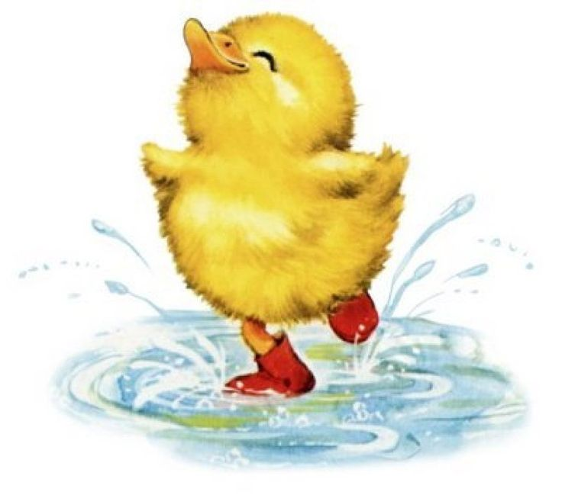

Children will stay in their classrooms playing a range of calm games. The dinner-time rules still apply. Children needing first aid will need to be sent to reception.

The quad is used at dinner-time for a small group of children who find it difficult to have positive play on the large playground. This is led by the learning mentor, Mrs Mumford.

Play-time:

Children should follow the whale award rules at break-time. The teacher on duty can give yellow and red cards. These need to be communicated with the class teacher who fills them in and sends the child to the head. Teachers who witnessed the incident must complete serious incident log on CPOMS and send to the head teacher with the yellow card. Children should always be escorted to the office when they have been given a yellow card.

Procedures for break-time:

Children are encouraged to eat their tuck outside on the playground.
When the bell goes at 10.45, KS1 and 11.00 KS2, children walk sensibly into their classrooms. We do not line up as this wastes time and can cause further problems with silliness in the line.

Dear Parent

I am disappointed to have to write and tell you that ____________________ is not behaving appropriately at dinner-time.

Unfortunately he/she has chosen to break the whale award rules many times which has resulted in ________________ having to complete a dinner-time journal to help him/her think about what he/she can do to improve their behaviour at dinner-time.

Not following the whale award rules cause other children to have an unhappy dinner-time, so we must try and help __________________ change their behaviour so all children can have a happy dinner-time.

If ____________________ continues to choose to break the rules it will result in exclusion at dinner-time. This will involve them being off the school premises from 12-1.00.

I will be happy to discuss this letter with you personally. Please let me know of a convenient time for you so we can work together to help improve _______________ behaviour at dinner-time.

Please return the slip at the bottom of this letter to acknowledge receipt of it.

Yours Sincerely

Mrs S Abdulla

I acknowledge receipt of the letter. A convenient time to come into school would be _________________________

Signed: _________________________ Parent/Guardian

Good behaviour opens the door to happy play-times, where everyone feels safe and secure.

Appendix 1

The power to discipline beyond the school gate

Disciplining beyond the school gate covers the school’s response to all non-criminal bad behaviour and bullying which occurs anywhere off the school premises and which is witnessed by a member of staff or reported to the school. The governing body must be satisfied that the measures proposed by the head teacher are lawful.

Any bad behaviour when the child is:
- taking part in any school-organised or school-related activity or
- travelling to or from school or
- wearing school uniform or
- in some other way identifiable as a pupil at the school.

Or, misbehaviour at any time, whether or not the conditions above apply, that:
- could have repercussions for the orderly running of the school or
- poses a threat to another pupil or member of the public or
- could adversely affect the reputation of the school.

As a result of any of these behaviours, the Head teacher will collect witness statements from both adults and children who have witnessed the event. The parents of the child involved will be contacted and invited into school to discuss the matter. Sanctions for the bad behaviour will follow those issued by the school for bad behaviour during the school day. Parental support will be sought for sanctions which they are able to administer outside of the school day.

Following any incident, the Head teacher will consider whether it is appropriate to notify the police or Community Support Officers in Trench of the actions taken against a pupil. If the behaviour is criminal or poses a serious threat to a member of the public, the police will always be informed. If there is any concern that the behaviour may be linked to the child suffering, or being likely to suffer, significant harm, safeguarding procedures would be followed.

Appendix 2

Searching and confiscation

The Head teacher, Assistant Head teacher and two senior members of staff have a statutory power to search pupils or their possessions, without consent, where they suspect the pupil has certain prohibited items. The items that can be searched for under this power are knives or weapons, alcohol, illegal drugs and stolen items. School staff can seize any banned or prohibited item found as a result of a search or is considered to be harmful or detrimental to school discipline.

Searching with consent
Schools’ common law powers to search:
School staff can search pupils with their consent for any item which is banned by the school rules.

1. The school does not need to have formal written consent from the pupil for this sort of search – it is enough for the teacher to ask the pupil to turn out his or her pockets or if the teacher can look in the pupil’s bag and for the pupil to agree.

2. Items which are banned in school include, mobile phones, electronic games or devices, any item which could be used as a weapon, matches, any form of drugs (including medicines, which have not been prescribed and a medical from completed), knives, firearms, sprays, alcohol or stolen items.

3. If a member of staff suspects a pupil has a banned item in his/her possession, they can instruct the pupil to turn out his or her pockets or bag and if the pupil refuses, the teacher can apply an appropriate punishment as set out in the school’s behaviour policy.

4. A pupil refusing to co-operate with such a search raises the same kind of issues as where a pupil refuses to stay in a detention or refuses to stop any other unacceptable behaviour when instructed by a member of staff – in such circumstances, schools can apply an appropriate disciplinary penalty.

Searching without consent
What the law says:

What can be searched for?
1. Knives or weapons, alcohol, illegal drugs and stolen items (referred to in the legislation as ‘prohibited items’).
Can I search?
2. Yes, if you are the Head teacher, Assistant Head teacher or a senior member of staff. But:
a. you must be the same sex as the pupil being searched; and
b. there must be a witness (also a staff member) and, if at all possible, they should be the same gender as the pupil being searched.

When can I search?
3. If you have reasonable grounds for suspecting that a pupil is in possession of a prohibited item.

Authorising members of staff
The Headteacher, Assistant Head teacher and two senior members of Staff are authorised to use these powers.

1. Teachers can only request a senior member of staff to undertake a search without consent if they have reasonable grounds for suspecting that a pupil may have in his or her possession a prohibited item. The teacher must decide in each particular case what constitutes reasonable grounds for suspicion. For example, they may have heard other pupils talking about the item or they might notice a pupil behaving in a way that causes them to be suspicious.

2. The powers allow school staff to search regardless of whether the pupil is found after the search to have that item. This includes circumstances where staff suspects a pupil of having items such as illegal drugs or stolen property which are later found not to be illegal or stolen.

Location of a search
1. Searches without consent can only be carried out on the school premises or, if elsewhere, where the member of staff has lawful control or charge of the pupil.

2. The powers only apply in England.

During the search
Extent of the search – clothes, possessions and trays

What the law says:
The person conducting the search may not require the pupil to remove any clothing other than outer clothing. ‘Outer clothing’ means clothing that is not worn next to the skin or immediately over a garment that is being worn as underwear but ‘outer clothing’ includes hats; shoes; boots; gloves and scarves.
‘Possessions’ means any goods over which the pupil has or appears to have control – this includes trays and bags. A pupil’s possessions can only be searched in the presence of the pupil and another member of staff. The power to search without consent enables a personal search, involving removal of outer clothing and searching of pockets.
Trays
Under common law powers, schools are able to search trays for any item provided the pupil agrees. Pupils will have a tray on condition that they consent to have it searched for any item whether or not the pupil is present.

If a pupil does not consent to a search then it is possible to conduct a search without consent but only for the “prohibited items” listed above.

Safety Interventions
Safety Interventions may be used by the person conducting the search (see appendix 3).

After the search
The power to seize and confiscate items – general
What the law allows:
Schools’ general power to discipline, as set out in Section 91 of the Education and Inspections Act 2006, enables a member of staff to confiscate, retain or dispose of a pupil’s property as a disciplinary penalty, where reasonable to do so.
1. The member of staff can use their discretion to confiscate, retain and/or destroy any item found as a result of a ‘with consent’ search so long as it is reasonable in the circumstances. Where any article is thought to be a weapon it must be passed to the police.

2. Staff have a defence to any complaint or other action brought against them. The law protects members of staff from liability in any proceedings brought against them for any loss of, or damage to, any item they have confiscated, provided they acted lawfully.

Items found as a result of a ‘without consent’ search
What the law says:
- A person carrying out a search can seize anything they have reasonable grounds for suspecting is a prohibited item (that is a weapon/knife; alcohol; illegal drugs or stolen items) or is evidence in relation to an offence.
- Where a person conducting a search finds alcohol, they must retain it for return to the parent.
- Where they find controlled drugs, these must be delivered to the police as soon as possible.
- Where they find other substances which are not believed to be controlled drugs these can be confiscated where a teacher believes them to be harmful or detrimental to good order and discipline.
- Where they find stolen items, these must be delivered to the police or returned to the owner, providing it is safe to do so.
- Any weapons or items which are evidence of an offence must be passed to the police as soon as possible.
- It is school policy to always deliver stolen items or controlled drugs to the police. If the owners of the items are known and do not pose a threat to the pupil, these will be returned to the owner.

Telling parents and dealing with complaints
Schools are not required to inform parents before a search takes place or to seek their consent to search their child.

1. There is no legal requirement to make or keep a record of a search, however as good practice the sheet below will be completed whenever a search and/or confiscation has taken place.

2. The school will always inform the individual pupil’s parents or guardians where alcohol, illegal drugs or potentially harmful substances are found along with any other banned items which might be found.

3. Complaints about screening or searching will be dealt with through the normal school complaints procedure.

Appendix 3

The use of reasonable force/Safety Intervention

What is reasonable force?
(i) The term ‘reasonable force’ or safety intervention covers the broad range of actions used by most teachers at some point in their career that involve a degree of physical contact with pupils.
(ii) A safety intervention is used as a last resort. It can be ranging from guiding a pupil to safety by the arm through to more extreme circumstances such as breaking up a fight or where a student needs to be restrained to prevent violence or injury to themselves and others.
(iii) ‘Reasonable in the circumstances’ means using no more force than is needed.
(iv) Restraint means to hold back physically or to bring a pupil to safety. It is typically used in more extreme circumstances, for example when two pupils are fighting and refuse to separate without physical intervention.
(v) School staff should always try to avoid acting in a way that might cause injury. Reasonable force/safety intervention is a last resort at Teagues Bridge.

When can reasonable force be used?
(i) Reasonable force/safety intervention can be used to prevent pupils from hurting themselves or others, from damaging property, or from causing disorder.
(ii) The following list is not exhaustive but provides some examples of situations where reasonable force can and cannot be used.

Schools can use reasonable force/safety intervention to:
- Prevent a pupil from attacking a member of staff or another pupil, or to stop a fight in the playground; and restrain a pupil at risk of harming themselves through physical outbursts.
- Only staff trained in safety interventions can use this to assist with the safety of the child/ren and adults.

Schools cannot:
- Use force as a punishment – it is always unlawful to use force as a punishment.

Staff training
Training is provided for senior staff so that they are able to support staff across the school. A senior member of staff will always support other staff across the school.

Telling parents when force has been used on their child
All incidents of reasonable force/safety intervention e are recorded in order to support the child and staff involved. (see sheet below)

What happens if a pupil complains when a safety intervention is used on them?

- All complaints about the use of force should be thoroughly, speedily, and appropriately investigated.
- Where a member of staff has acted within the law – that is, they have used reasonable force/safety intervention in order to prevent injury, damage to property or disorder – this will provide a defence to any criminal prosecution or other civil or public law action.
- When a complaint is made the onus is on the person making the complaint to prove that his/her allegations are true – it is not for the member of staff to show that he/she has acted reasonably.
- Suspension must not be an automatic response when a member of staff has been accused of using excessive force. Schools should refer to the “Dealing with Allegations of Abuse against Teachers and Other Staff” guidance where an allegation of using excessive force is made against a teacher. This guidance makes clear that a person must not be suspended automatically, or without careful thought.
- Schools must consider carefully whether the circumstances of the case warrant a person being suspended until the allegation is resolved or whether alternative arrangements are more appropriate.
- If a decision is taken to suspend a teacher, the school should ensure that the teacher has access to a named contact who can provide support.
- Governing bodies should always consider whether a teacher has acted within the law when reaching a decision on whether or not to take disciplinary action against the teacher.
- As employers, schools and local authorities have a duty of care towards their employees. It is important that schools provide appropriate pastoral care to any member of staff who is subject to a formal allegation following a use of force incident.

What about other physical contact with pupils?
- It is not illegal to touch a pupil. There are occasions when physical contact, other than reasonable force/safety intervention, with a pupil is proper and necessary.
- Examples of where touching a pupil might be proper or necessary:
a. Holding the hand of the child at the front/back of the line when
going to assembly or when walking together around the school;
b. When comforting a distressed pupil;
c. When a pupil is being congratulated or praised;
d. To demonstrate how to use a musical instrument;
e. To demonstrate exercises or techniques during PE lessons or sports coaching; and
f. To give first aid.



Name of child:_______________________ (Male/Female) Class: ________

Search and confiscation Record

Reason for the search

Names of staff carrying out the search and those staff acting as witness include title

Items found

Other agencies involved – please list with name and title

Parents contacted

Date:

Time:

Sanctions/Next steps

Meeting with parent and child following the incident

Any further intervention or agency involvement required

Signed: Date:

Designation:

Name of child: (Male/Female) Class:

Safety Intervention record

Reason for the use of a safety intervention

Names of staff using the safety intervention:

Parents contacted

Date:

Time:

Other agencies involved – please list with name and title

Sanctions/Next steps

Meeting with parent and child following the incident

Any further intervention or agency involvement required

Signed: Date:

Designation:

Parenting Contracts:

Introduction
The Anti-Social Behaviour Act 2003 gave schools and LA’s new powers to make formal agreements with parents to address their children’s behaviour and attendance at school.
The education and Inspections act 2006 brought about four legislative changes to the guidance on education-related Parenting Contracts, Parenting orders and Penalty notices. These changes relate to pupil behaviour (rather than school attendance) and are, in summary.

- That schools and local authorities will be able to offer parenting contracts as an earlier intervention prior to pupil being excluded;

- That schools will be able to apply for behaviour related parenting orders;

- That parenting orders will be able to be applied for where a pupil has seriously misbehaved regardless of whether they have been excluded;

- That penalty notices will be available for parents of pupils who are found during the first five days of exclusion a public place during school hours without reasonable justification.

What is a parenting Contract?

- A parenting contract is a formal agreement between a parent, school and the LA

- It is a voluntary arrangement. Neither the parents nor the LA or school can be forced to make this sort of agreement. If the LA prosecute a parent for truancy or apply for a parenting order for behaviour they can use any evidence of a parent’s refusal to make this sort of agreement or failure to keep to its terms.

- Parenting contracts are intended to provide parents with support they need and to encourage a positive joint working relationship between school and in any underlying causes.

- Under the contract, the parent agrees to provide/comply with specified requirements e.g. to ensure the child attends school regularly and punctually over a specified time period.

- LA/Governing body agrees to provide specified support to enable the parent to comply.

Circumstances in which a Parenting Contract might be pursued

- In considering whether the necessary conditions for a parenting contract are fulfilled, LA’s and school governing bodies should have regard to all their statutory duties and in particular to the points set out in paragraphs 1-23 of the guidance on ‘Education related parenting contracts, Parenting orders and Penalty notices’.
- To a parent where a child is excluded from school, whether for a fixed term period or permanently.
- Or as an early intervention in response to emerging behaviour problems.
- Where a parenting contract is being offered as an early intervention, schools and LA’s need to ascertain that there has been misbehaviour sufficient to trigger the statutory parenting contract where the school or LA have reason to believe that a pupil has behaved in such a way that they are likely to cause significant disruption to the education of other pupils or significant detriment to the welfare of that pupil or other pupils or to the health and safety of any staff, or form part of a pattern of behaviour which could lead to the pupil being excluded.
- The purpose of a parenting contract is to improve the pupils’ behaviour at school and to address any underlying causes. It is not to be seen as a punitive measure against the parent. A parenting contract will be an appropriate course of action where the parent wishes to address their child’s poor behaviour in school but needs support to do so effectively.

Assessing when a parenting contract is appropriate

- In deciding whether a parenting contract might be appropriate, the Local Authority or governing body should consider all the issues behind the behaviours and/or the non-attendance of the pupil, in particular whether the pupils behaviour may be improved through working with the parent and providing support to them and if so, what form this support should take.

At what point should the contract be arranged

- The parenting contract should be arranged as soon as possible after the misbehaviour or exclusion and completion of any exclusion review and appeal process.
- In the case of a permanent exclusion this would be the date which it is known that the parent does not wish to lodge an appeal against the Head Teachers decision.
- In the case of fixed term exclusion the date on which the review process is complete would be the date upon which the governing body endorses the decision to exclude or if the exclusion is not considered by the governing body, the date on which the exclusion began.

Liaison between the head teacher, governing body, LA and other agencies involved

- Parenting contracts require the party entering into the contract to fund any cost of the supportive element of the contract. In the context of the schools this will be the governing body. Therefore it is the governing body’s name that should appear on the contract and the governing body will have ultimate responsibility for the contract. The governing body may delegate responsibility for the contract to the head teacher and the head teacher may commit funds on behalf of the governing body. However the overall policy decision of whether parenting contracts should form part of the schools behaviour policy must remain with the governing body.
- The LA and the school should liaise prior to entering into a parenting contract in order to share information about the pupil and family and any other agencies that might be involved. If other agencies are involved they must be consulted and invited to the meeting if necessary as their support may need to be included in the contract.

Contracting parents and drawing up a contract

Once all agencies have been consulted the school should arrange a meeting with all parties involved. Consideration should be given to the best way to approach parents. Children will be invited if it is felt appropriate (KS2 only).

The specific requirements in the contract should be devised to present further behaviour and/or attendance problems.

Examples of specified requirements will depend on the particular circumstances but may include some of the following:

- Ensuring that the child attends school or alternative provision regularly and on time
- Parents must attend meetings as and when necessary
- Parent and pupils must attend parenting programmes if appropriate.
- Parents attend a parenting programme or support group
- Signing weekly behaviour reports
- Ensuring that the pupil does not come into contact with certain pupils

The contract will be written in language that the parents can understand and will strike an effective balance between general and specific requirements.

The governing body and LA’s side of the contract is a statement that agreeing to provide the parents with support for the purpose of complying with the requirements and should specify the types of support that will be provided under the contract.

Copies of the contract will be circulated to all parties involved and the original will remain in the school.

There are no specified time limits for the contracts in the Anti-Social Behaviour Act so it is a question of what is reasonable and effective. A minimum period would be 3 months and a maximum of 12 months. It may be necessary to maintain a level of support after the contract has come to an end.

Regular contact must be maintained with parents to discuss progress and any problems in meeting the requirements of the contract. It may also involve regular contact with other agencies that may be involved.

Dealing with Breaches

Although the contract is a voluntary agreement any departure from it could be sued in evidence should the LA or school seek a parenting order through the Magistrates Court.

In the case of parents failing to comply with the contract this would be a relevant consideration for the LA in deciding to apply for a parenting order. Any breach of contract must be recorded. If parents are having difficulties achieving the agreements in the contract a review meeting should be called to discuss the way forward and possibly amend the contract to support both child and parents.



Parent Contract agreement form

Agreement between (insert parents name) the Local Authority, the Head teacher and the Governors of Teagues Bridge Primary School.

We the Head Teacher and School Governors expect (insert child’s name) to:

- Attend school regularly
- Abide by all the school rules
- Respect all people and the property of the school

We the head Teacher and school Governors will ensure that:

- There will be a range of educational activities and opportunities provided for (insert child’s name).
- There is consultation with (insert parent’s name) and the Local Authority regarding the education and behaviour of (insert child’s name).

We the Local Authority will:

- Attend any meetings that are called to discuss progress or problems
- Ensure that during the period of the contract a named Senior Officer will monitor and review the situation

The Local Authority Officer is (insert LA officer name)

This parenting contract will be for the period of 3 months
From (insert start date) to (Insert end date)

Signed __________________________________________ Parent 1

Signed __________________________________________ Parent 2

Signed __________________________________________ Pupil

Signed __________________________________________ Head Teacher

Signed __________________________________________ Governor

Signed ___________________________________________ LA Officer

IMPORTANT DATES:

The next meeting will be ______________________________________________

OTHER IMPORTANT DATES ARE:

_____________________________________
_____________________________________
_____________________________________
_____________________________________

This agreement will be reviewed on:

______________________________________

USEFUL CONTACTS:

PARENTAL CONSENT TO INFORMATION SHARING

I/We understand and agree that information about me/us has been and will continue to be collected so that the school and LA can assess and provide appropriate assistance and services. This LA and school may share this information with external agencies and providers of relevant services to ensure that we are provided with the most appropriate services.
The school and LA will keep the information updated and notify anyone who is given the information of any changes.

Signed ____________________________________________ Parent 1

Signed ____________________________________________ Parent 2

Signed ____________________________________________ Pupil

Appendix 5


Teagues Bridge Primary School, Teagues Cresecent, Trench.
TF2 6RE
2nd February 2022

www.teaguesbridgeprimary.org
Governing Body Statement of Behaviour Principles

Reviewed: | 2nd February 2022
Next Review on: | February 2023
Staff Responsibility | Mrs S. Abdulla
Governor responsibility | Rose Gregory/Steve Reynolds

GOVERNING BODY STATEMENT OF BEHAVIOUR PRINCIPLES

The Department for Education requires governing bodies of maintained schools to publish statement of behaviour principles for their school. The governing body therefore has a duty to produce and review, a written statement of general principles to guide the head teacher in determining measure to promote good behaviour and discipline amongst pupils.

Teagues Bridge Primary School is an inclusive school. We are committed to promoting respect, fairness and social inclusion and these are the principles underlying our behaviour policy. We are committed to improving outcomes for our children and staff and to promote good relations across the whole school community.
Every child at Teagues Bridge has a right to feel safe at all times:
- All young people, staff and other members of the school
community have the right to feel safe at all times.
- We expect all members of the school community to behave responsibly and to treat each other with respect.
- They should be aware that bullying or harassment of any description is unacceptable.

Every child at Teagues Bridge deserves high standards of behaviour:

- The governors strongly believe that high standards of behaviour lie at the heart of a successful school.
- Good teaching and learning promote good behaviour and
good behaviour promotes effective learning.
- Children have the right to learn and to achieve their potential; in all aspects of their lives and staff have the right to teach.
- Governors also believe that the expectation of high standards of behaviour which are required during the school day can have a positive effect on the life of young people outside school in encouraging them to become successful citizens.


Every child at Teagues Bridge has the right to feel included and equal:

- We are an inclusive school; we believe in equality and in valuing the
Individual.
- We believe all members of the school community should be free from discrimination, harassment and bullying and will not tolerate them in any form. Measures to counteract bullying and discrimination will be consistently applied and monitored for their effectiveness.
- The school’s legal duties in order to comply with the equality Act 2010 and which are described in the School’s Equality Scheme will be further reinforced through the behaviour and anti-bullying policy.
- We recognise some children may need additional support to meet behaviour expectations.
Every child at Teagues Bridge has the right to be rewarded for positive behaviour:

- We believe positive behaviour should be rewarded in order to encourage good behaviour in the school and community.
- The reward system should be fair and consistent.
- We believe if children feel good about themselves
They will show good behaviour.

Every child has the right to learn in a calm and well-behaved environment.
- Sanctions for unacceptable/disruptive behaviour should be known and understood by all staff, pupils and parents/carers.
- Ensure that children are very clear of the school rules and the consequences and how this can escalate.
- All children will sign to agree to keep the school rules on the whale card.

Every child has the right to be respected at Teagues Bridge:
- We believe that RESPECT is both ways.
- We teach children the value of RESPECT.

- We explore other values during the year in order to grow good citizens for our community.

Home/School Agreement:
The Home/School Agreement will be an important part of communicating our approach so that parents/carers can be encouraged to support their child, just as the pupils should be helped to understand their responsibilities during their time in school, in the wider community and in preparation for their life after school.
The child, parent and head teacher will sign the Home/School Agreement to ensure we all work together for the good of the children and their journey at Teagues Bridge.

The use of reasonable force:
The governors expect the Whole School Behaviour Policy/Use of reasonable force policy to clearly outline the circumstances where staff may use reasonable force and other physical contact. At all times the use of force should be a last resort but governors agree it may be sued in the following circumstances:
- In self-defence or when safety is an issue
- Where there is a risk of significant damage to property
- To search pupils for weapons/stolen property
- If the child is likely to harm themselves or others
The governors expect that ‘authorised’ staff are trained in the use of reasonable force and restraint (MAPA training). Teagues Bridge records and reports all significant incidents including all use of force. All behaviour incidents of any description are also recorded in order to determine patterns, problems etc.
The Power to discipline behaviour beyond the school gate.
The governors expect the behaviour policy to include procedures for dealing with disruptive/poor behaviour and bullying which occurs anywhere off the school premises and which is witnessed by a member of staff or reported to the school. The policy will also include the school’s response to any bad behaviour when a child is:
- Taking part in any school-organised or school related activities, wearing school uniform, or identifiable as a pupil at the school
Even if the conditions above do not apply, the policy must take account of misbehaviour at any time which:
- Could have repercussions for the orderly running of the school, poses a threat to another pupil or member of the public or could adversely affect the reputation of the school

Pastoral care:
The behaviour policy will include details of how the school will respond to an allegation against a member of staff. The governors expect the headteacher to draw on and follow the advice in the ‘Dealing with allegations of abuse against teachers and other staff’ guidance when setting out the pastoral support school staff can expect, if they are accused of misusing their powers.
In addition, the behaviour policy will set out the disciplinary action that will be taken against children who are found to have made malicious accusations against school staff.

Appendix 6
Trauma Informed Practice Script:
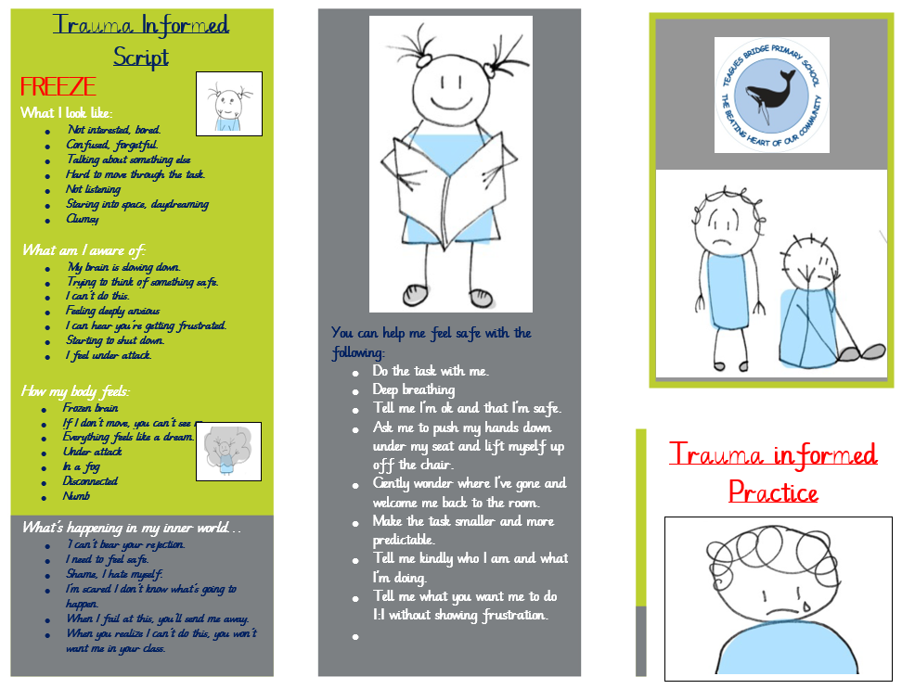
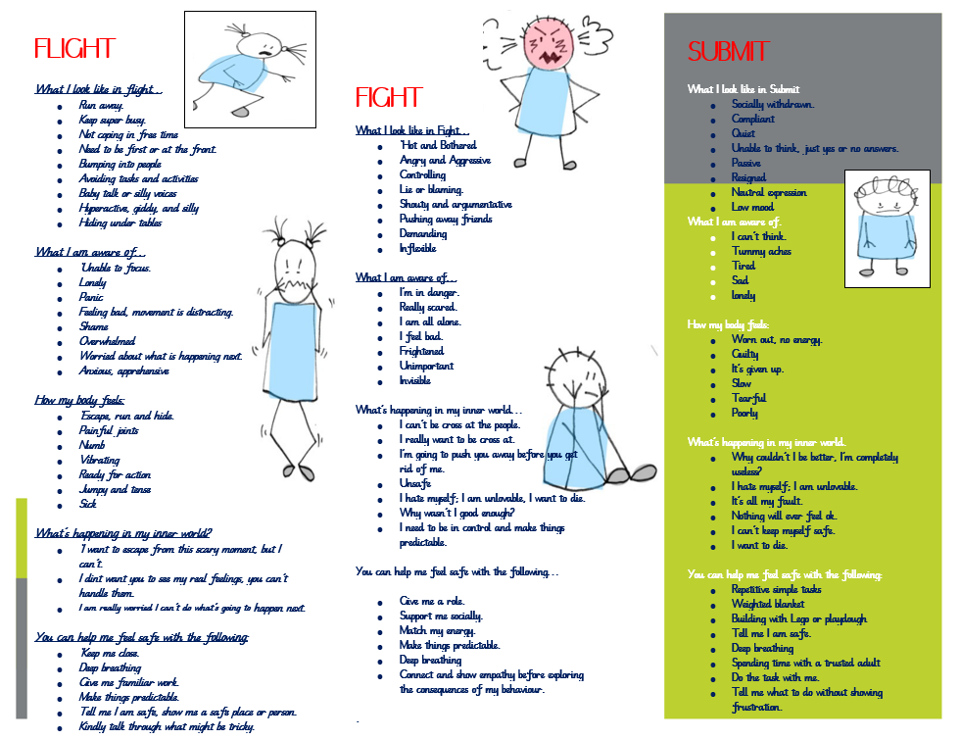

Appendix 7
Behaviour script

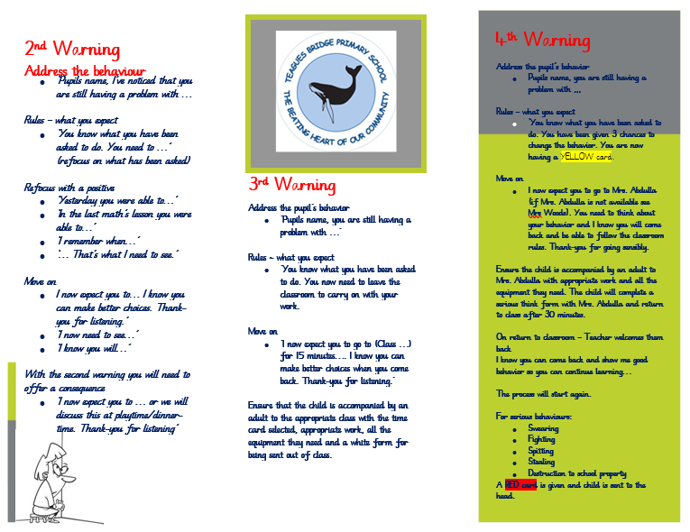
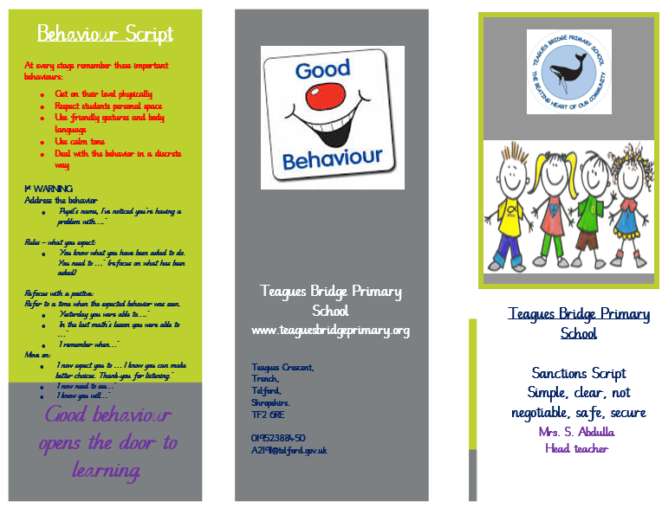

Appendix 8
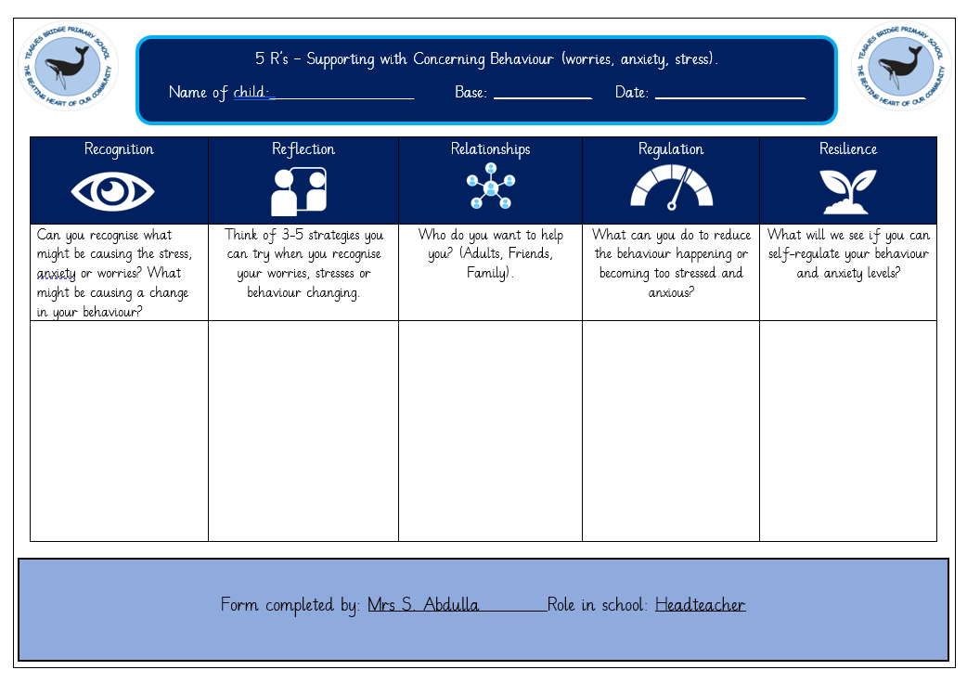

Appendix 9 ~ Individual Behaviour Plan
Name: | Year group:
DOB: | Teacher:
Base: | Medical Conditions:

- This form is used when behaviour is persistent and yellow cards (6) don’t work.
Topography of behaviour (what the child does?):

Trigger behaviours (when is such behaviour likely to occur?):

Strengths/Praise points/bridge builders:

Positive intervention strategies:
Verbal advice and support |  | Distraction (keywords, objects, likes)
Reassurance |  | Regulation box/zone
Environmental changes |  | Time out
Humour |  | Withdrawal
Consequences |  | Time out to calm
Planned ignoring |  | Transfer adult
 |  | Preferred handling (see PHP)
 |  | Rewards/incentives

Details of interventions:

Debriefing process following incident:

Recording (behaviour log//incident report/ communication with parents):

Date IBP completed: | Date of review:
Completed by: | Signed:
Details of review: | Outcomes:
Will IBP continue: | YES/NO
APPENDIX 10 My behaviour promise used in conjunction with parents when 9 yellow cards have been issued and other plans have been implemented but unsuccessful.
Or
This is used when individuals or groups of children are not following the rules and are causing low-level disruption in the classroom. The promise is discussed with the children and then shared with parents.

BEHAVIOUR PROMISE
Name:
I agree:

To help me to do this My Teacher agrees to:

For all types of behaviour the teacher will be contacting my parents, he will also contact them and inform them if it improves.
There will be consequences for:
- Being rude to the teacher | - There will be a minutes taken off my break-time for every time I am rude to the teacher/adults.  - Peg moved down.
- Being distracted during work time | - Peg will be moved down.  - There will be a minutes taken off my break-time.  - If work is not completed it will be done at dinner-time.
- Leaving the classroom without asking. | - Yellow card.
- Out of your seat and wondering around. | - Peg moved down  - 1 minute off break-time
- Being disrespectful to adults (talking when the teacher is, answering back, smirking). | - Yellow card
- Not following instructions first time. | - Peg moved down  - 1 minute off break

Staff will have no choice but to send for Mrs Abdulla or Mrs Woods when my behaviour escalates.
If my behaviour becomes unacceptable, this could lead to a suspension.

Child’s signature: _________________________________________ Date: ______________________
Teacher’s signature: _____________________________________ Date: ______________________

Appendix 11
Pupil Safety Plan ~ this is used when disruptive behaviour is persistent and other plans and promises have been explored.

My Safety and Support Plan

Name:
Signature: Date:
Name of staff developing the plan: Sarah Abdulla and Natalie Woods
Signature: Date:
Signature: Date:


Recognition:
Topography of the behaviour (what does the child do ~ teachers’ point of view)

Recognition:
Topography of the behaviour (child’s point of view)

Triggers ~ What is causing the behaviour:
(Teacher’s point of view)

Triggers ~ What might be causing a change in your behaviour?
(Child’s point of view)

What strengths and qualities do I bring?
(Getting to know me)

Reflection:
What works for me?
(What makes a good day? What keeps me engaged and stimulated?)

Reflection:
What doesn’t work for me?
(What makes for a bad day, what do I find unpleasant or distressing, what do I prefer to avoid)

Relationships
Who do you want to help you? (Adults, friends, where can I go when my behaviour is changing?)

Regulation:
What can you do to reduce the behaviour happening?

Regulation ~ Positive intervention strategies to support behaviour changes:
Verbal advice/support

Reassurance Distraction

Environment change Regulation box/zone

Humour Time out

Consequence Time out to calm

Planned ignoring Work with adult

Rewards/incentives Wearing my coat

Details of Interventions:

Consequence when there is a change in behaviour:

Debriefing process following an incident:

Behaviours that need to change:

Resilience:
What will we see if you can self-regulate your behaviour?

Review:

Outcomes:

Will Safety plan continue: YES/NO

