Female Genital Mutilation (FGM) Policy
2025-2026


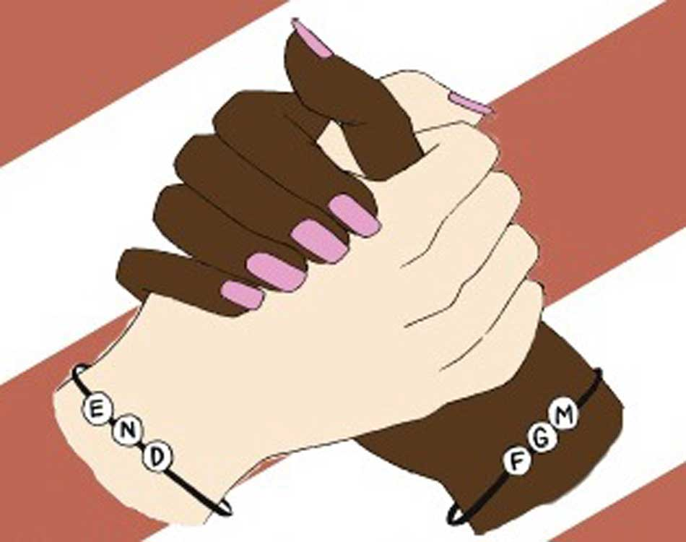
Sarah Abdulla ~ Headteacher
www.teaguesbridgeprimary.com

Policy version 3

Teagues Bridge Primary School
FGM Policy and Practice
Written on: | 23rd July 2015
Reviewed on: | July 2025
Next Review: | July 2026
Staff Responsibility | Mrs S. Abdulla
Governor responsibility | Stephen Reynolds

Rationale:
Teagues Bridge Primary has robust and rigorous safeguarding procedures and takes its responsibilities of child protection seriously.
Female Genital Mutilation is a form of child abuse and as such, is dealt with under the schools Child Protection/Safeguarding Policy. At Teagues Bridge Primary, the Head Teacher and Governors expect Safeguarding to be everybody’s responsibility and expect all staff to adhere to and follow these policies.
The school uses the World Health Organisation definition as written below.
Definition of FGM:

‘Female genital mutilation (FGM) comprises all procedures that involve partial or total removal of the external female genitalia, or other injury to the female genital organs for non-medical reasons.’

Government Documents:
The school has taken information from several documents to write this appendix. These include, Government Home Office Guidelines, the Ofsted Guidelines for “Inspecting Safeguarding”, NSPCC Guidance.
The UK Government has written advice and guidance on FGM that states:
- “FGM is considered child abuse in the UK and a grave violation of the human rights of girls and women. In all circumstances where FGM is practised on a child it is a violation of the child’s right to life, their right to their bodily integrity, as well as their right to health. The UK Government has signed a number of international human rights laws against FGM, including the Convention on the Rights of the Child.”
- “Girls are at particular risk of FGM during school summer holidays. This is the time when families may take their children abroad for the procedure. Many girls may not be aware that they may be at risk of undergoing FGM.”

UK communities that are most at risk of FGM include Kenyans, Somalis, Sudanese, Sierra Leoneans, Egyptians, Nigerians and Eritreans. However women from non-African communities who are at risk of FGM include Yemeni, Kurdish, Indonesian and Pakistani women.”

FGM is recognized internationally as a violation of the human rights of girls and women. It reflects deep-rooted inequality between the sexes, and constitutes an extreme form of discrimination against women. It is nearly always carried out on minors and is a violation of the rights of children. The practice also violates a person's rights to health, security and physical integrity, the right to be free from torture and cruel, inhuman or degrading treatment, and the right to life when the procedure results in death.

What is Female Genital Mutilation?
FGM comprises all procedures involving partial or total removal of the external female genitalia or other injury to the female genital organs for non-medical reasons. It has no health benefits and harms girls and women in many ways. It involves removing and damaging healthy and normal female genital tissue, and hence interferes with the natural function of girls’ and women’s bodies. The practice causes severe pain and has several immediate and longterm health consequences, including difficulties in childbirth also causing dangers to the child.
FGM is known by a number of names including ‘female genital cutting’, ‘female circumcision’ or ‘initiation’. The term female circumcision suggests that the practice is similar to male circumcision but it bears no resemblance to male circumcision, has serious health consequences and no medical benefits’.
FGM is also linked to domestic abuse, particularly in relation to ‘honour based violence’. Please see the links to other documents at the end of this document for further information and links to other T&W Local Safeguarding Children Board Procedures.

Types of female Genital Mutilation
Female genital mutilation is classified into 4 major types.
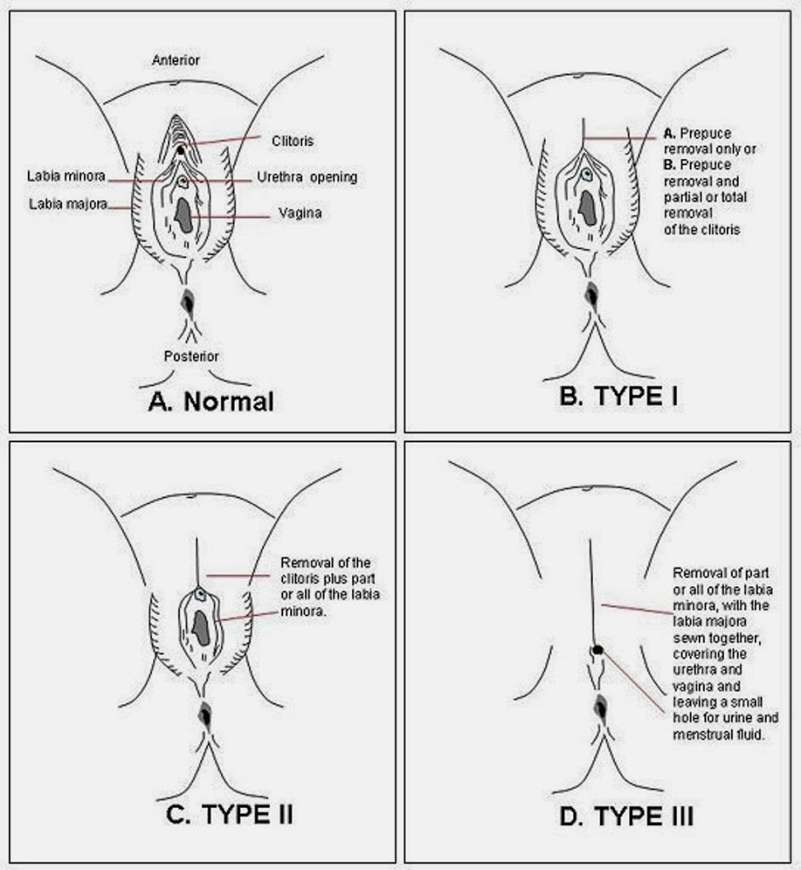

- Type 1: Often referred to as clitoridectomy, this is the partial or total removal of the clitoris (a small, sensitive and erectile part of the female genitals), and in very rare cases, only the prepuce (the fold of skin surrounding the clitoris).
- Type 2: Often referred to as excision, this is the partial or total removal of the clitoris and the labia minora (the inner folds of the vulva), with or without excision of the labia majora (the outer folds of skin of the vulva ).
- Type 3: Often referred to as infibulation, this is the narrowing of the vaginal opening through the creation of a covering seal. The seal is formed by cutting and repositioning the labia minora, or labia majora, sometimes through stitching, with or without removal of the clitoris (clitoridectomy).
- Type 4: This includes all other harmful procedures to the female genitalia for non-medical purposes, e.g. pricking, piercing, incising, scraping and cauterizing the genital area.
DE infibulation refers to the practice of cutting open the sealed vaginal opening in a woman who has been infibulated, which is often necessary for improving health and well-being as well as to allow intercourse or to facilitate childbirth.
The age at which girls undergo FGM varies enormously according to the community. The procedure may be carried out when the girl is newborn, during childhood or adolescence, just before marriage or during the first pregnancy. However, most cases of FGM are thought to take place between the ages of 5 and 8 and therefore girls within that age bracket are at a higher risk.

Cultural and social factors for performing FGM
The reasons why female genital mutilations are performed vary from one region to another as well as over time and include a mix of sociocultural factors within families and communities. The most cited reasons are:
- Where FGM is a social convention (social norm), the social pressure to conform to what others do and have been doing, as well as the need to be accepted socially and the fear of being rejected by the community, are strong motivations to perpetuate the practice. In some communities, FGM is almost universally performed and unquestioned.
- FGM is often considered a necessary part of raising a girl, and a way to prepare her for adulthood and marriage.
- FGM is often motivated by beliefs about what is considered acceptable sexual behaviour. It aims to ensure premarital virginity and marital fidelity. FGM is in many communities believed to reduce a woman's libido and therefore believed to help her resist extramarital sexual acts. When a vaginal opening is covered or narrowed (type 3), the fear of the pain of opening it, and the fear that this will be found out, is expected to further discourage extramarital sexual intercourse among women with this type of FGM.
- Where it is believed that being cut increases marriageability, FGM is more likely to be carried out.
- FGM is associated with cultural ideals of femininity and modesty, which include the notion that girls are clean and beautiful after removal of body parts that are considered unclean, unfeminine, or male.
- Though no religious scripts prescribe the practice, practitioners often believe the practice has religious support.
- Religious leaders take varying positions with regard to FGM: some promote it, some consider it irrelevant to religion, and others contribute to its elimination.
- Local structures of power and authority, such as community leaders, religious leaders, circumcisers, and even some medical personnel can contribute to upholding the practice.
- In most societies, where FGM is practised, it is considered a cultural tradition, which is often used as an argument for its continuation.
- In some societies, recent adoption of the practice is linked to copying the traditions of neighbouring groups. Sometimes it has started as part of a wider religious or traditional revival movement
Despite the harm it causes, many women from FGM practising communities consider FGM normal to protect their ‘cultural identity’. As a result of the belief systems of the cultural groups who practise FGM, many women who have undergone FGM believe they appear more attractive to men than women who have not undergone FGM. Women who have attempted to resist exposing their daughters to FGM report that they and their families were ostracised by their community and told nobody would want to marry their daughters. In some cases where women are deemed to have shamed the family honour, they have been subjected to honour-based abuse.
Although FGM is practised by secular communities, it is most often claimed to be carried out in accordance with religious beliefs. However, FGM predates Christianity, Islam and Judaism, and the Bible, Koran, Torah and other religious texts do not advocate or justify FGM.
Who performs FGM?
The practice of female genital mutilation is often perpetrated by an older woman in the practicing community and can be a way of her gaining prestige and making a good income. It may be possible that families will practise FGM in the UK when a female family elder is around, particularly when she is visiting from a country of origin.
It is often performed with crude blunt instruments such as un-sterilised household knives or razor blades but broken glass and stones are also used and often without anaesthetic. The more affluent may have the procedure performed in a health care facility by qualified health personnel. Neither of these practices are acceptable.

The effects of FGM:
FGM can cause both short term and long-term complications. Some of these are as a result of the procedure being performed in unhygienic circumstances.
Short-term implications:
▪ Severe pain
▪ Shock-both emotional and psychological as well as medical
▪ Haemorrhage
▪ Wound infection including tetanus and blood borne viruses such as HIV and Hepatitis B and C
▪ Damage to organs around clitoris and labia
▪ Urine retention
▪ Fracture of bones or dislocation of joints as a result of restraint
▪ Damage to other organs
▪ Death

Long-term implications can entail:
▪ Damage to the reproductive system including infertility
▪ Chronic vaginal and pelvic infections
▪ Cysts and abscesses
▪ Complications in pregnancy and child birth, including death
▪ Psychological damage
▪ Painful sexual intercourse
▪ Sexual dysfunction
▪ Difficulties in menstruation
▪ Difficulties in passing urine and chronic urine infections
▪ Renal impairment and possible renal failure
▪ Increased risk of HIV and other sexually transmitted infections

There is increasing awareness of the severe psychological consequences of FGM which can be life long. There is evidence to suggest that girls having undergone FGM suffer from post traumatic stress disorder with flash backs and many suffer from anxiety and mood disorder. The feeling of betrayal, incompleteness, anger and regret are themes reported by young women undergoing counselling.

Identifying girls at risk of FGM:
A girl from a practicing community may be at risk of FGM but it cannot be assumed that all families from practicing communities will want their females to undergo FGM.
The risk of FGM to an individual is greater when the community is less well integrated into British society, when their own mother or sister has been the subject of FGM or when they have been withdrawn from Personal, Social and Health Education or Personal and Social Education lessons at school. The withdrawal from such lessons may be the parents’ way of keeping the girl uninformed of her rights and her own body.
A girl may be taken out of the country for a holiday for the procedure to be carried out abroad with time for recovery, but there is also evidence that FGM is carried out in the UK. The summer holiday is a peak period for cases of forced marriage and female genital mutilation. Schools, at this time in particular, and LAs are encouraged to be alert to the signs of potential abuse.
Alerts to imminent FGM may include:
• A visiting female elder being in the UK from the country of origin
• A professional hearing reference to FGM e.g. hearing someone talking about a ‘special procedure’
• A disclosure or request for help if the girl is aware or suspects she is at risk
• Parents taking the child out of the country for a prolonged period
• The girl talking about a long holiday to one of the countries where FGM is practiced
FGM may already have taken place but it is important that this is recognised so that help can be offered to the girl, other family members at risk can be safeguarded and so that a criminal investigation can be carried out.
Indications that FGM has already been carried out may be suspected if:
• A girl seems to have difficulty walking, sitting or standing
• A girl spends longer then normal in the bathroom/toilet due to difficulties urinating
• A girl spends long periods away from the classroom with bladder or menstrual problems
• A girl misses a lot of time off school or college

• A girl has a change in behaviour
• A girl being unduly reluctant to have a normal medical examination
• A girl confides in someone or may ask for help but not be explicit due to fear or embarrassment

Legal Context ~ FGM is illegal in the UK!!!
The Female Genital Mutilation Act 2003 applies to England, Wales and Northern Ireland and a person, whatever their nationality or residence status, is guilty of an offence under this Act if they excise, infibulate or otherwise mutilate the whole or any part of a girl’s or woman’s labia majora, labia minora or clitoris within the UK.
Necessary operations by a registered medical practitioner or midwife for medical reasons or related to child birth are specific exclusions under the Act.
It is also an offence to assist a girl or woman in mutilating her own genitalia
Under the 2003 Act, it is an offence for a UK national to assist in FGM abroad and for a girl to be taken abroad for FGM to take place.
Anyone found guilty under the 2003 Act will be liable to a maximum penalty fine or up to 14 years imprisonment or both.
FGM is a human rights issue (Article 3 of the European Convention on Human Rights and the 1989 United Nations Convention on the Right of the Child, Part 1, Article 37).

Responding to FGM:
Girls and young women at risk of FGM need to be safeguarded. Anyone who has information that a child is potentially or actually at risk of significant harm is required to inform Children’s Social Care or the Police (Children Act 1989; consolidated by s10 Children Act 2004 which places a duty on all key agencies to co-operate to improve the well-being of children and young people). Children’s Social Care services will then assess the risk to the child under a section 47 investigation.
Staff in education settings/obstetrics and midwifery services need to be aware of the potential risk to girls and women from communities known to practice FGM.
Professionals need to be aware of the sensitive and complex nature of FGM. Often the family does not see FGM as an act of abuse and in all other ways provide a loving environment. Removal of the girl from the family home may not be appropriate.
Each case needs to be responded to depending on the particular circumstances and level of danger at the time.
If an individual has undergone FGM, professionals must consider whether other girls are at risk.

When talking about FGM professionals, it is good practice to:
a) Ensure a female professional is available if the girl prefers
b) Make no assumptions
c) Be sensitive to the fact that the girl may still be loyal to her family
d) Be non judgmental and stick to facts e.g. the legal position and health implications
e) Gain accurate information and keep accurate records
f) Use simple, non loaded and value neutral terminology
g) Ask direct questions to avoid confusion

If an interpreter is required, they must not be a family member nor have any influence in the girl’s community.
Females may be frightened about contact with statutory agencies for a variety of reasons including being in breach of immigration rules. However, the female may need medical treatment of may be the victim of a crime. The situation should be handled sensitively and may need agreement between the police and UK Border Agency officials.
Females may also find it difficult to disclose FGM because of fear of the consequences for the family, including being taken to court.
If a medical examination is required, this should be carried out by an appropriately trained person and should be carried out under safeguarding procedures by SARC (West Road, Wellington, TF1 2BB).
Professionals may feel uncomfortable about disclosing information about FGM, but law and policy allow for disclosure when it is in the public interest or where a crime may have been committed. Professionals should follow appropriate guidance regarding confidentiality and disclosure, e.g. Information Sharing Guidance for Practioners Nursing and Midwifery Council’s advice on confidentiality.
Professionals need to be aware that an individual may be at risk of both FGM and forced marriage. The national and local guidance on forced marriage should be consulted.

Clinical Issues:
Women and girls who have suffered mutilation may be very reluctant to agree to a vaginal or rectal examination and may refuse routine cervical smears and/or infection screening. It may be impossible to perform a vaginal examination at all and be very difficult or impossible to pass a urinary catheter.
Nurses and midwives need to deal with this in a sensitive manner and be prepared sufficiently that they do not exhibit signs of shock, confusion, horror, or revulsion on seeing the genitalia. Even though sensitivity is needed, it is very important to ask women whether they have been ‘cut’ or ‘circumcised’. Some seek help because they wish to have the FGM reversed before marrying or may be experiencing problems conceiving because of difficulties with penetration. These women and girls need to be referred to appropriate clinics.

Legal Interventions:
Working Together to Safeguard Children (2023) states:
“If at any time it is considered that the child may be a child in need as defined in the Children Act 2004, or that the child has suffered significant harm or is likely to do so, a referral should be made immediately to local authority children’s social care. This referral can be made by any professional.”

FGM is recognised as significant harm.
Professionals should intervene to safeguard girls who may be at risk of FGM or has been affected by it. This is by using the relevant existing statutory procedures. There may be a joint investigation which would be handled in line with the Safeguarding Board procedures and Working Together to Safeguard Children (2023).
The police may use their protection powers under section 46 of the Children Act 2004 where there is reasonable cause to believe that a child or young person under 18 years is at risk of significant harm. Children’s social care would be informed by the police and initiate child protection enquiries.
Emergency Protection Order (EPO) can be applied for by anyone but in general is by children’s social care. An EPO authorises the applicant to remove the girl and keep her in safe accommodation. It lasts for 8 days but can be renewed for up to a further 7 days.
Care Orders and Supervision Orders - Children’s social care may need to consider whether the circumstances constitute likely significant harm to justify initiating care proceedings. The court will decide whether the threshold has been reached and which order is most appropriate depending on the circumstances and the age of the child or young person (Children Act 1989 section 31).
Under the Children Act 2004, local authorities can apply to the courts for various orders to prevent a child being taken abroad for FGM.
A Prohibitive Steps Order (Children Act 2004) can be sought to prevent parents or carers from carrying out a particular act without the consent of the court.

Procedures School has in place:
Teagues Bridge Primary School has decided to take proactive action to protect and prevent our girls being forced to undertake FGM. The Head Teacher and Governors do this in 4 ways:

1. A robust Attendance Policy that does not authorise holidays, extended or otherwise.
2. FGM training for Child Protection DSPs and disseminated training for all staff at the front line dealing with the children (all our staff are Safeguard Trained)
3. FGM discussions by Child Protection DSPs with parents of children from practising communities who are at risk.
4. Comprehensive PSHE and Relationship and Sex Education delivered to KS2 children with a discussion about FGM with Year 6 girls (from female teachers).
In order to protect our children it is important that key information is known by all of the school community.

Indications that FGM has taken place:
- Prolonged absence from school with noticeable behaviour change – especially after a return from holiday.
- Spend long periods of time away from the class during the day.
- A child who has undergone FGM should be seen as a child protection issue. Medical assessment and therapeutic services to be considered at the Strategy Meeting.

Indications that a child is at risk of FGM:
- The family comes from a community known to practice FGM - especially if there are elderly women present.
- In conversation a child may talk about FGM.
- A child may express anxiety about a special ceremony.
- The child may talk or have anxieties about forthcoming holidays to their country of origin.
- Parent/Guardian requests permission for authorised absence for overseas travel or you are aware that absence is required for vaccinations.
- If a woman has already undergone FGM – and it comes to the attention of any professional, consideration needs to be given to any Child Protection implications e.g. for younger siblings, extended family members and a referral made to Social Care or the Police if appropriate.

Record
All interventions should be accurately recorded on the concerns form and safeguarding procedures followed.

Refer
The Head Teacher needs to seek advice about making referrals to Social Care and to report FGM to the police immediately.

Orgnaisations working on issues on or around FGM:

POLICE SERVICE
Metropolitan Police Service / Project Azure 020 7161 2888
UK GOVERNMENT
https://www.gov.uk/female-genital-mutilation
HELPLINES
National Society for the Prevention of Cruelty to Children (NSPCC) FGM Helpline
24 –hour Helpline. Free phone 0800 028 3550 www.nspcc.org.uk/fgm
Black Association of Women Step Out (BAWSO)
24-hour Helpline: 0800 731 8147 www.bawso.org.uk
ChildLine
24-hour Helpline for children: 0800 1111 www.childline.org.uk
National Domestic Violence Helpline
24-hour Helpline: 0808 2000 247 www.nationaldomesticviolencehelpline.org.uk
NSPCC British Sign Language Helpline for deaf or hard-of-hearing callers
ISDN videophone: 020 8463 1148 Webcam: nspcc.signvideo.tv (available Monday – Friday, 9am – 5pm, in English language only) Text: 0800 056 0566
OTHER ORGANISATIONS
AFRUCA ~ Africans Unite Against Child Abuse
www.afruca.org
28 Too Many
http://28toomany.org/
Africans Unite Against Child Abuse (AFRUCA)
http://www.afruca.org/
Agency for Culture and Change Management UK (ACCM UK)
http://www.accmuk.com/
Birmingham & Solihull Women’s Aid
http://bswaid.org/
Foundation for Women’s Health Research & Development (FORWARD)
http://www.forwarduk.org.uk/
Halo Project
http://www.haloproject.org.uk/
Manor Gardens Health Advocacy Project
http://www.manorgardenscentre.org/
The Lily Project
www.visioncornwall.com
The Maya Centre
www.mayacentre.org.uk.
For more organisations and local services, please visit
https://www.gov.uk/female-genital-mutilation

The government’s FGM unit can offer advice and support to local areas who would like to strengthen or develop their work on tackling FGM.
To contact the FGM unit, please email FGMEnquiries@homeoffice.gsi.gov.uk
More information on the role of the FGM unit can be found at:
https://www.gov.uk/government/collections/ female-genital-mutilation

Conclusion:

Female genital mutilation is not a race or a religious issue; it is a safeguarding issue which will need to be managed consistently. All staff involved in the safeguarding of children must recognise this.
The practice of female genital mutilation tends to run in families and therefore if one family member is identified as being at risk of undergoing FGM or has undergone FGM, risks to other female family members must be recognised.
Any concerns regarding female genital mutilation must be acted upon in accordance with local policy and guidance. The referrer, however, must feel reassured that a sensitive strategy will follow, including the sensitive management of any subsequent investigation and child protection conference.

