

www.teaguesbridgeprimary.org
Schools Asthma Policy
November 2025

Teagues Bridge Primary School

School Asthma Policy

Written on: | 23rd July 2016
Reviewed: | 6th November 2025
Next review | November 2026
Staff Responsibility | Mrs N Smith
Governor responsibility | S. Reynolds

The Asthma lead for the school is Mrs Heather Whitehouse.
Teagues Bridge Primary School is an inclusive community that aims to support and welcome pupils with asthma. The school ensures that the whole school environment, which includes physical, social, sporting and educational activities, is inclusive and favourable to pupils with asthma.
Teagues Bridge Primary School is committed to providing pupils with a physical environment, which is accessible to pupils with asthma and that children with asthma have full access to extended school activities, school productions, after school clubs and residential visits.
The schools’ asthma policy is drawn up in consultation with a range of local key stakeholders within both the school and health settings. All staff understand their duty of care to children and young people in the event of an emergency and feel confident in knowing what to do in an emergency. All school staff have receive annual asthma awareness training (see appendix 1 for emergency procedures).
The school has clear guidance and record keeping arrangement for the administration and storage of medicines at school. This policy runs alongside of the school’s health and safety policy and medication policy.

Policy Guidelines:
Pupils with asthma are encouraged to:
- Take control of their condition and are included in all school activities
- Not to be forced to take part in activity if they feel unwell
- Have the appropriate inhalers with them during physical activity and that pupils take them when needed
All Teachers and school after school leaders need to;
- Be aware of the potential triggers for pupil’s asthma when exercising
- Complete a risk assessment for any out of school visit and include a copy of the Asthma Health Care Plan. Factors to consider include how routine and emergency medicines will be stored and administrated and where help could be obtained in an emergency
- Consider any additional medicines, equipment or factors when planning residential visits. These may be in addition to any medicines, facilities and healthcare plans that are normally available in school
All staff need to;
- Understand their duty of care of pupils in the event of an emergency
- Attend training on an annual basis and know what to do in an emergency for the pupils in their care with asthma
- Understand asthma and are trained in what to do in an emergency
- Under common law duty of care act like any reasonably prudent parent, this may include administrating medicine
- Refer to school Asthma Health Care plans (Appendix 2) to inform the appropriate staff, of pupils in their care who may need emergency help.
A copy of the pupil’s health care plan would need to be sent to the emergency care setting with the pupil. On occasions when this is not possible, the form is sent or the information on it should be communicated to the hospital as soon as possible.
If a pupil needs to be taken to hospital and the parent is unable to get to school, a member of staff will accompany the pupil and will stay with them until the parent arrives. The school tries to ensure that the staff member will be someone known to the pupil.
Staff should not take pupils to hospital in their own car – an emergency 999 call for an ambulance should be made instead.

Administration of Medicines:
Emergency medicines
- All pupils at this school with asthma have easy access to their emergency medicines. All inhalers and spacers are kept for pupils in their individual classrooms in a designated plastic box.
- All pupils are encouraged to carry and administer their own emergency medicine, when their parents and health specialists determine they are able to start taking responsibility for their condition (Appendix 3 and 4). They should record on the sheet when they have taken their inhaler and this needs to be signed by an adult.
- Pupils, who do not carry and administer their own emergency medicines, should know where their inhaler is stored and how to gain access and seek assistance from a member of staff.
- All school staff have been informed through training that they are required, under common law duty of care, to act like any reasonable parent. In an emergency situation, this may include taking action such as administering medicines
Drawing up School Asthma Health Care Plans;
- This school uses an adapted School Health Care Plan to record important details about individual pupil’s medical needs, their triggers, signs, symptoms, medicines
- A school health care plan accompanied by an explanation is sent to all parents of pupils with asthma for completion:
  - At the start of the school year (September)
  - On admission to the school
  - When a diagnosis is first communicated with the school
- See Appendix 5 for copy of the letter
- The parents are asked to fill out the pupil’s school Asthma Health Care Plan. Parents then return these completed forms to the school. Parents may need to liaise with their child’s health care professionals to complete the form
- Teagues Bridge ensures that a relevant member of school staff is available, if required to help complete the health care plan for pupils with particularly complex healthcare needs
School Asthma Register;
- The school Asthma Health Care Plans are used to create a centralised register of pupils with asthma
- Mrs Johnson and Mrs Woods are responsible for the register at Teagues Bridge and follow up any of the details on a pupil’s Asthma Health Care Plan or if permission for administration of medicines is unclear or incomplete.
- Parents are regularly reminded to update their pupil’s Asthma Health Care Plan if their pupil has a medical emergency or if there have been changes to their symptoms, medicines or treatment
- Every pupil with a health care plan at this school has their plan discussed and renewed at least once a year and a copy is sent home
- Health Care Plans are kept in the main office, as well as with their Teacher and all members of staff who work with the pupil, have access to the plan (Medical folder in each base)
- When a member of staff is new to a pupil group, for examples due to staff absence, the school makes sure that they are made aware of the health care plans of pupils in their care
- The school ensures that all staff protect pupil confidentiality
- This school seeks permission from parents to allow the health care plan to be sent ahead to emergency staff should it occur during school hours or at an out-of-school-hours activity
- This school seeks permission from pupils and parents before sharing any medical information with any other party
- All parents of pupils with Asthma are asked to provide consent on the health care plan giving staff permission to administer medicines in an emergency
- Parents of pupils with Asthma at this school are all asked at the start of each school year about the Health Care Plan if they, or the pupil’s healthcare professional believe the pupil is able to self-manage, carry and administer their own emergency medicines
- If a pupil requires regular/daily help in administering their medicines then the school outlines the school’s agreement to administer those medicine/s on the Health Care Plan. Both the school and parents keep a copy of the agreement

Roles and Responsibilities;
The governing body has responsibility to:
- Ensure the health and safety of all staff and anyone else on the premises or taking part in school activities. This responsibility extends to those staff and others leading activities taking place off site, such as visits, outings and residential visits
- Ensure health and safety policies and risk assessments are inclusive of the needs of pupils with Asthma
- Make sure the Asthma policy is effectively monitored and regularly updated
- Provide indemnity for teachers who volunteer to administer medicine to pupils with Asthma
The headteacher has a responsibility to:
- Ensure the school is inclusive and welcoming and that the Asthma policy is in line with local and national guidance and policy frameworks
- Liaise between interested parties ~ including pupils, school staff, welfare assistants, school nurses, parents, governors, the health service, the LA and local emergency services
- Ensure that information held by the school is accurate and up to date and that there are good information sharing systems in place using individual health care plans
- Ensure pupil confidentiality
- Assess the training and development needs of staff and arrange for them to be met
- Ensure all staff know the Asthma policy and know which pupils have Asthma (each base has a folder containing this information which is updated regularly)
- Delegate a staff member to check expiry date of medicines and to ensure spacers are cleaned in a half termly basis to maintain the school Asthma register
- Monitor and review the policy on a regular basis, with input from staff and external stakeholders
All staff have a responsibility to:
- Be aware of the potential triggers, signs and symptoms of Asthma and know what to do in an emergency
- Understand the school’s Asthma policy and procedures
- Know which pupils have Asthma and be familiar with the content of their individual health plan
- Allow all pupils to have immediate access to their emergency medicines
- Maintain effective communication with parents including informing them if their child has been unwell at school
- Ensure pupils carry their medicines with them, have them when they go on an educational visit or out of the classroom
- Be aware that long term conditions can affect a pupil’s learning and provide extra help when pupils need it
- Liaise with parents, the pupils healthcare professionals, special educational needs co-ordinator and welfare officers if a pupil is falling behind with their work because of their condition
- Use opportunities such as PSHE to raise pupil awareness about Asthma
- Understand Asthma and the impact it can have on pupils
- Ensure all pupils with asthma are not excluded from activities they wish to take part in.
The school nurse who works with our school has a responsibility to:
- Support with updating the school’s Asthma policy
- Provide information about where the school can access training
- Provide support and information to the identified member of staff responsible for ensuring parents complete the health care plans
Individual doctors and specialist healthcare professionals caring for pupils who attend this school, have responsibility to:
- Help complete the school health plans provided by parents if appropriate
- Where possible and without compromising the best interests of the pupil, try to prescribe medicines that can be taken outside of school hours
- Offer parents of every pupil a written self-management plan to ensure parents and pupils know how to self-manage at school and at home
- Ensure the pupil knows how to take their medicines effectively
- Ensure pupils have regular reviews of their condition and the medicines they take
- Provide the school with information and advice if a pupil in their care has severe Asthma symptoms
- Understand and provide input to the school’s medical policy
- Provide inhalers and spacers when requested by parents
The parents at this school have a responsibility to:
- Tell the school if their child has Asthma
- Ensure the school has a complete and up-to-date school health care plan for their child
- Inform the school about the medicines their child requires during school hours
- Inform the school of any Inhaler the child requires while taking part in visits, outings or field trips and other out-of-school activities such as school team sports
- Inform the school about any changes to their child’s inhalers e.g. what they take and how much
- Inform the school of any changes to their child’s condition
- Ensure their child’s inhalers and spacers are labelled with their full name
- Ensure that school has inhaler needed by their child and that the inhaler is within their expiry date and is updated regularly
- Keep their child at home if they are not well enough to attend school
- Ensure their child has regular reviews with their doctor or specialist health care professionals
- Ensure their child has a written self-management plan from their doctor to help them manage their child’s condition

EMERGENCY RESPONSE
Person 1 - CALL AMBULANCE

PERSON 2
Contact parents/next of kin calmly, asking them to come to school urgently but without causing panic. Give facts only, don’t speculate, don’t exaggerate. Retrieve health care plans and any medication to be sent with ambulance. Inform Headteacher
PERSON 1

Open main gate

Open bottom gate
If access required here

Wait outside for
Ambulance and talk to casualty
School Asthma Health Care Plan
Pupil’s name
Date of birth
Base
Pupil’s address
Date Asthma Diagnosed
Parents Name
Phone no. (Work)
(Home)
Mobile
Parents Name
Phone no. (Work)
(Home)
(Mobile)
G.P. Name
G.P. Phone No.
Clinic/Hospital contact Name
Phone No.

Describe how the asthma affects your child including their typical symptoms and asthma ‘triggers’

Describe their daily care requirements including the name of their asthma medicine, how often it is used and the dose (e.g. Once or twice a day, just when they have symptoms, before sport)

Describe what an asthma attack looks like for your child and the action to be taken of this occurs.

Who is to be contacted in an emergency? Give three contact telephone numbers and their names.

ADVICE FOR PARENTS
Remember:
- It is your responsibility to tell school about any changes in your child’s asthma/and or their asthma medications
- It is your responsibility to ensure that your child has their ‘relieving’ medication with them in school and that it is clearly labelled with their name. You should confirm this with your child’s class teacher.
- It is your responsibility to ensure that your child’s asthma medication has not expired.
- Your child should not be exposed to cigarette smoke

REQUEST FOR CHILD TO CARRY MEDICATION
Name of school
Pupil’s name
Base
Address

Name of Medicine

Procedures to be taken in an emergency

Contact name
Daytime phone no.
Relationship to pupil

I would like my son/daughter to keep their medicine themselves for use as necessary.

Signed: ________________________________________________________________

Print name: __________________________________________________________

Relationship to pupil: _________________________________________________

Date: __________________________________________

Example letter for parents/Carers to accompany School Asthma Health Care Plan

Dear Parent/Carer
Re: The School Asthma Health Care Plan

Thank-you for informing us of your child’s asthma on his/her registration form.
As part of accepted good practice and with advice from the local PCT, hospital specialists, and the Department for Education and Skills, our school has recently established a School Asthma Policy.
As part of this policy, we now ask all parents/carers of children with Asthma to help us by completing a School Health Care Plan for your child/ren. This is attached to this letter. The completed School Asthma Health Care Plan will store information details about your child’s current medicines, triggers, individual symptoms and emergency contact numbers. The plan will help school staff to better understand your child’s individual condition and needs.
Please complete this plan and return to school by ______________________________________.
I look forward to receiving your child’s completed School Asthma Health Care Plan.
Thank-you for your help
Yours Sincerely

Mrs S. Abdulla
(Headteacher)
Record of Medicine administered to Individual children
To be kept with the inhaler in the form of a card
Fill in the pupil’s details in section 1 and then one form section 2 each time medicine is given in school.

Section 1:
Name of school
Name of pupil
Date medicine provided by parent
Base
Quantity received
Name and strength of medicine
Expiry date
Quantity returned
Dose and frequency of medicine

Section 2:
Date |  | Date
Time given |  | Time given
Dose given |  | Dose given
Name of staff |  | Name of staff
Staff Signed |  | Staff Signed
Witness |  | Witness
Advice for children from Royal Children’s Hospital website
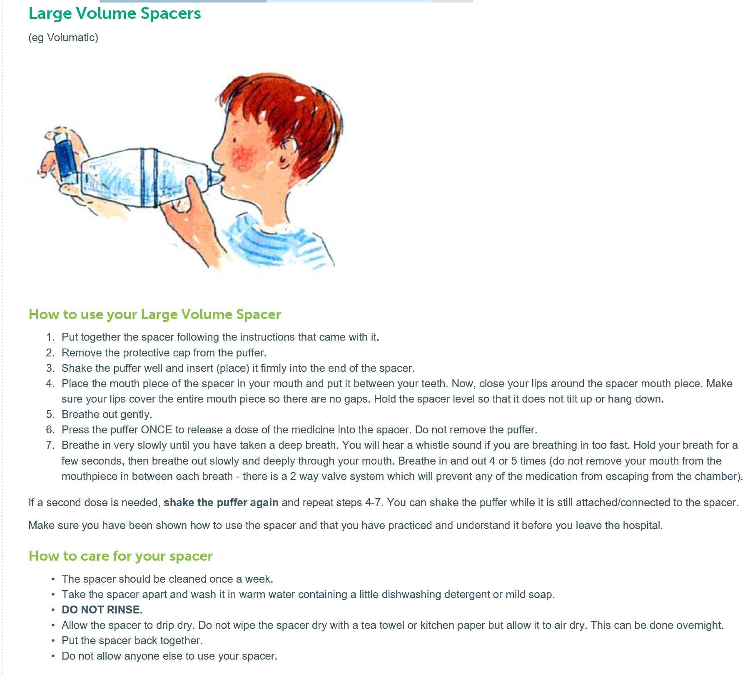

How to manage an Asthma Attack in School
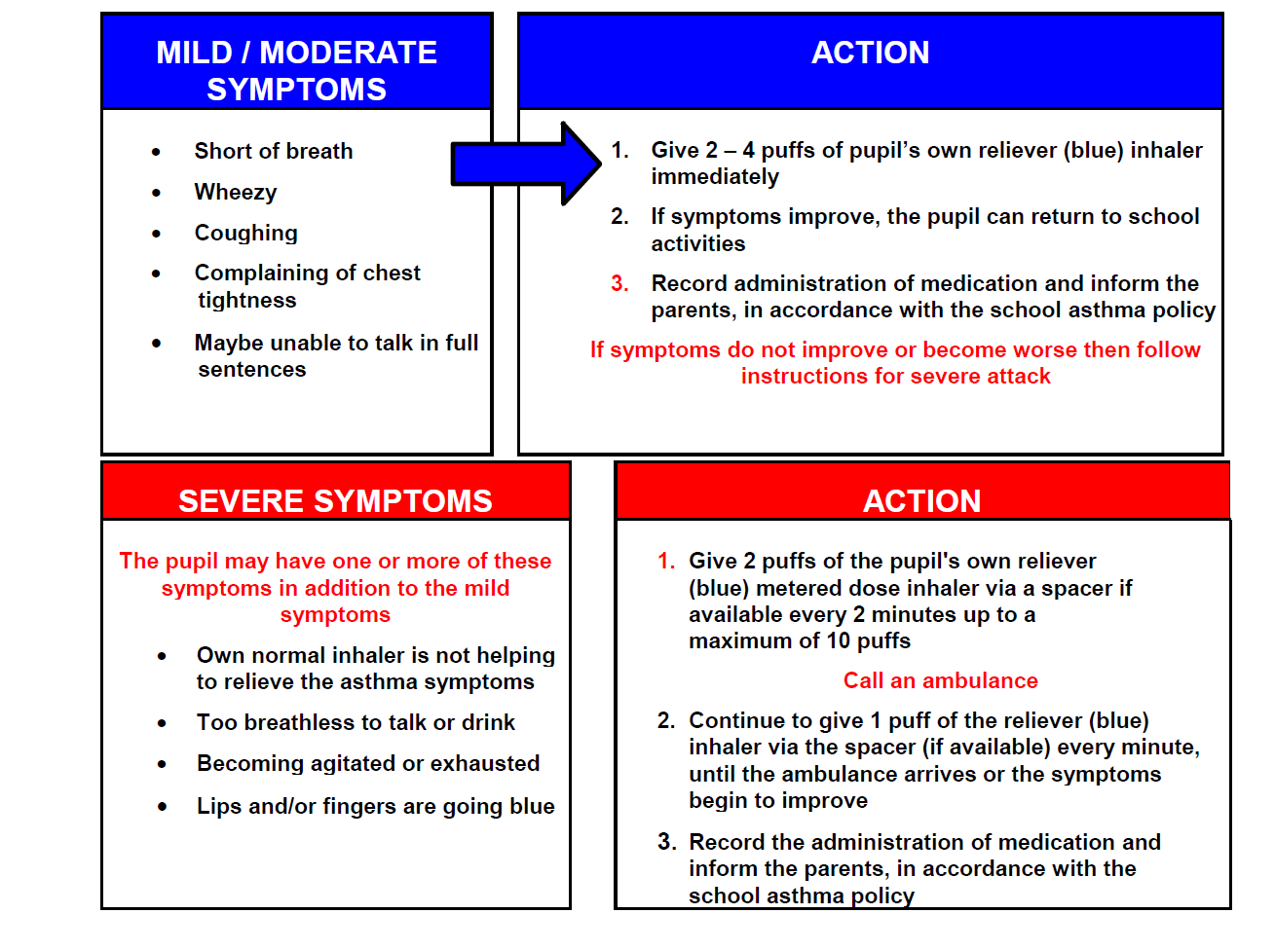

No Inhaler
If the child’s inhaler has run out or is broken they may use the school’s emergency inhaler stored in the shower room. Check the list for consent from Parent/Carers.
Record administration of medication and inform parents, in accordance with the school emergency inhaler protocol.

No Inhaler
If the child’s inhaler has run out or is broken they may use the school’s emergency inhaler stored in the shower room. Check the list for consent from Parent/Carers.
Record administration of medication and inform parents, in accordance with the school emergency inhaler protocol.

