


Mrs S. Abdulla
This policy is written for children with English as an additional language
November 2025
EAL Policy

Reviewed on: | 5th November 2025
Next review | November 2026
Staff Responsibility | Mrs S. Abdulla
Governor responsibility | Steve Reynolds

Statement of aims:
Teagues Bridge Primary is committed to making appropriate provision of teaching and resources for pupils whom English is an additional language and for raising the achievement of minority ethnic pupils who are at risk from underachievement. The school will identify individual pupil’s needs, recognise the skills they bring to school and ensure equality of access to the curriculum.
We aim to ensure that all EAL pupils are able to:
- Use English confidently and competently
- Use English as a means of learning across the curriculum
- Where appropriate, make use of their knowledge of other languages
- Ensure they can access and comprehend the English language
The context of our school:
35% of the learners in Teagues Bridge are of non-white British ethnicity. This is above that of the LA which is currently .
Our EAL learners generally come from a range of ethnic groups and from a range of backgrounds. Some of our EAL learners arrive in school having had no exposure to English language and culture. Others arrive in our school with some prior experience of school and with some literacy skills in their home language and a little English.
Breakdown of Ethnicity
Autumn Term 2023
96/271 pupils on roll are registered as not WBRI equating to 35.42%
2 (0.74%) are any other Asian background (AOTH)
5 (1.85%) are any other White background (WOTH)
1 (0.37%) is Arab other (OARA)
10 (3.69%) are Black African (BAFR)
1 (0.37%) is Black Ghanaian (BGHA)
1 (0.37%) is Chinese (CHNE)
1 (0.37%) is Chinese and any other Ethnic group (MCOE)
1 (0.37%) is Egyptian (OEGY)
13 (4.8%) are Indian (AIND)
2 (0.74%) are Kurdish (OKRD)
2 (0.74%) are other Asian (AOTA)
3 (1.11%) are other Pakistani (AOPK)
1 (0.37%) is other White British (WOWB)
1 (0.37%) is Pakistani (APKN)
7 (2.58%) are White and Asian (MWAS)
2 (0.74%) are White and Black African (MWBA)
7 (2.58%) are White and Black Caribbean (MWBC)
1 (0.37%) is White Eastern European (WEEU)
34 (12.55%) are White European (WEUR)
1 (0.37%) is White Other (WOTW)

Admitting New Pupils:

We follow the school’s normal admission procedure which includes the collection of the following additional information:
- Country of origin
- Date of arrival in U.K.( where applicable)
- Pupil’s first language
- Other languages spoken at home/by pupil
- Pupil’s level of literacy in these languages
- Pupil’s educational background
We normally attempt to contact previous schools. Parents/carers and pupils are taken on a tour of the school and introduced to key personnel. They are provided with appropriate information about the school. Care is taken to ensure we know how to say names and how to address parents and pupils appropriately.

We will develop their spoken and written English by:
- Ensuring vocabulary work covers the technical as well as the everyday meaning of key words, metaphors and idioms
- Display key vocabulary
- Provide a range of reading materials that highlight the different ways in which English is used
- Ensure there are opportunities for talking, and that talking is used to support writing
- Ensure all new arrivals have an assessment from SMDS
- Ensure children are given adequate support from SMSD service
- Produce vocabulary books for children to take home with English and their own language
- Build on children’s experiences of language at home and in the wider community, so that their developing uses of English and other languages support one another

Ensure access to the curriculum and to assessment by:
- Using accessible texts and materials that suit the child’s age and level of learning
- Provide support through ICT, video, audio, dictionaries and translators
- Use home or first language where appropriate
- Teachers will model the use of language clearly
- Implement the NASSEA EAL assessment framework ~ which identifies clear steps for learning and progress.

Teaching and Learning:
Planning in all areas of the curriculum is shared with support staff. Plans will identify the demands of the national curriculum and provide differentiated opportunities matched to individual EAL pupils’ needs.
Key language features of language, which are necessary for effective participation, are identified. These might be key words, certain patterns of grammar, and uses of language or forms of text.
Classroom activities have clear learning objectives and appropriate support and resources are deployed to ensure that pupils are able to participate in lessons. Staff review groupings to ensure that EAL learners have access to strong English language peer models.
We currently have two support staff from SMDS (Schools, multicultural, Development Service). Their support is targeted for 1:1 teaching with EAL learners across the school. Starting with those children will little or no English.
Strategies to support EAL Learners:
- Collaborative group work
- Enhanced opportunities for speaking and listening
- Effective role models of speaking, reading and writing
- Additional verbal support-repetition, alternative phrasing, peer support, learning buddy.
- Additional visual support, e.g. interactive whiteboards, posters, objects, non-verbal clues, pictures, gestures, use of ICT.
- Bilingual dictionaries, on-line support, key word lists.
- Books with teacher’s pictures in and key words for the classroom.
- Working wall, graphic organisers, writing frames, directed activities.
- Opportunities for role play
- Pupils receive regular feedback from staff

Planning, Monitoring and Evaluation:
An initial assessment of the language stage of newly arrived pupils is undertaken by SMDS. A referral is made from the school to request this assessment and it is carried out using the NASSEA EAL assessment framework. Information is gathered about:
- The pupils linguistic background and competence in other languages
- The pupils’ previous education and schooling experience
- The pupils’ family and biographical background
A report is written and this includes next steps for the EAL learner, this is communicated with the class teacher and the EAL support.
Reports are written every half term for EAL children, to ensure the interventions are appropriate and having an impact on learning. To monitor progress and the development of language, particularly English.

Assessment and Record Keeping:
The initial role and responsibility is of all staff towards all EAL children. It should be recognised that EAL learners can make rapid progress in acquiring English but also to be fully competent in the use academic language for learning can take up to 10 years.
We use the NASSEA steps as recommended by the EAL Advisory Team, to measure English language competence for New to English children. These children are targeted on a half termly basis.
We carry out on-going recording of attainment and progress in line with agreed school procedures for EAL children not New to English, monitoring the progress made at least half termly, then highlighting children in need of targeting for focus support.
The statutory assessment arrangements of the National Curriculum allow us to make special arrangements for children who are learning English as an additional language.
For the science and written mathematics test at Key Stage 2, we can provide verbal translations of words or phrases in the test papers which we think are likely to prove difficult for children in their first year in the English school system. For the mental arithmetic test at Key Stage 2 we can provide a verbal translation of the test to children who have limited English, and who joined the school after 1st September in the year preceding the tests.
The school analyses EAL/Minority Ethnic pupil achievement and regularly evaluates the effectiveness of additional support provided in terms of pupil progress.
Parents/carers and the Wider Community:
We provide a welcoming admission process for the induction, assessment and support for new arrival pupils and their families/carers.
We take account of parents/carers linguistic, cultural and religious backgrounds when meeting with them and developing home-school links.
We aim to ensure that our written and spoken communication with families and with the community is effective through the use of plain English. Staff are willing to help as translators and interpreter’s whenever possible.
We aim to work closely with members of the wider community to support all our EAL pupils.

Staff Development:
The school ensures that all staff receives training for any new projects to support EAL learners. The headteacher attends the LA EAL network meeting every term. CPD is organised with SMDS. Key teaching assistants that support EAL learners have received up-to-date training around the area of EAL learners and new arrivals to the school from abroad.

Review and Evaluation of the policy:
The evaluation process will serve as the basis for planning programmes of action and interventions for EAL learners. Targets and support will be reviewed regularly.
School data will provide relevant information on the attainment and achievement of EAL pupils compared to national expectations and other groups within the school. Therefore, ensuring they are making good or better progress that their peers.


This policy has been adopted by the governors and all members of staff.
It will be reviewed annually by the headteacher.

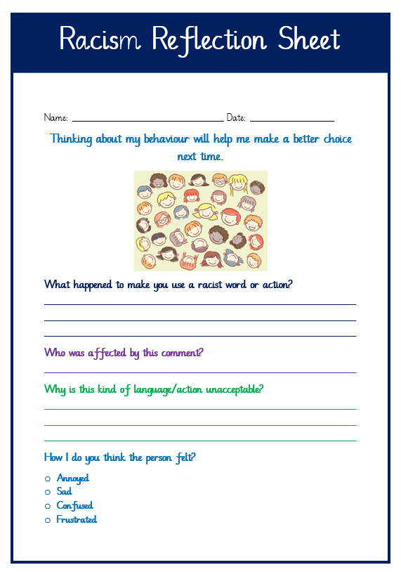

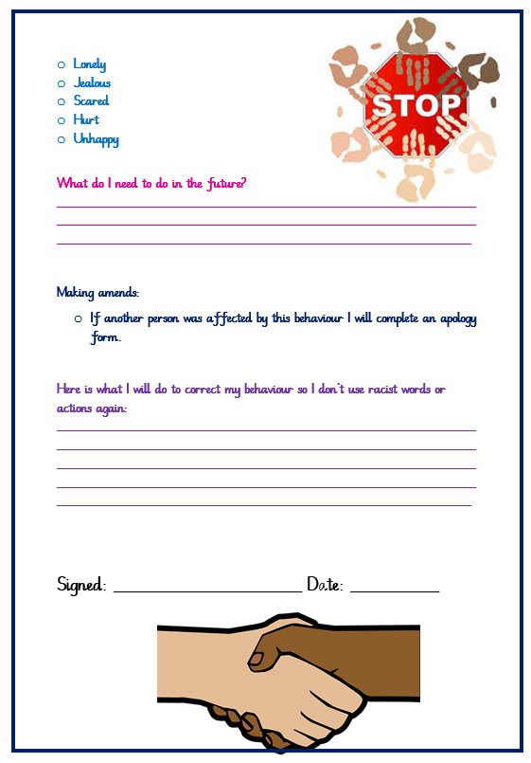

Racist Incident Logging Record

- This record is confidential and should be retained by the school in a secure place. These records do not need to be returned to the LA.
- All reporting incidents should be subject to a detailed investigation and the outcome recorded.
- The governing body request that a monitoring report is submitted on a termly basis. This covers the number and types of incidents that have occurred, and the actions taken by the school.
Time of incident Tick | Place of incident Tick
Before school | Classroom
AM lesson | Corridor
Break/Lunch | Playground
PM lesson | School gate
After school | On route to school
Other | Other

Type of incident Tick
Physical aggression | Graffiti
Provocative behaviour | Distribution of material  of a racist nature
Name calling/teasing | Other
Verbal Abuse
Verbal threats
Cultural/Family
Member of staff/pupil/parent/carer reporting the incident

Name of victim:
Base: Year group: Year

Name of perpetrator:
Base: Year group: year

Base: __________________________ Year group: ____________________________

Incident related to ethnicity:
White
Black
Mixed
Asian
Chinese
Other
Description of the incident/incidents:
From the victim:

From the child accused of bullying:

Frequency and duration of racist bullying behaviour:
Once or twice persisting over two months
Several times a week only at dinner-time

Dates and times of Incident/incidents:

Recorded by:
Position:

Action Plan

To support the victim of the bullying incident/incidents
Action | Time frame | Key person | Review Date

Checklist for the victim | Yes/No
Has the victim had the chance to say what happened?
Has the victim had an opportunity to talk to the person doing the bullying about how they feel?
Has the victim been given support to make sure they feel safe and gain confidence?
Has a date been set to review the situation to make sure it has been sorted out?
Has the school put things in place to try and stop it happening again?
Have the victim’s parents / carers been involved?
Will the victim be offered extra support if they need
Has the victim been informed of the outcomes and actions taken?
If no bullying has taken place or there is insufficient evidence, is there clear actions to
Re-assure and meet the needs of those concerned?

Action Plan

To support the child accused of the bullying
Action | Time frame | Key person | Review Date

Checklist for the bully | Yes/No
Has the accused bully had the chance to say why they have been bullying?
Has the bully had an opportunity to talk to the person who they bullied?
Has the accused bully listened to the victim and accepted responsibility?
Has the pupil been told that what they are doing is wrong and that they will be a consequence to such behaviour?
Has the pupil been given time to reflect?
Has the school put things in place to try and stop it happening again?
Have the accused bullies’ parents / carers been involved?
Has the accused bully written a letter of apology?
Has the accused bully been given targets to achieve to improve their behaviour?
Has the pupil been given opportunities to develop friendships and join clubs?
If no bullying has taken place or there is insufficient evidence, is there clear actions to
Re-assure and meet the needs of those concerned?

Information on action taken Tick
Parent/Carers informed
Meeting/Letter
Referral to the police
LA informed
Warning to perpetrator
Internal exclusion
External exclusion
CAF/TAC
Support offered to victim
Other
Follow up review dates and interventions:
Weekly meetings
Monthly review ~
Completed by :
Role:
Checked by:
Role:
Date:

Outcome of review meeting:
Has the racism stopped? YES NO

Describe any other outcomes, who was involved and when they occurred:

Headteacher to sign to ensure correct procedures have been followed and actions carried out.

Signed: ______________________________________________________(Headteacher)

Date: _________________________________________________________

Assistant head to check that policy and procedure has been followed:

Signed: ______________________________________________________(Assistant Head)

Date: _________________________________________________________

Recorded by: ____________________________________
Position: ________________________________________

