
Lockdown Procedures and Policy
September 2025
www.teaguesbridgeprimary.org
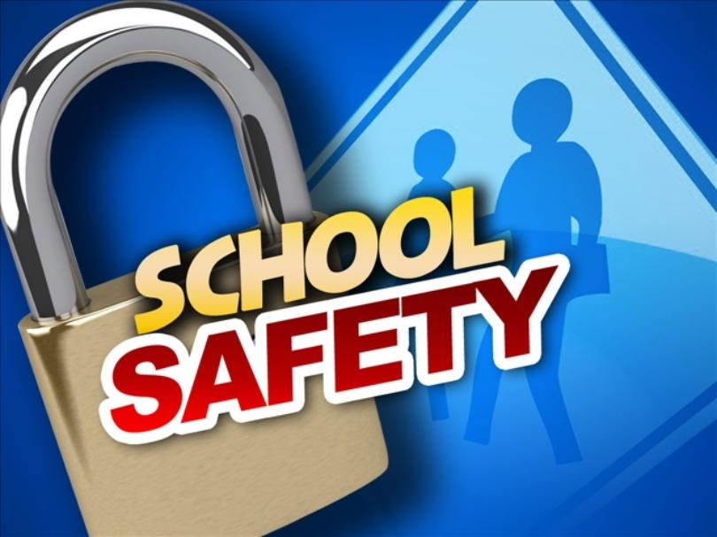

Written on: | 1st September 2018
Reviewed: | 1st September 2025
Next Review: | September 2026
Staff Responsibility | Mrs S. Abdulla
Governor responsibility | Kevin Evans

Lock Down Policy and Procedures
Rationale:
As part of our Health and Safety policies and procedures the school has a Lockdown Policy.

On very rare occasions it may be necessary to seal off the school so that it is not able to be entered from the outside. This will ensure that pupils, staff and visitors are safe in situations where there is a hazard in the school grounds or outside the school in the near vicinity.
A lockdown is implemented when there is serious security risks of the premises due to, for example, near-by chemical spillage, proximity of dangerous dogs, serious weather conditions or attempted access by unauthorised persons intent in causing harm/damage.

NaCTSO (National Counter Terrorism Security Office) **Guidance**
In January 2016, NaCTSO provided the following advice to leaders of schools and other Educational Establishments for Reviewing Protective Security.

Bomb threats: Procedures for handling bomb threats
Most bomb threats are made over the phone and the overwhelming majority are hoaxes, made with the intent of causing alarm and disruption. Any hoax is a crime and, no matter how ridiculous or unconvincing, must be reported to the police.
Be alert, but not alarmed!
On receipt of a “bomb threat” - Dial 999 and police will respond. You should always consider their advice before a decision is taken to close or evacuate.

Notification of Lockdown
Staff will be notified lock down procedures are to immediately take place on hearing short bursts of air horns from halls and playground.

Procedures:

Follow the CLOSE procedure:
- Close all windows and doors
- Lock up
- Out of sight and minimise movement
- Stay silent and avoid drawing attention
- Endure. Be aware you may be in lock down for some time

1. These signals will activate a process of children being ushered into the school building if on the playgrounds as quickly as possible and the locking of the school’s offices, fob connecting doors and all outside doors where it is possible to remain safe.

2. At the given signal the children remain in the room they are in and the staff will ensure the windows and doors are closed/locked and screened where possible and children are positioned away from possible sightlines from external windows/doors. Lights, Smart boards and computer monitors to be turned off.

3. Children or staff not in class for any reason will proceed to the nearest occupied classroom and remain with that class and class teacher e.g. children using toilets when siren goes. If a class is in the opposite hall from where their classroom is they are to go to one of the nearest rooms.
4. If practicable staff should notify the front office by e-mail, using the class I-Pads, that they have entered lock down and those children not accounted for.

5. Staff to support children in keeping calm and quiet.

6. Staff to remain in lockdown positions until informed by key staff e.g. Headteacher, Senior leadership Team, Chair of Governors or office staff in person that there is an all clear.

7. As soon as possible after the lockdown teachers return to their base classrooms and conduct a roll call and notify the office immediately of any pupils not accounted for.

8. Front office staff ensure that their office(s) are locked and police called if necessary.

9. Head or office staff member locks the school’s front doors, front gates, carpark gates and entrances.

10. Admin assistant, Gill Lewis to inform Pre-school and lock back gates if open.

11. Individual teachers/HLTAs/TAs lock/close classroom door(s) and windows. Nearest adult to check exit doors in KS2/KS1/EYFS and outdoor classroom doors are lock.

12. Staff in PPA room to lock down in this room.

13. Catering Staff to lock back door to kitchen and turn off lights.

14. No adult or child to leave the room for any reason whilst in lock down.

INDIVIDUAL STAFF CANNOT SIGN OUT OR LEAVE THE PREMISES DURING LOCKDOWN
WITHOUT PRIOR AGREEMENT OF THE HEADTEACHER BEFORE LEAVING

Staff Roles:

1. Headteacher or Administrator (Hannah Powell) will be nominated as the lockdown manager to initiate, manage and conclude the lockdown.

2. Headteacher to Administrator to call the police and Local authority if necessary (LA phone number on display in the main office).

3. If a class is out of school, office staff will call the class teacher and warn them that school is in lockdown. Advice will be given as to when it is safe to return to school.

4. Teachers/HLTA’s/TA’s close classroom doors and windows. Year 6 adult to close KS2 external door to playground. Year 5 adult to check girls’ toilets. Base 6 adult to check boys’ toilets. Base 7 adult to lock doors in the hall. EYFS adult to check toilets. Year 1 adult to check toilets and lock door in corridor. Year 3 adult to lock door in corridor.

5. Teachers will keep a calm atmosphere in the classroom, the children engaged in a quiet activity or read a story and keep alert to the emotional needs of the pupils.

6. Do not allow anyone out of the classroom during a lockdown under any circumstances.

7. Office staff (Hannah Powell), to contact any members of staff on courses by telephoning the venue or e-mailing if they have access to their computer. Staff must respond to confirm they have received the alert. No staff member to return to school until advice is given.

8. Office staff (Gill Lewis), to contact any visitors/volunteers etc due to come into school. Alerting them to the lockdown and advising them when it is safe to come to school.

Communication with parents:
•If necessary, parents will be notified as soon as it is practical to do so via the school’s established communication network – website/ e-mail/ telephone
Depending on the type and severity of the incident, parents may be asked NOT to collect their children from school as it may put them and their child at risk.
Pupils will not be released to parents during a lock down.
Parents will be asked not to call school as this may tie up emergency lines.
If the end of the day is extended due to the lock down, parents will be notified and will receive information about the time and place pupils can be picked up from office staff or emergency services.
A letter to parents will be sent home as the nearest possible day following any serious incident to inform parents of context of lockdown and to encourage parent to reinforce with their children the importance of following procedures in these very rare circumstances.

Lockdown drills
Lock down practices will take place a minimum of once a year to ensure everyone knows exactly what to do in such a situation. Monitoring of practices will take place and debriefed to staff so improvements can be made.

Review
This policy and procedures will be reviewed annually as a part of Emergency Fire and Evacuation Plan and H+S Policy
Mrs S. Abdulla Headteacher

Additional information
Guidance on receipt of a bomb threat
http://www.cpni.gov.uk/security-planning/business-continuity-plan/bomb-threats/

Bomb threat checklist
http://www.cpni.gov.uk/documents/posters%20and%20checklists/bomb-threatchecklist.pdf?epslanguage=en-gb

