
teaguesbridgeprimary.org
Written By S.A. Abdulla~Mental Health Lead
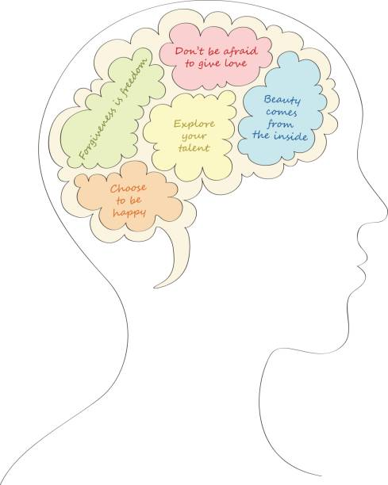
Mental Health and Well-being Policy.
September 2025

Mental Health Policy

Written on: | 11th June 2017
Reviewed on: | 6th September 2025
Next review: | September 2026
Staff Responsibility | Sarah Abdulla
Governor responsibility | Stephen Reynolds

Policy Statement

Mental health is a state of well-being in which every individual realises his or her own potential, can cope with the normal stresses of life, can work productively and fruitfully, and is able to make a contribution to her or his community. (World Health Organization)

At our school, we aim to promote positive mental health for every member of our staff and student body. We pursue this aim using both universal, whole school approaches and specialised, targeted approaches aimed at vulnerable students.

In addition to promoting positive mental health, we aim to recognise and respond to mental ill health. In an average classroom, three children will be suffering from a diagnosable mental health issue. By developing and implementing practical, relevant and effective mental health policies and procedures we can promote a safe and stable environment for students affected both directly, and indirectly by mental ill health.

Scope
This policy describes the school’s approach to promoting positive mental health and wellbeing. This policy is intended as guidance for all staff including non-teaching staff and governors.

This policy should be read in conjunction with our medical policy in cases where a student’s mental health overlaps with or is linked to a medical issue and the SEND policy where a student has an identified special educational need.

The Policy Aims to:
- Promote positive mental health in all staff and students
- Increase understanding and awareness of common mental health issues
- Alert staff to early warning signs of mental ill health
- Provide support to staff working with young people with mental health issues
- Provide support to students suffering mental ill health and their peers and parents/carers

Lead Members of Staff
Whilst all staff have a responsibility to promote the mental health of students. Staff with a specific, relevant remit include:

- Mrs Sarah Abdulla - designated child protection / safeguarding officer
- Mrs Sarah Abdulla/Mrs Emma Wilkinson - mental health lead
- Mrs Heather Whitehouse/Vikki Preece - lead first aider
- Mrs Emma Mumford - pastoral lead
- Mrs Sarah Abdulla - CPD lead
- Mrs Natalie Woods - PSHE co-ordinator

Any member of staff who is concerned about the mental health or wellbeing of a student should speak to the mental health lead in the first instance. If there is a fear that the student is in danger of immediate harm then the normal child protection procedures should be followed with an immediate referral to the designated child protection office of staff or the head teacher. If the student presents a medical emergency then the normal procedures for medical emergencies should be followed, including alerting the first aid staff and contacting the emergency services if necessary.

Where a referral to CAMHS is appropriate, this will be led and managed by Mrs Abdulla, mental health lead. CAMHS referrals are made through the TAC and CAF process.

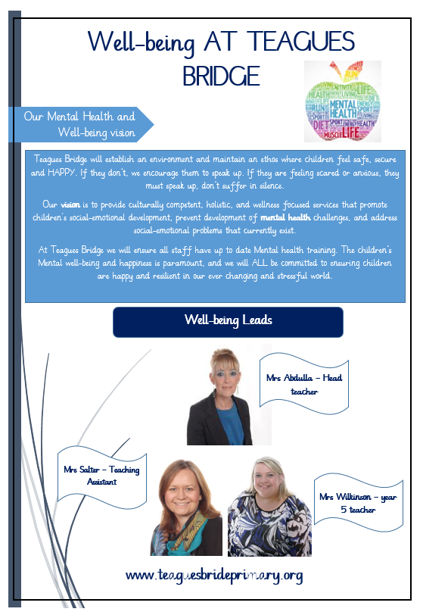

Individual Care Plans
It is helpful to draw up an individual care plan for pupils causing concern or who receive a diagnosis pertaining to their mental health. This should be drawn up involving the pupil, the parents and relevant health professionals. This can include:
- Details of a pupil’s condition
- Special requirements and precautions
- Medication and any side effects
- What to do, and who to contact in an emergency
- The role the school can play

Teaching about Mental Health
The skills, knowledge and understanding needed by our students to keep themselves and others physically and mentally healthy and safe are included as part of our developmental PSHE curriculum.

Signposting
We will ensure that staff, students and parents are aware of sources of support within school and in the local community. What support is available within our school and local community, who it is aimed at and how to access it. Such information can be found in the staff handbook.

We will display relevant sources of support in communal areas such as common rooms and toilets and will regularly highlight sources of support to students within relevant parts of the curriculum. Whenever we highlight sources of support, we will increase the chance of student help-seeking by ensuring students understand:
- What help is available
- Who it is aimed at
- How to access it
- Why to access it
- What is likely to happen next

Warning Signs
School staff may become aware of warning signs which indicate a student is experiencing mental health or emotional wellbeing issues. These warning signs should always be taken seriously and staff observing any of these warning signs should communicate their concerns with Mrs Abdulla, our mental health and emotional wellbeing lead.

Possible warning signs include:
- Physical signs of harm that are repeated or appear non-accidental
- Changes in eating / sleeping habits
- Increased isolation from friends or family, becoming socially withdrawn
- Changes in activity and mood
- Lowering of academic achievement
- Talking or joking about self-harm or suicide
- Abusing drugs or alcohol
- Expressing feelings of failure, uselessness or loss of hope
- Changes in clothing – e.g. long sleeves in warm weather
- Secretive behaviour
- Skipping PE or getting changed secretively
- Lateness to or absence from school
- Repeated physical pain or nausea with no evident cause
- An increase in lateness or absenteeism

Managing disclosures
A student may choose to disclose concerns about themselves or a friend to any member of staff so all staff need to know how to respond appropriately to a disclosure.

If a student chooses to disclose concerns about their own mental health or that of a friend to a member of staff, the member of staff’s response should always be calm, supportive and non-judgemental.

Staff should listen, rather than advise and our first thoughts should be of the student’s emotional and physical safety rather than of exploring ‘Why?’

All disclosures should be recorded in writing and held on the student’s confidential file. This written record should include:
- Date
- The name of the member of staff to whom the disclosure was made
- Main points from the conversation
- Agreed next steps
This information should be shared with the mental health lead, Mrs Abdulla who will provide store the record appropriately and offer support and advice about next steps.

Confidentiality
We should be honest with regards to the issue of confidentiality. If we it is necessary for us to pass our concerns about a student on then we should discuss with the student:
- Who we are going to talk to
- What we are going to tell them
- Why we need to tell them

We should never share information about a student without first telling them. Ideally we would receive their consent, though there are certain situations when information must always be shared with another member of staff and / or a parent. [This will generally be along the lines of ‘students up to the age of 16 who are in danger of harm’]

It is always advisable to share disclosures with a colleague, usually the mental health lead, Mrs Abdulla this helps to safeguard our own emotional wellbeing as we are no longer solely responsible for the student, it ensures continuity of care in our absence and it provides an extra source of ideas and support. We should explain this to the student and discuss with them who it would be most appropriate and helpful to share this information with.

Parents must always be informed if the child is in imminent danger who at risk of harm, if children are felling stressed or anxious they may choose to tell their parents themselves. If this is the case, the student should be given 24 hours to share this information before the school contacts parents. We should always give students the option of us informing parents for them or with them.
If a child gives us reason to believe that there may be underlying child protection issues, parents should not be informed, but the child protection office Mrs Abdulla must be informed immediately.

Working with Parents
Where it is deemed appropriate to inform parents, we need to be sensitive in our approach. Before disclosing to parents we should consider the following questions (on a case by case basis):
- Can the meeting happen face to face? This is preferable.
- Where should the meeting happen? At school, at their home or somewhere neutral?
- Who should be present? Consider parents, the student, other members of staff.
- What are the aims of the meeting?

It can be shocking and upsetting for parents to learn of their child’s issues and many may respond with anger, fear or upset during the first conversation. We should be accepting of this (within reason) and give the parent time to reflect.

We should always highlight further sources of information and give them leaflets to take away where possible as they will often find it hard to take much in whilst coming to terms with the news that you’re sharing. Sharing sources of further support aimed specifically at parents can also be helpful too e.g. parent helplines and forums.

We should always provide clear means of contacting us with further questions and consider booking in a follow up meeting or phone call right away as parents often have many questions as they process the information. Finish each meeting with agreed next step and always keep a brief record of the meeting on the child’s confidential record.

Working with All Parents
Parents are often very welcoming of support and information from the school about supporting their children’s emotional and mental health. In order to support parents we will:
- Highlight sources of information and support about common mental health issues on our school website
- Ensure that all parents are aware of who to talk to, and how to get about this, if they have concerns about their own child or a friend of their child
- Make our mental health policy easily accessible to parents
- Share ideas about how parents can support positive mental health in their children through our regular information evenings
- Keep parents informed about the mental health topics their children are learning about in PSHE and share ideas for extending and exploring this learning at home

Supporting Peers
When a student is suffering from mental health issues, it can be a difficult time for their friends. Friends often want to support but do not know how. In the case of self-harm or eating disorders, it is possible that friends may learn unhealthy coping mechanisms from each other. In order to keep peers safe, we will consider on a case by case basis which friends may need additional support. Support will be provided either in one to one or group settings and will be guided by conversations by the student who is suffering and their parents with whom we will discuss:
- What it is helpful for friends to know and what they should not be told
- How friends can best support
- Things friends should avoid doing / saying which may inadvertently cause upset
- Warning signs that their friend help (e.g. signs of relapse)

Additionally, we will want to highlight with peers:
- Where and how to access support for themselves
- Safe sources of further information about their friend’s condition
- Healthy ways of coping with the difficult emotions they may be feeling

Appendix A: Further information and sources of support about common mental health issues

Prevalence of Mental Health and Emotional Wellbeing Issues

- 1 in 10 children and young people aged 5 - 16 suffer from a diagnosable mental health disorder - that is around three children in every class.
- Between 1 in every 12 and 1 in 15 children and young people deliberately self-harm.
- There has been a big increase in the number of young people being admitted to hospital because of self-harm. Over the last ten years this figure has increased by 68%.
- More than half of all adults with mental health problems were diagnosed in childhood. Less than half were treated appropriately at the time.
- Nearly 80,000 children and young people suffer from severe depression.
- The number of young people aged 15-16 with depression nearly doubled between the 1980s and the 2000s.
- Over 8,000 children aged under 10 years old suffer from severe depression.
- 3.3% or about 290,000 children and young people have an anxiety disorder.
- 72% of children in care have behavioural or emotional problems - these are some of the most vulnerable people in our society.

Below, we have sign-posted information and guidance about the issues most commonly seen in school-aged children. The links will take you through to the most relevant page of the listed website. Some pages are aimed primarily at parents but they are listed here because we think they are useful for school staff too.

Support on all of these issues can be accessed via Young Minds (www.youngminds.org.uk), Mind (www.mind.org.uk) and (for e-learning opportunities) Minded (www.minded.org.uk).

Self-harm
Self-harm describes any behaviour where a young person causes harm to themselves in order to cope with thoughts, feelings or experiences they are not able to manage in any other way. It most frequently takes the form of cutting, burning or non-lethal overdoses in adolescents, while younger children and young people with special needs are more likely to pick or scratch at wounds, pull out their hair or bang or bruise themselves.

Online support
SelfHarm.co.uk: www.selfharm.co.uk
National Self-Harm Network: www.nshn.co.uk

Appendix 1:
Mental well-being referral form:
