Special Leave Policy ~ 2025
Version 4



www.teaguesbridgeprimary.org

Special Leave Policy
Autumn 2025
Version 4
Written on: | 6th April 2018
Reviewed on: | 6th September 2025
Next Review: | September 2026
Staff Responsibility | Mrs S. Abdulla
Governor responsibility | Stephen Reynolds (COG)

Introduction
This policy relates to leave from work in addition to maternity/paternity/adoption leave, flexible working requests, annual leave, time off in lieu, Time off for Trade Union Duties and sickness absence. Any circumstance not mentioned in this policy should be discussed with the Headteacher so that a decision can be made on a case-by-case basis.
- Scope of Policy
This policy applies to all School employees but does not apply to casual workers.
- Policy Commitments
There is an expectation that School employees attend work when required during School opening and in line with their contract of employment, but the school recognises the need for its employees to respond to emergency or unforeseen personal/home commitments.
It is recognised that special leave is requested very infrequently by most employees. Special leave arrangements are intended to operate flexibly and in a climate of trust between the school and its employees.
The following arrangements therefore provide a framework within which special leave requests can be considered to meet specific circumstances. Given the high level of mutual trust placed in all the parties involved it follows that, abuses of the scheme (and therefore mutual trust) must be dealt with very severely.
Within this School requests for special leave will be considered by the Headteacher However, in adopting this policy, Governors have agreed time off with pay where this is specified within the policy.
Where there are excessive requests for special leave, the Headteacher may refuse a request or grant it without pay even where paid time has been specified within the policy.
In addition, excess special leave requests may also be taken into account should an employee be subject to absence management.
- Payment
Payment for special leave will be determined by the individual circumstances around the request. In this School or unless otherwise stated, requests for leave granted may be without pay.
Longer periods of leave should be discussed as soon as possible with the Headteacher and will be made up of a mixture of unpaid leave, paid special leave and time-off in lieu, annual or flexi leave (where applicable). The employee may wish to substitute time off in lieu or annual leave (where applicable) for unpaid special leave retrospectively.
- Special Leave Requests
The policy covers:
- Emergency time off for dependents
- Bereavement leave (including funerals)
- Public service leave
- Time off for employment interviews
- Time off for medical / dental appointments
- Time off for medical screening
- Time off for study leave
- Time off for professional examinations
- Time off for religious observance
- Attending court as a witness
- Fertility treatment
- Time off for ‘other’ circumstances

The school also provides other leave arrangements:
- Time off for antenatal appointments covered in the Maternity and Family Friendly Policy

Emergency Time Off for Dependants
This section covers occasions when employees may need to take time off to deal with emergency situations that occur outside of the workplace and are not known about in advance.
Time off will be allowed for staff to deal with domestic emergencies relating to dependants. This will be unpaid. For the purposes of definition dependants are:
- Partner or Spouse
- Child/Stepchild
- Parents of the employee
- Other relatives who reside with the employee or any person who relies on the employee to plan for the provision of care in the event of illness or injury.
Lodgers, boarder’s tenants and employees are not dependants.
Time off will be allowed to deal with the following situations:
- Physical or mental illness of a dependant.
- Where the dependant has been involved in an accident or assaulted.
- To make longer term care arrangements for a dependant who is ill i.e. if a child is ill to arrange for someone to look after them.
- To deal with disrupted care arrangements i.e. if a childminder or district nurse contracted to provide care whilst an employee is at work fails to arrive or is late.
- To deal with incidents arising from a child’s attendance at school and which unexpectedly requires the employees’ attendance as a matter of urgency.
- Other exceptional circumstances arising directly from established caring responsibilities.
In the above cases the employee is required to complete the ‘Request for Time off’ form before their expected start time and in line with School policy to inform the head of the following:-
- The reason for their absence.
- The anticipated length of their absence.
- An estimated time of return to work.
In emergency situations contact should be made as soon as is reasonably practicable.
It is expected that the following should be arranged outside of working hours and time off may only be allowed with extenuating circumstances and by prior arrangement with the Headteacher. This time will be unpaid:
- Attendance at non-emergency dental or doctors’ appointments for yourself or with a dependant.
- Attendance at parents’ evenings or other pre-arranged school appointments.
- Absences to provide non-emergency transportation for a dependant.

Longer Term Arrangements
When it becomes apparent that an employee is having excessive special leave requests/time off as a result of caring responsibilities, this should be brought to the employee’s attention along with any supportive options the School may have to offer, e.g. consideration of flexible working arrangements. If this is a consideration, the employee should submit a flexible working request (see flexible working policy).
Bereavement Leave
This section provides information about time off that can be granted in the unfortunate event that there is a death of an employee’s immediate relative or those who are important to your employee but is not an immediate relative.
Individuals deal with the death of those close to them in different ways. Similarly, individuals may have different levels of responsibility placed upon them in terms of arrangements created by the death.
An immediate relative includes a spouse, civil partner or partner* (including same sex partners), child **, parent, stepparent or a person with whom the employee is in a relationship of domestic dependency.
*Partner includes someone with whom the employee is co-habiting but is not the employee’s spouse or civil partner.
**Child includes children in respect of whom the employee is the adoptive parent and legal guardians and carers.
For these reasons bereavement leave will be granted to meet the specific circumstances facing individual employees. Up to five days paid bereavement leave will be allowed following discussion with the Headteacher.
Unpaid time off will also be considered for those who may fall outside of ‘immediate relatives’ such as uncles, aunties, grandparents, grandchildren, son/daughter in law and mother/father in law or those who are important to the employee. Again, this is following a discussion with the Headteacher.

Funerals
Time off to attend the funeral of an immediate relative will be considered under ‘Bereavement Leave’. Time off for those who fall outside of ‘immediate relatives’ will be considered by the Headteacher. Time off will be unpaid.

Public Service Leave
Leave For Public Duties
From time to time staff may be expected to carry out public duties. Governing Bodies should recognise the benefit of this role within their local community.
Under statute an employee is entitled to have reasonable time off during working hours (to attend sub/committee meetings and doing other things approved by the body to discharge its functions) if s/he is a:
- a magistrate
- By law, employers must allow an employee who is a magistrate reasonable time off work to carry out their duties.
- Employees who are magistrates are required to be in court at least 13 days, or 26 half-days a year.
- All time off for magistrates’ duties will be unpaid.
- Employees will receive their magistrate rota well in advance and are required to share this with their line manager as soon as it is available. Therefore, time off can be planed and agreed well in advance.
- elected member of a local authority
- member of statutory tribunal
- member of a health authority
- member of a health service trust
- member of a family practitioner committee
- a governor of a school or college
- a member of a youth offending panel
- a member of the board of visitors to prisons and remand homes.

(A full list of public duties which qualify can be found in Employment Relations Act 1996)
All absences of this nature are subject to service needs, must be agreed in advance by the Headteacher or Governing Body and will be unpaid (School to amend should they decide to pay for part/all of this leave).
In determining if absence will be allowed during working hours the Headteacher will take into consideration:
- The amount of time required for the duty.
- How much time the employee has already taken for that duty.
- The effect of the employees absence on the service.

Employees are responsible for ensuring that public services undertaken do not conflict with the work of the School or draw into question their loyalty to their employer.

Service with Non-Regular Forces
Headteachers/Governors may consider allowing members of the non-regular forces up to two weeks unpaid leave per year to attend fortnight long Training camps. Employees should apply as soon as they are aware of the camp dates for permission to attend. In times of national need members of the reserve forces will be released to meet Government requirements.

Time Off for Interviews
Employees who are selected for interview will be paid for reasonable interview absence should it fall during their working hours.
Where there are unreasonable requests to attend interviews, the Headteacher may offer the time off without pay.
Time Off for Medical / Dental appointments
It is expected that routine medical and dental appointments will be taken outside of the School day. This includes attending routine appointments with a dependant. As stated above, this time off may only be allowed with extenuating circumstances and by prior arrangement with the Headteacher. This time will be unpaid:
Where an employee has to attend a hospital or consultant appointment which are often dependant on the medical professional’s availability, time off will be granted on receipt of an appointment card/letter/text message. This can also include emergency dentist appointment and doctor appointments. First appointment may be with pay. This will be decided following a meeting with the headteacher.
In this School time off for hospital/consultant/dental appointments are generally without pay.

Time Off For Medical Screening
Necessary paid time off will be granted for the purpose of cancer
screening.

Time Off For Study Leave
Employees who are undertaking a professional qualification which is relevant to the role they undertake or the needs of the School, may submit a request for study leave to take prior to a formal examination to the Headteacher/Governors to consider.
Whilst the School recognises an individuals need to professionally develop, consideration for study leave may only be granted where the qualification benefits the role/ School, and the school are aware the employee is studying.
It is anticipated that requests submitted will be for a maximum of one day in order to prepare for the exam.
All request should be with as much notice as a possible to enable the manager/Headteacher to consider the request and organise appropriate cover within the School.
Where the request is granted and it is of benefit to the School, time off will be paid. All other requests will be unpaid.

Time Off for Professional Examinations

Where an employee is undertaking an exam which is relevant to their employment, the Headteacher / Governors will agree paid time off for the exam. The Headteacher / Governors should be notified of the date as soon as possible in order to grant for and plan cover for the request.

Time off for examinations not relevant to an individual’s employment will be considered in line with time off for ‘other’ circumstances. This time will be unpaid.

Time Off for Religious Observance

Requests for a religious festival or spiritual observance should be submitted with as much notice as possible to enable the manager/Headteacher to consider the request. This time will be unpaid.

Where there are several requests from employees for a particular event or a request is at short notice, the Headteacher may not be able to grant all. The Headteacher should speak to all employees to reach an agreement/compromise. If this is a regular (annual) request, the School may wish to put a mechanism in place e.g. a rota, in order to grant a certain number of requests each year whilst ensuring the operational needs of the School are maintained.

Time Off for Attending Court as a Witness

Where an employee is required to attend Court as a witness, time will be granted without pay upon seeing the appropriate court notification. Time is unpaid as the employee can claim loss of earnings from the Court.

Time Off for Fertility Treatment
Time off to attend medical appointments for fertility treatment should be taken in accordance with the medical/dental appointments.
Where the employee has to attend a hospital or consultant appointment, time off will be granted on receipt of an appointment card/letter/text message.
In this School, time off for hospital/consultant appointments are without pay.
Illness arising as a result of the treatment should be counted as sick leave. At the point the employee is pregnant the rules around sickness absence and pregnancy apply.

Time Off for children who are absent from school due to illness
At Teagues Bridge we do understand that it is difficult when your child is ill and often time off cannot be avoided due to childcare arrangements.
Time off for a child’s illness will be paid for on day one, allowing time to get them medical advice and arrange childcare cover. Every day absence after day one will be unpaid.

Time Off for ‘other’ circumstances
Time off for ‘other’ circumstances are at the discretion of the Headteacher/Governors and is without pay.
Headteacher/Governors may allow employees paid time off where they have been able to accrue working hours to take off in lieu or are willing to make the time up by coming in early or staying later or even completing tasks at the weekend or evening.
Examples if ‘other’ circumstance are:
- Attend child’s sports day, School production or parents meeting
- Moving house
- Graduation ceremony
- Wedding or celebration

- Considering Special Leave Requests

In considering requests for special leave the headteacher will take into account:
- Contractual and other legal requirements.
- The circumstances of the request.
- The relationship between the member of staff and the person that the leave is being taken to assist.
- The amount of special leave previously taken and other paid leave outstanding.
- The impact of the circumstances on the employee.
- The impact of any absence on the service and colleagues
Personal sickness is covered by the Sickness Absence Policy and is not special leave.
- Adjustments
Headteachers have discretion to adjust the scheme to meet the specific circumstances presented by each special leave request. Because, by their nature, special leave requests will be at short notice or even after the absence, adjustments will often be retrospective.
Human Resources will be pleased to advise on any aspect of local adjustments.

Unauthorised Absence is generally a disciplinary matter but before taking any action, the extent of the absence, frequency, and reason for it will be explored. Where a member of staff who has taken unauthorised absence had not contacted the school, you should seek to make contact with them. Continued unauthorised absence can result in stopping the employees pay and advice from your Human Resources advisor should be taken.
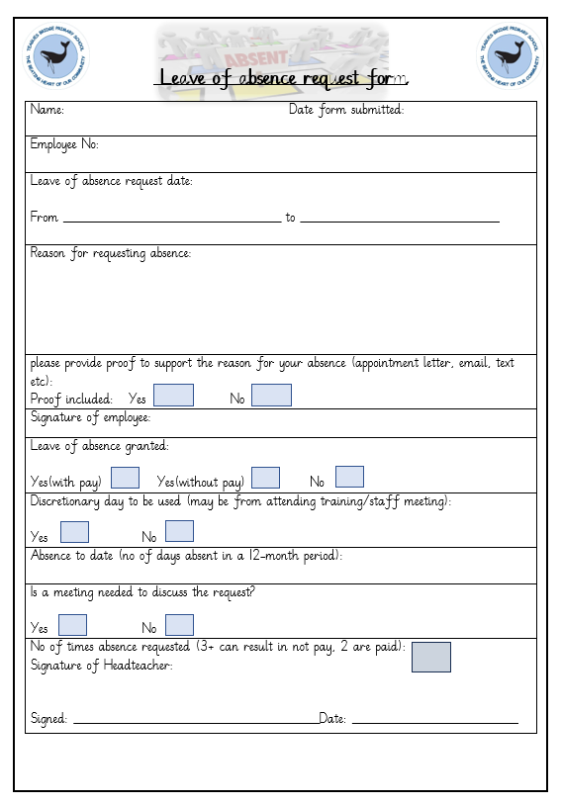
Form to be completed when requesting any time off.

