Food Allergy Policy
November 2025
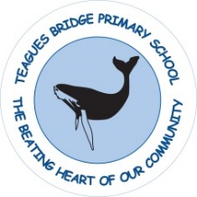
www.teaguesbridgeprimary.org

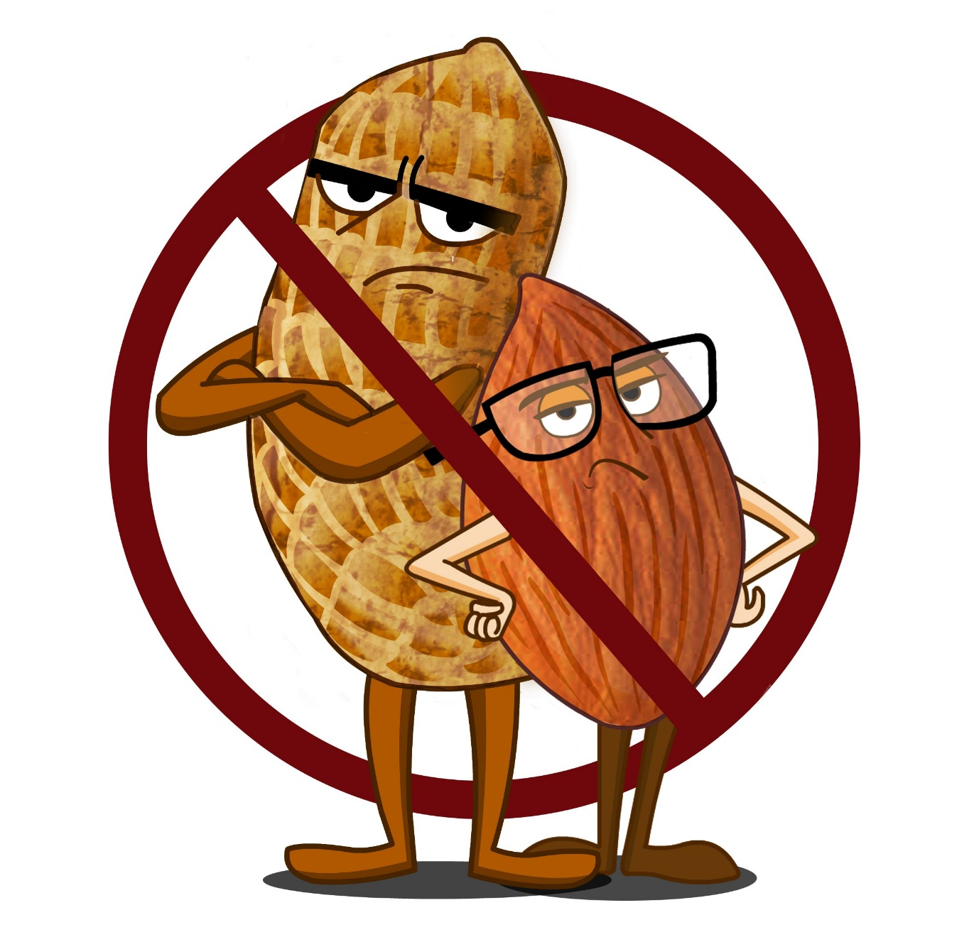

Written on: | 9th February 2017
Reviewed on: | 6th November 2025
Next Review on: | November 2026
Staff Responsibility | Mrs N Smith
Governor responsibility | Steve Reynolds

Food Allergy Policy

Teagues Bridge Primary School recognises that although most food intolerances produce symptoms that are uncomfortable, some people can suffer a severe food allergy with more serious consequences and in some instances these may even be life threatening. A number of pupils in the school have severe or moderate allergies to food and amongst the most common is nut allergy.

Teagues Bridge Primary School recognises that it has to provide a safe environment and aims to ensure that foods provided, brought in/or produced in the school do not contain nuts as far as is reasonably possible.

The school is committed to pupil safety and therefore has created this policy to reduce the risk of children having allergy related events while in its care.

Aims

• To reduce the likelihood of a pupil with a known food allergy displaying a severe reaction to a specific food while in school.
• To foster an understanding of and sense of responsibility for the specific needs of the individual members of the school community.
• To create an awareness of the action to take should someone with a severe food
allergy display its symptoms.

Parents are required to inform the school of any known food allergies that their child has. This information goes to the school office and kept on record and an Allergy Action Plan will be put in place.

Parents should update this information if any allergy is diagnosed at any stage of their child’s education.

Parents must advise the school of the action that should be taken if their child develops the symptoms of an allergic reaction while in school.

All members of staff are given the names of children who have specific food allergies through the confidential information sheets issued at the beginning of each school year. Photographs of pupils with severe food allergies are displayed in the Awareness folder.

The school will access training to enable staff to recognise the symptoms of an allergic reaction and to respond appropriately.

All staff have been trained in the use of the EPIPEN should a child with a known food allergy go into anaphylaxis.

All parents are asked to ensure that their child does not bring nuts or foods containing nuts into school. This includes snacks, lunch box items and birthday treats. Parents should send fruit or vegetable snacks or snacks that are store bought and have an ingredients list on the food label.

We want to minimise the risk from nuts or foods containing nuts as much as is reasonably possibly.

Food provision in school

The school kitchen does not use nuts, nut oils or nut containing products in the preparation of food; but cannot guarantee that the source of manufacture is completely nut-free. The kitchen is made fully aware of food allergies.

The school does not sell foods that specifically list nut or peanut products on the ingredients list of a food label.

In the case of a pupil with multiple or unusual allergies, the school may require the parent to provide lunches and snacks to ensure the pupil’s safety.

The school will attempt to avoid serving nuts or food with nuts, but cannot guarantee that products with nuts will never be present. Likewise, the school cannot monitor products sold at events attended by pupil’s offsite or served on trips. But will do all that it can to minimise risk.

Any school community groups will not bring nuts into school, or nut containing products, intentionally; this is part of the hiring agreement for community groups.

Teagues Bridge Primary school cannot guarantee that there will be nothing in the school that might trigger an allergic reaction or that a pupil or adult will never experience an allergy related event while at school. With effort and care we can, however, try together to ensure a safe environment for all our community which keeps risks to a minimum.

Food or water sharing

All pupils are prohibited from sharing their food, snacks or drinks with each other. Pupils use their own, named water bottles to avoid contamination.

Extract from Childrens Food Trust

Individual schools, or local authorities, may choose to remove nuts from their menus and have policies preventing nuts from being brought onto the school premises, if they feel that this is in the interest of their school community. This approach is common in primary schools, where they are less likely to have vending machines in place. Young pupils may not be mature enough to be responsible for managing their condition by avoiding allergens, and so by limiting their availability at school, this may reduce the number of allergy related incidents. Schools may feel that by prohibiting nuts on site, the school would be a nut-free environment, and so reduce the risk of any allergic reactions. However, this approach may induce a false sense of security for those pupils with a nut allergy, and does not teach pupils avoidance strategies for outside of school where they may come in contact with nuts. Also, from the school’s perspective, there is no absolute guarantee that a nut ban will ensure there are no nuts on the school premises. Nut bans may not always be the most appropriate approach. An alternative solution is to create awareness across the whole school on how to manage the risk of allergic reactions from nuts’.
Most common foods likely to cause allergic reaction:
- Any nuts
- Fruit & cereal bars that contain nuts
- Nutella Chocolate Spread
- Peanut Butter (of any kind)
- Chocolate bars & sweets that contain nuts
- Sesame Seed Rolls
- Milky Way Magic Stars
- Snickers Chocolate Bars
- Picnic Bars
- Cereal, Granola, Fruit and Nut Bars
- Peanut M&Ms
- Chocolate and Nut Cookies
- Cakes containing Almond Essence and other nuts e.g. Bakewell Tarts / Battenburg Cake / Almond Slices / Date and Walnut Slices
- Anything containing marzipan
- Kinder ‘Happy Hippo’ (very serious as contains bits of hazelnut)
- Sesame Breadsticks
- Crispbreads and Crackers containing sesame seeds
- Nougat
- Baklava
- Turkish Delight
- Peanut-based sauces like satay

Allergy Action Plan

THIS CHILD HAS THE FOLLOWING ALLERGIES:
Photo

Name:

Name:
D.O.B:
Emergency contact details:
1:

2:

GP:

Mild-moderate allergic reaction:
- Swollen lips, face or eyes
- Itchy/tingling mouth
- Hives or itchy skin rash
- Abdominal pain or vomiting
- Sudden change in behaviour
ACTION:
- Stay with the child, call for help if necessary
- Give antihistamine (if vomited, can repeat dose)
- Contact parent/carer

Watch for signs of ANAPHYLAXIS
(life-threatening allergic reaction):

AIRWAY: Persistent cough, hoarse voice, difficulty, swallowing, swollen tongue
BREATHING: Difficult or noisy breathing, wheeze or persistent cough
CONSCIOUSNESS: Persistent dizziness/pale or floppy suddenly sleepy,
collapse, unconscious
If ANY ONE of these signs is present:
- Lie child flat. If breathing is difficult allow to sit
- Dial 999 for an ambulance* and say ANAPHALAXIS (“ANA-FIL-AX-IS”)
- Stay with child, contact parent/carer
- Commence CPR if there are no signs of life
*You can dial 999 from any phone, even if there is no credit left on a mobile. Medical observation in hospital is recommended after anaphylaxis

Additional Instructions:
This plan has been prepared by:
Name: ______________________________________________________________

Signature: __________________________________________________________ Date __________________________________________
This plan has been prepared by:

