

Handwriting Policy
September 2025



Teagues Bridge Primary School
Handwriting Policy
Written on: | 1st September 2021
Review on: | 1st September 2025
Staff Responsibility | Sarah Abdulla & Natalie Woods
Governor responsibility | Steve Reynolds
Signed by Chair

Aims
For teachers and teaching assistants
- To know the correct style, letter formation and joins in handwriting to ensure consistency across the school
- To understand the progression in handwriting so that pupils are taught in every lesson and pupils’ handwriting develops and improves.
- To ensure high expectations in handwriting lessons and that pupils are expected to apply the same standards in other independent writing.

For pupils
- To know the importance of clear and neat presentation in order to communicate meaning effectively.
- To write legibly in joined handwriting and printing styles with increasing style and speed by:
- Having a correct pencil grip
- Knowing that all letters start from the top, apart from d and e, which start in the middle
- Forming all letters correctly
- Knowing the size and orientation of letters

Teaching Time
There should be daily handwriting lessons in EYFS, Key Stage 1 and Key Stage 2. Children who find handwriting difficult should be targeted through additional daily intervention.

Model used
At Teagues Bridge Primary School, we follow the Nelson handwriting model with the following letter formations.

Lower Case
Upper Case
ABCDEFGHIJKLMNOPQRSTUVWXYZ

Numbers
0 1 2 3 4 5 6 7 8 9

The Four Joins
- To letters without ascenders
- To letters with ascenders
- Horizontal joins
- Horizontal joins to letters with ascenders
The break letters that are not joined are: b g j p x y z s
At Teagues Bridge, we will progress to a fully joined font when the children are ready.
However, children must be taught individual letters first so that they see them as individual units before learning to join.
Resources
Year Group | Pupil Books | Resources and  Assessment Books | Workbooks | Classroom Aids
Reception (EYFS) |  | 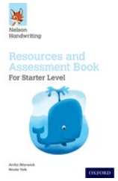 | 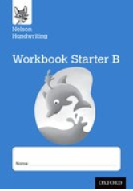  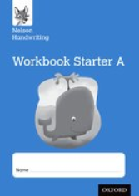  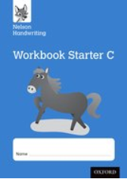 | 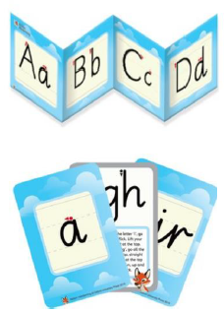
Year One | 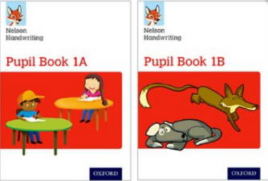 | 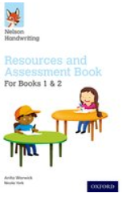 | 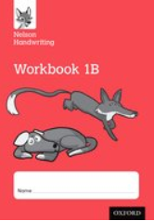  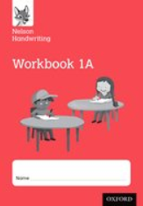
Year Two | 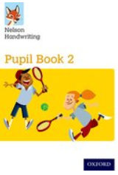 | 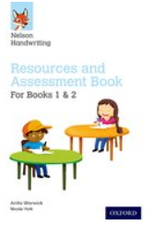 | 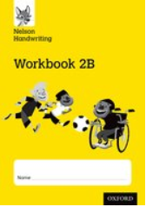
Year Three | 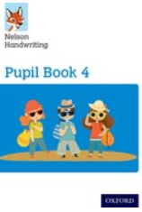  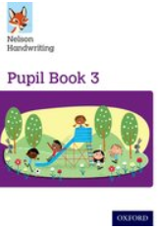 | 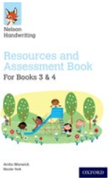 | 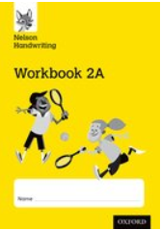
Year Four
Year Five | 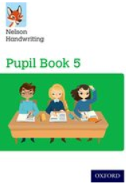 | 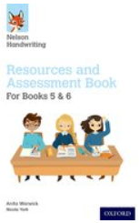
Year Six | 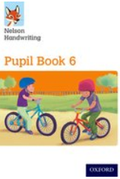

Paper
As motor skills increase, then the size of handwriting should decrease. Children should start writing in A4 plain books, then, as their handwriting improves, then lined exercise books should be introduced.

Reception
All children should write in A4 plain books. When ready to move on to lines, the children should have pencil lines drawn on for them before the children write. These lines should be well spaced (about 2cms apart).

Year 1
All children should write in 2cm wide lined exercise books.

Year 2
Most children should be ready to start the year in narrow lined books. For some children, they will need to continue in wide lined books until ready. Handwriting practice should be completed in English books daily.
All children should be allowed to use unlined paper from time to time, so that they can practise applying skills; considering issues of presentation and aesthetics.

Years 3 to 6
Children should use narrow lined writing books. Handwriting practice should be completed in English books daily at the start of an English lesson.

Techniques for teaching letter formation
- Model good handwriting all the time
- Demonstrate
- Talk through the process
- Encourage children to verbalise the process
- Children form letters in the air
- Fingers trace over tactile letters
- Write over highlighter pen (or dotted letters)
- Draw round templates
- Write in sand with finger or sticks
- Write with chalk on chalkboard
- Wax resist letters
- Form letters with beads in plasticine
- Form letters with pegs on pegboards
- Finger trace the outline of letters on the back of the person in front of you

Getting ready to write
Seat posture
- Chair and table should be at a comfortable height
- The table should support the forearm so that it rests lightly on the surface and is parallel to the floor
- Encourage children to sit up straight and not slouch
- The height of the chair should be such that the thighs are horizontal and feet flat on the floor
- Tables should be free of clutter
- Rooms should be well lit
- Left-handed pupils should sit to the left of the peer

Pencil Grip
Children should write with a HB pencil (or pen which is rewarded alongside a pen licence) with a rounded tip. Pencils should be reasonably sharp.

For right handers
- Hold lightly between the thumb and forefinger about 3cm away from the point.
- The paper should be placed to the right with a slight tilt to the left.
- Use the left hand to steady the paper.

For left handers
- Hold lightly between thumb and forefinger resting on the first knuckle of the middle finger
- Hold about 3cm from the tip
- The hand should be kept below the writing line
- The paper should be tilted slightly to the right at about 20-30 degrees
- Use the right hand to steady the paper
NB – it is very important that a right-handed child is NOT seated on the left hand side of a left handed children as their elbows will collide.

Assessment
Phase leaders in team meetings and senior leaders should monitor children’s writing and presentation in books regularly (at least termly). The following should be considered:
- Is the writing generally legible?
- Are the letters correctly shaped and proportioned?
- Are the joins made correctly?
- Are the spaces between the letters, words and lines appropriate?
- Is the size of the writing appropriate?
- Is the writing properly aligned?
- Are the writing standards achieved by most pupils in line with the National Curriculum?
- Does the handwriting from handwriting practice match presentation and handwriting in other books?

Individual Assessment
Children should be observed as the write during handwriting lessons – the teacher must circulate, monitor and intervene. Teachers also need to monitor and mark whole pieces of writing. The following should be considered:
- Is the posture correct?
- Does the child hold the pencil correctly?
- Does the child use the correct movement when forming and/or joining letters?
- Are there any letters reversed or inverted?
- Does the child write fluently and rhythmically?
- Is the writing easily legible?
- Is the pupil’s handwriting in line with expectations in the National Curriculum?
Overview of handwriting – EYFS and KS1
Stage | Focus | Session outline
1a | Letter formation  - ‘Around’ letters: c a o d g q  - ‘Down’ letters: l t b p k h i j m n r u y  - ‘Curly’ letters: e f s  - ‘Zigzag’ letters: v w z x. | Demonstrate  - TOL as you use your mental checklist to write the letter g.  ✓ start at her hair bobble on top of her head  ✓ round face  ✓ back to bobble  ✓ very straight hair  ✓ round curl to finish.  Repeat a few times using MTYT.  2. Ask the children to TTYP to say the mental checklist.  3. Take feedback.  4. Ask two partners to tell you how to write the letter g.  Repeat a couple more times until the children can say the mental checklist to each other.  Practice  - Check that the children are still sitting in the perfect handwriting position.  - Rub out the picture and any letters from the board – the children must not copy.  - Ask the children to write one letter, slowly and carefully. (Do not ask them to draw the handwriting picture.)  - Model again how you repeat writing the letter, getting a bit quicker each time.  - Go round the room praising what you see so others can hear. Don’t sit with one child. For example: “Nice round chin there! Love the long straight hair. What a great curl.”  Review  - Write the letter on the board and make one error, drawing on children’s common errors.  - Ask the children to TTYP to find your ‘two best bits’, for example, you remembered to start at the bobble. Then ask children to TTYP to find ‘one to fix’.  - Rewrite the letter perfectly, correcting using children’s feedback.  - Ask children to practise again.  Expectation  - One line of the letter taught  - Repeat a second line if they are not secure.
1b | Relative size of letters  - ‘Sun letters’: b d h k l (f and t are just a little bit smaller)  - ‘Boat letters’: a c e i m n o r s u v w x z  - ‘Water letters’: g j p q y. | Demonstrate  - Draw the sun, boat and water pictures in the correct position on the line.  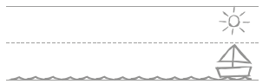  - Show children where to start a – level with the top of the boat. Recall the checklist for a as you write the letter.  - Show children where to start n – level with the top of the boat. Use the Checklist for n as you write the letter.  - Show children where to start d – level with the top of the boat. Use the Checklist for d as you write the letter.  2. Ask children to TTYP: What size is each letter? (Choose from boat, water or sun.)  3. Take feedback.  Practice  - Check that the children are still sitting in the perfect handwriting position.  - Rub out the word from the board – the children must not copy.  - Ask the children to write each letter, slowly and carefully.  - Model again how you repeat writing the word, getting a bit quicker each time.  - Go round the room praising what you see so others can hear. Don’t sit with one child. For example: “a is sitting on the line – good. You’ve made n into a boat letter.”  Review  - Write the word on the board and make one error, drawing on children’s common errors.  - Ask the children to TTYP to find your ‘two best bits’. Then ask them to TTYP to find ‘one to fix’.  - Rewrite the word perfectly, correcting using children’s feedback.  - Ask the children to practise again.  - Now ask them to find ‘two best bits’ and ‘one to fix’ in each other’s work.  Expectation  - One line of the letter taught  - One or two lines of a word containing the letter taught.
2 | Capital Letters | Demonstrate  - Draw the sun, boat and water pictures in the correct position on the line.  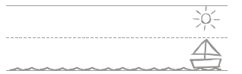  - Show the children where to start the letter and the strokes needed to form it. Use the guide to ensure you are modelling this correctly.  - Remind children about the size of the capital letter.  Practice  - Check the children are sitting the perfect handwriting position.  - Rub out the model on the board, children must not copy.  - Ask the children to write each letter slowly and carefully.  - Model again how you write each letter, getting quicker each time.  - Circulate the room praising what you see.  Review  - Write the letter on the board, making an error.  - Ask the children to TTYP to find two positives and one fix.  - Rewrite the letter perfectly, correcting using the children’s feedback.  - Ask the children to practise again.  - Ask the children to work with a partner to find two positives and one thing to fix in their own work.
3 | A mature style of handwriting for  the following letters: a d g o c q u y b p. | Demonstrate  1. TOL as you use your mental checklist to write the letter d.  ✓ start at her hair bobble on top of her head  ✓ all the way over the top of her head  ✓ curve down her face  ✓ round chin  ✓ join the chin by her ear  ✓ up to the bobble  ✓ straight tall spiky hair – up and down  ✓ curve at the line and draw small flick (not curvy)  Repeat a few times using MTYT.  2. Ask the children to TTYP to say the mental checklist.  3. Take feedback.  4. Ask two partners to tell you how to write the letter d.  Repeat a couple more times until the children can say the mental checklist to each other.  Practice  1. Use the handwriting signal to check that the children are still sitting in the perfect handwriting position.  2. Rub out the picture and any letters from the board – the children must not copy.  3. Ask the children to write one letter, slowly and carefully. (Do not ask them to draw the handwriting picture.)  4. Model again how you repeat writing the letter, getting a bit quicker each time.  5. Go round the room praising what you see so others can hear. Don’t sit with one child. For example: “Nice round chin there! Love the long straight hair. What a great curl.”  Review  1. Write the letter on the board and make one error, drawing on children’s common errors.  2. Ask the children to TTYP to find your ‘two best bits’, for example, you remembered to start at the bobble. Then ask children to TTYP to find ‘one to fix’.  3. Rewrite the letter perfectly, correcting using children’s feedback.  4. Ask children to practise again.  5. Ask children to find ‘two best bits’ and ‘one to fix’ in each other’s work.  Expectation  •One line of the letter taught  •Two lines of a words containing the letter taught.  •1 sentence applying the words.
4 | The arm join, and the washing line join | Use the following routine for every lesson. (This is a sample lesson for joining a to i)  See ‘Handwriting Stage 3’ in the Handwriting files in Read Write Inc. Phonics Online for the joins to practise.  Demonstrate  1. Demonstrate how to write the letters.  • TOL about where to start a – level with the top of the boat. Recall the checklist for Annie as you write the letter.  • TOL as you write the join – not too spiky, not too round, not too squeezed, not too spaced.  • TOL as you write i. Recall the checklist for i.  2. Ask children to TTYP: What size is each letter? (Boat, sun or water.) What is good about your join?  3. Take feedback.  Practice  1. Use the handwriting signal to check that the children are still sitting in the perfect handwriting position.  2. Rub out the joined letters from the board – the children must not copy.  3. Ask the children to write each letter and the join, slowly and carefully.  4. Model again how you repeat writing the letters and join, getting a bit quicker each time.  5. Go round the room praising what you see so others can hear. Don’t sit with one child. For example: “I love the spacing of your join and the join is not too spiky or too round.”  Review  1. Write the letters and join on the board and make one error, drawing on children’s common errors.  2. Ask the children to TTYP to find your ‘two best bits’. Then ask them to TTYP to find ‘one to fix’.  3. Rewrite the letters and join perfectly, correcting using children’s feedback.  4. Ask the children to practise again.  5. Now ask them to find ‘two best bits’ and ‘one to fix’ in each other’s work.  Expectation  • One line of the letter taught  • Two lines of a words containing the letter taught.  • 1 sentence applying the words.

Overview of handwriting – KS2
Lesson Structure
1.Play the Pen Grip and Posture video.
2.Play the letter or join formation video (Years 3/4)
3.Teacher model the letter or join formation
4.Children practice the letter or join – completing a whole line.
5.Teacher model applying the letter for join to writing words.
6.Children practice the letter or join by writing words – completing the whole line.
7.Children then apply the words in a sentence (on set days)

Unit Structure
One unit will last for 8 days, with children completing the following in their books on each day:
Day 1 – Download sheet 1 - All of task A and 3 words from task B (a line of each word)
Day 2 – Download sheet 1 - All of task A and 3 other words from task B (a line of each word)
Day 3 – Download sheet 1 - All of task A and 3 sentences containing words from task B (teacher to create and model the sentences).
Day 4 – Download Sheet 2 – All of task A.
Day 5 - Download Sheet 2 – All of task A and task B sentence
Day 6 – Pupil Book – Focus A (2 lines of each) and Focus B (1 line of each)
Day 7 – Pupil Book – Focus A (2 lines of each) and sentences containing words from the book (teacher to create and model the sentences).
Day 8 - Pupil Book – Focus A (2 lines of each) and extension activity from the book.

Specific Handwriting Difficulties
Faulty Pencil Grip
An overtight pencil is the most common fault. Crooking of the forefinger and pressing too hard are common indications of this. Encourage the pupil to relax and to hold the pencil lightly between their thumb and their middle finger, while their forefinger rests lightly on the pencil.
Incorrect letter formation
Children are often able to write letters which are correctly shaped but have been produced by incorrect movements. If bad habits of this kind are allowed to become ingrained, the child will be seriously hampered when he or she progresses to joined handwriting. It is important, in the early stages of development, to ensure that:
- All letters are started in the correct place
- In general, movements start at the top and go down
- Ovals are made with an anticlockwise movement

Reversals, inversions and mirror writing
Common problems include:
- Reversals: b for d, and p for q
- Inversions: w for m
- Mirror writing: was for saw

Causes include:
- Confusion between left and right
- A lack of commitment to one hand
- A natural tendency for left-handers to pull the hand across the body from right to left
- A general lack of maturity or confidence
Children with these problems can be helped by increased emphasis on the writing direction and the consistent use of one hand for writing.

