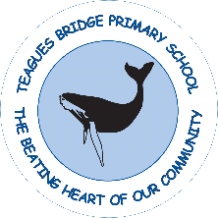
History Policy
2025-2026

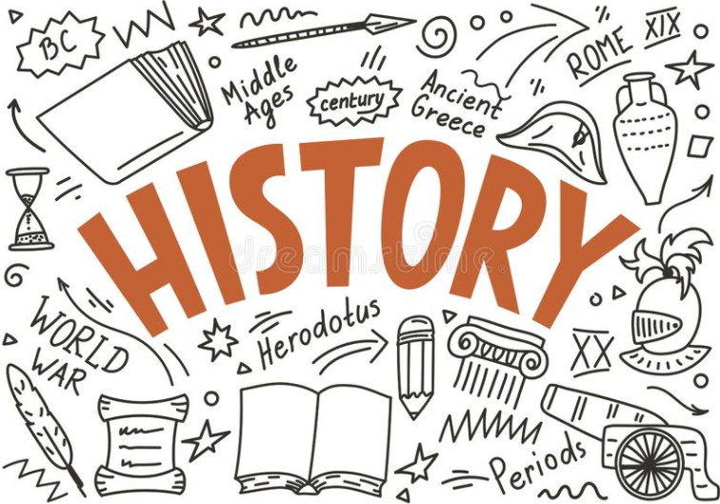

Written on: | 5th November 2021
Reviewed on: | 20th September 2025
Next Review: | September 2026
Staff Responsibility | Sophie Wood
Governor responsibility | Kevin Evans

Our Vision
History has always been held in high regard at Teagues Bridge primary, with the school’s own rich history within the context of the local area a celebrated and inspiring feature of the school. The intent of our History curriculum is to deliver a curriculum which is accessible to all and that will maximise the outcomes for every child so that they know more, remember more and understand more.
As a result of this they will
• Increase and develop their historical skills, concepts, knowledge and attitudes.
• Increase their understanding of the present in the context of the past.
• Develop and use their skills in enquiry, analysis, evaluation, and argument.
• Develop their interest in the past, arousing their curiosity and motivation to learn.
• Develop a sense of identity through learning about the past

Introduction
At Teagues Bridge Primary School, we are committed to providing all children with learning opportunities to engage in history. This policy sets out a framework within which teaching and non-teaching staff can work, and gives guidance on planning, teaching and assessment. It has been developed through a process of consultation with school staff and governors.
History is about real people who lived, and real events which happened in the past. History is concerned with sequence, time and chronology and is the study of evidence about the past; it gives us a sense of identity, set within our social, political, cultural and economic relationships. History fires the children’s curiosity about the past in Britain and the wider world and plays an essential part in preparing us for living and working in the contemporary world. Pupils consider how the past influences the present, what past societies were like, how these societies organised their politics, and what beliefs and cultures influenced people’s actions. As they do this, children develop a chronological framework for their knowledge of significant events and people. They see the diversity of human experience and understand more about themselves as individuals and members of society. What they learn can influence their decisions about personal choices, attitudes and values. In history, children find evidence, weigh it up and reach their own conclusions. To do this they need to be able to research, sift through evidence, and argue for their point of view – skills that are prized in adult life.

Aims
The aims of history are:
- To instil in the children a curiosity and understanding of events, places and people in a variety of times and environments.
- To develop an interest in the past and an appreciation of human achievements and aspirations
- To understand the values of our society
- To learn about the major issues and events in the history of our own country and of the world and how these events may have influenced one another
- To develop a knowledge of chronology within which the children can organise their understanding of the past
- To understand how the past was different from the present and that people of other times and places may have had different values and attitudes from ours
- To understand the nature of evidence by emphasising the process of enquiry and by developing the range of skills required to interpret primary and secondary source materials
- To distinguish between historical facts and the interpretation of those facts
- To understand that events have a multiplicity of causes and that historical explanation is provisional, debatable and sometimes controversial

Curriculum
The children undertake a broad and balanced programme that takes account of abilities, aptitudes and physical, emotional and intellectual development. Through history the children learn a range of skills, concepts, attitudes and methods of working. In our History lessons, we ensure that both our pupils’ substantive and disciplinary knowledge is built upon year on year.
Substantive Knowledge– Is knowledge and ‘substance’ of our curriculum e.g. people, dates, features of something
Disciplinary Knowledge-Is skills our children develop how interpret the past – how do we know what we know? E.g. changes, continuation, causes, sources.
So that our pupils are able to learn more and know more, we believe it is vital that our history curriculum develops both categories.

​Skills to Gain Knowledge

Our aim is to ensure that our pupils become historians who can confidently attain knowledge regardless of the subject or topic. In order to do this, we carefully plan our history lessons so that eight main skills are taught. These skills ensure that children able to unpick historical knowledge throughout their life.
The eight skills are:
- Constructing the Past: is all about learning how does history ‘fit’ together? Our understanding of the past and how it interacts with itself. We ensure this by linking our pupils’ knowledge to previous topics and make sure that they have opportunities to compare across topics.
- Sequencing the Past: is about the chronology and the understanding of time and place throughout history. In our lessons, we allow children to develop their skills and knowledge of chronology by making lessons practical to develop understanding-e.g. by toilet roll timelines.
- Continuity and Change: is about identifying whether something has changed or stayed the same throughout history. We ensure this by making lots of comparisons of their knowledge within and across year groups. e.g. whether housing, beliefs, society improved or not.
- Cause and Effect: is about understanding that events happened to bring about another event and the implications of these. Furthermore, it is about identifying potential reasons for change and the positive/negative implications of them. We ensure this by teaching cause and effect explicitly.
- Significance and Interpretation: is about identifying what is important and that our understanding of the past comes from different sources. We ensure children develop a deep knowledge of this by linking this to change, cause and effect so our pupils understand what and why certain elements were important. We also teach children that our understanding of the past comes from different sources.
- Planning and Carrying Out Historical Enquiries: is about providing opportunities for our children to develop their knowledge/understanding by carrying out investigations into a certain aspect or theme. At first, children are guided through historical enquiries using materials and sources to make judgements before being able to do this on their own.
- Using Sources as Evidence: is about first of all knowing that history is made up of a variety of sources and different types of sources. We ensure that our children know how to analyse and investigate sources and use them to back up their arguments and judgements.
- Vocabulary: is about our pupils knowing how to use vocabulary to become articulate historians. We do this by using our school’s vocabulary progression document to know what words children should know in each year group and reinforcing these in lessons through stem sentences.

Early Years
History is taught in Reception as an integral part of the topic work through child-initiated and adult led activities through a range of quality stories. The children are given the opportunity to find out about past and present events in their own lives, and those of their families and other people they know. History makes a significant contribution to developing a child’s understanding of the world through activities such as looking at pictures of famous people in history or discovering the meaning of new and old in relation to their own lives.

Key Stage 1
During Key Stage 1, pupils learn about people’s lives and lifestyles. They find out about significant men, women, children and events from the recent and more distant past in Britain and the wider world. They listen and respond to stories and use sources of information to help them ask and answer questions. They learn how the past is different from the present. At Teagues Bridge primary school, we ensure that children learn about their local history by exploring significant people and events that are unique to our locality.

Key Stage 2
During Key Stage 2 pupils learn about significant people, events and places from both recent and more distant past. They learn about change and continuity in their own area, in Britain and in other parts of the world. They look at history in a variety of ways, for example from political, economic, technological and scientific, social, religious, cultural or aesthetic perspectives. They use different sources of information to help them investigate the past both in depth and in overview, using dates and historical vocabulary to describe events, people and developments. They also learn that the past can be represented and interpreted in different ways.

Teaching and Learning
The school uses a variety of teaching and learning styles in history lessons. Our principal aim is to develop the children’s knowledge, skills and understanding in history and we use a variety of teaching and learning styles in our history lessons. Key historical concepts are taught in each year group and this knowledge is then built upon in subsequent year groups through different themes. We believe in whole-class teaching methods and combine these with enquiry-based research activities. At Teagues Bridge, we believe children learn best when:
- They have access to, and are able to handle artefacts
- They go on visits to museums and places of interest
- They have access to secondary sources such as books and photographs
- Visitors talk about personal experiences of the past
- They listen to and interact with stories from the past
- They undertake fieldwork by interviewing family and older friends about changes in their own and other people’s lives
- They use drama and dance to act out historical events
- They are shown, or use independently, resources from the internet and videos
- They are able to use non-fiction books for research
- They are provided with opportunities to work independently or collaboratively, to ask as well as answer historical questions.
We recognise the fact that we have children of differing ability in all our classes, and so we provide suitable learning opportunities for all children by matching the challenge of the task to the ability of the child. We achieve this through a range of strategies which are differentiated by task, expected outcome and/or support from peers or adults.

History curriculum planning
At Teagues Bridge Primary School, history is taught through as a half term history driver. Our curriculum is carefully planned on long term plans to engage and excite all our learners. Our long-term and medium-term plans map out the skills and knowledge covered in each theme for each key stage.

Assessment and Recording
At Teagues Bridge School, assessment is an integral part of the teaching process. Assessment is used to inform planning and to facilitate differentiation. The assessment of children’s work is on-going to ensure that understanding is being achieved and that progress is being made. Feedback is given to the children as soon as possible and marking work will be guided by the school’s Marking Policy.

Monitoring
Monitoring takes place regularly through sampling children’s work, and teacher planning,
through a book scrutiny and lesson observations.

Roles and Responsibilities
The subject is led by the staff as a whole and each year time is set aside to review standards and monitor curriculum provision and ensure training and resources are up to date.

Resources
We have a wide range of textbooks and interactive boards to access the internet as a class. Visits are planned to enhance learning and give hands on activity. People with an interest, or expertise, in a particular topic or area of history could be invited into school to work with the children. These might be parents, grandparents, other family members, neighbours or representatives of the local community.

