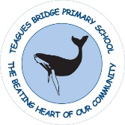
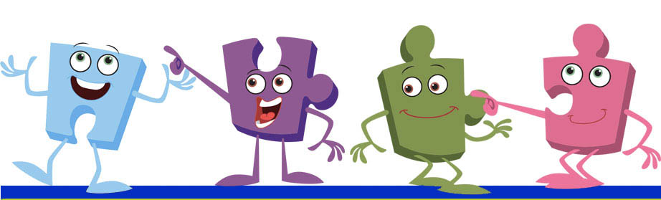
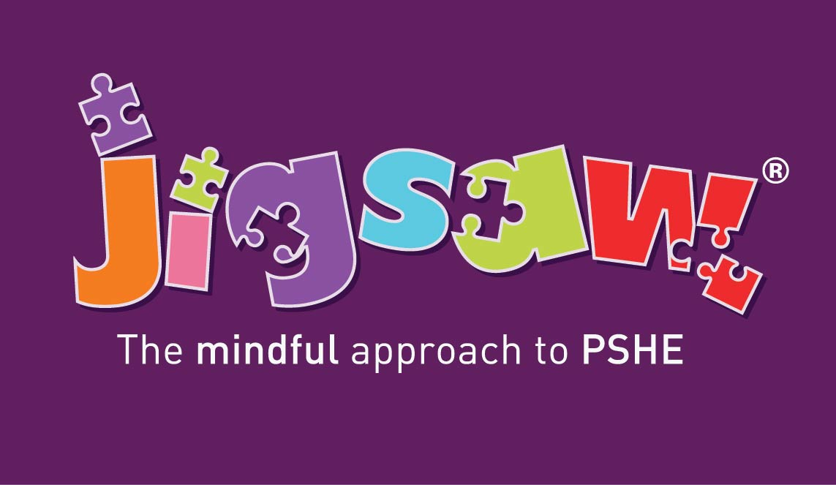

Written on: | 3rd June 2019
Reviewed on: | 14th August 2025
Next Review: | August 2026
Staff Responsibility | Natalie Woods
Governor responsibility | Kevin Evans

JIGSAW PSHE Policy
Introduction:

All schools must provide a curriculum that is broadly based, balanced and meets the needs of all pupils. Under section 78 of the Education Act 2002 and the Academies Act 2010, a PSHE curriculum:
- Promotes the spiritual, moral, cultural, mental and physical development of pupils at the school and of society, and
- Prepares pupils at the school for the opportunities, responsibilities and experiences of later life.

The Government’s PSHE education review of PSHE Education (March 2013) stated that the subject would remain non-statutory and that no new programmes of study would be published. The DfE specified as part of its National Curriculum guidance that ‘All schools should make provision for personal, social, health and economic education (PSHE), drawing on good practice’. The review also detailed:
“PSHE remains an important and necessary part of all pupils’ education. We believe that all schools should teach PSHE, drawing on good practice, and have outlined this expectation in the introduction to the new National Curriculum” (Written Ministerial Statement: Review of Personal, Social, Health and Economic education, March 2013).

This Jigsaw PSHE policy is informed by existing DfE guidance on Sex and Relationships Education (Sex and Relationship Education Guidance, July 2025), SRE supplementary guidance ( Sex Education Forum/ Brook/ PSHE Association, March2014) preventing and tackling bullying (Preventing and tackling bullying: Advice for head teachers, staff and governing bodies, July 2013), Drug and Alcohol Education (DfE and ACPO drug advice for schools: Advice for local authorities, headteachers, school staff and governing bodies, September 2012), safeguarding (Working Together to Safeguard Children: A guide to inter-agency working to safeguard and promote the welfare of children, 2018) and equality (Equality Act 2010: Advice for school leaders, school staff, governing bodies and local authorities, revised February 2013).

Links to these documents:
https://www.gov.uk/government/publications/relationships-education-relationships-and-sex-education-rse-and-health-education

http://www.pshe-association.org.uk/uploads/media/17/7910.pdf

https://www.gov.uk/government/publications/dfe-and-acpo-drug-advice-for-schools

http://www.education.gov.uk/aboutdfe/advice/f0076899/preventing-and-tackling-bullying

http://www.education.gov.uk/schools/guidanceandadvice?f_category=Safeguarding&page=1

http://www.education.gov.uk/aboutdfe/advice/f00215460/equality-act-2010-departmental-advice

Aim of the Jigsaw PSHE programme

To provide pupils with the knowledge, understanding, attitudes, values and skills they need in order to reach their potential as individuals and within the community.
Pupils are encouraged to take part in a wide range of activities and experiences across and beyond the curriculum, contributing fully to the life of their school and communities. In doing so they learn to recognise their own worth, work well with others and become increasingly responsible for their own learning. They reflect on their experiences and understand how they are developing personally and socially, tackling many of the spiritual, moral, social and cultural issues that are part of growing up.
They learn to understand and respect our common humanity; diversity and differences so that they can go on to form the effective, fulfilling relationships that are an essential part of life and learning.

Objectives/Pupil learning intentions:
Jigsaw PSHE will support the development of the skills, attitudes, values and behaviour, which enable pupils to:

- Have a sense of purpose
- Value self and others
- Form relationships
- Make and act on informed decisions
- Communicate effectively
- Work with others
- Respond to challenge
- Be an active partner in their own learning
- Be active citizens within the local community
- Explore issues related to living in a democratic society
- Become healthy and fulfilled individuals

Jigsaw Content
Jigsaw covers all areas of PSHE for the primary phase, as the table below shows: Term

 | Puzzle name | Content
Autumn 1: | Being Me in My World | Includes understanding my place in the class, school and global community as well as devising Learning Charters)
Autumn 2: | Celebrating Difference | Includes anti-bullying (cyber and homophobic bullying included) and diversity work
Spring 1: | Dreams and Goals | Includes goal-setting, aspirations, working together to design and organise fund-raising events
Spring 2: | Healthy Me | Includes drugs and alcohol education, self-esteem and confidence as well as healthy lifestyle choices
Summer 1: | Relationships | Includes understanding friendship, family and other relationships, conflict resolution and communication skills
Summer 2: | Changing Me | Includes Sex and Relationship Education in the context of looking at change

Relationships and Sex Education
Definition of RSHE:
‘RSHE is lifelong learning process of acquiring information, developing skills and forming positive beliefs and attitudes about sex, sexuality, relationships and feelings’ (Sex Education Forum, 1999).
Effective RSHE can make a significant contribution to the development of the personal skills needed by pupils if they are to establish and maintain relationships. It also enables children and young people to make responsible and informed decisions about their health and well-being.
It is important to note that the RSHE at our school sits within the school’s values framework and that we consider it vital to do this work in partnership with parents and carers.
We are mindful that parents/carers do have the legal right to withdraw their children from the RSHE that is part of the PSHE (Jigsaw) Programme, whilst we hope they do not feel the need to do so.

Jigsaw Content
The grid below shows specific learning intentions for each year group in the ‘Changing Me’ Puzzle . These specific lessons sit within the whole Puzzle (6 lessons) which looks at change and coping with change in lots of contexts, so changes as we grow up and enter puberty are seen as one sort of change that we can all cope with.

Year group | Piece number and name | Learning Intentions  Pupils will be able to…
1 | Piece 4 girls and boys bodies | Identify the parts of the body that make boys different to girls and use the correct names for these: penis, testicles, vagina.  Respect my body and understand which parts are private.
2 | Piece 4 girls and boys bodies | Recognise the physical differences between boys and girls, use the correct names for parts of the body (penis, testicles, vagina) and appreciate that some parts of my body are private.  Tell you what I like/don’t like about being a boy/girl.
3 | Piece 1 How babies grow. | Understand that in animals and humans lots of changes happen between conception and growing up, and that usually it is the female who has the baby’  Express how I feel when I see babies or baby animals.
3 | Piece 2 Babies | Understand how babies grow and develop in the mother’s uterus and understand what a baby needs to live and grow.  Express how I might feel if I had a new baby in my family.
3 | Piece 3 Outside body changes. | Understand that boys’ and girls’ bodies need to change so that when they grow up their bodies can make babies.  Identify how boys’ and girls’ bodies change on the outside during this growing up process.  Recognise how I feel about these changes happening to me and know how to cope with those feelings.
3 | Piece 4 inside body changes. | Identify how boys’ and girls’ bodies change on the inside during the growing up process and why these changes are necessary so that their bodies can make babies when they grow up.  Recognise how I feel about these changes happening to me and how to cope with these feelings.
4 | Piece 2 having a baby. | Correctly label the internal and external parts of male and female bodies that are necessary for making a baby.  Understand that having a baby is a personal choice and express how I feel about having children when I am an adult.
4 | Piece 3 Girls and Puberty. | Describe how a girl’s body changes in order for her to be able to have babies when she is an adult, and that menstruation (having periods) is a natural part of this.
5 | Piece 2 Puberty for Girls. | Explain how a girl’s body changes during puberty and understand the importance of looking after myself physically and emotionally.  Understand that puberty is a natural process that happens to everybody and that it will be OK for me.
5 | Piece 3 Puberty for Girls and boys | Describe how boys’ and girls’ bodies change during puberty.  express how I feel about the changes that will happen to me during puberty.
5 | Piece 4 Conception | Understand that sexual intercourse can lead to conception and that is how babies are usually made  Understand that sometimes people need IVF to help them have a baby.  Appreciate how amazing it is that human bodies can reproduce in these ways.
6 | Piece 2 Puberty | Explain how girls’ and boys’ bodies change during puberty and understand the importance of looking after myself physically and emotionally.  express how I feel about the changes that will happen to me during puberty.
6 | Piece 3 Girl talk Boy talk. | Ask the questions I need answered about changes during puberty.  reflect on how I feel about asking the questions and about the answers I receive.
6 | Piece 4 Babies ~ conception to birth. | Describe how a baby develops from conception through the nine months of pregnancy, and how it is born  recognise how I feel when I reflect on the development and birth of a baby.
6 | Piece 5 Attraction. | Understand how being physically attracted to someone changes the nature of the relationship.  express how I feel about the growing independence of becoming a teenager and am confident that I can cope with this.

Withdrawal from RSHE lessons
Parents/carers have the right to withdraw their children from all or part of the Sex and Relationships Education provided at school except for those parts included in statutory National Curriculum Science. Those parents/carers wishing to exercise this right are invited in to see the head teacher and/or RSHE Co-ordinator who will explore any concerns and discuss any impact that withdrawal may have on the child. Once a child has been withdrawn they cannot take part in the RSHE programme until the request for withdrawal has been removed. Materials are available to parents/carers who wish to supplement the school RSHE programme or who wish to deliver RSHE to their children at home.

Drug and Alcohol Education
Definition of ‘Drugs’:
This policy uses the definition that a drug is: ‘A substance people take to change the way they feel, think or behave’ (United Nations Office on Drugs and Crime). The term ‘Drugs’ includes
• All illegal drugs
• All legal drugs including alcohol, tobacco and volatile substances which can be inhaled
• All over-the-counter and prescription medicines

Effective Drug and Alcohol Education can make a significant contribution to the development of the personal skills needed by pupils as they grow up. It also enables young people to make responsible and informed decisions about their health and well-being.

Moral and Values Framework
The Drug and Alcohol Education programme at our school reflects the school ethos and demonstrates and encourages the following values. For example:
o Respect for self
o Respect for others
o Responsibility for their own actions
o Responsibility for their family, friends, schools and wider community

Jigsaw Content
The grid below shows specific Drug and Alcohol Education learning intentions for each year group in the ‘Healthy Me’ Puzzle.

Year group | Piece number and name | Learning Intentions  Pupils will be able to…
222 | Piece 3 Medicine Safety. | Understand how medicines work in my body and how important it is to use them safely.  feel positive about caring for my body and keeping it healthy.
3 | Piece 3 What do I know about drugs? | Tell you my knowledge and attitude towards drugs.  identify how I feel towards drugs.
4 | Piece 3 Smoking. | Understand the facts about smoking and its effects on health, and also some of the reasons some people start to smoke.  can relate to feelings of shame and guilt and know how to act assertively to resist pressure from myself and others.
4 | Piece 4 Alcohol | Understand the facts about alcohol and its effects on health, particularly the liver, and also some of the reasons some people drink alcohol.  Can relate to feelings of shame and guilt and know how to act assertively to resist pressure from myself and others.
5 | Piece 1 Smoking | Know the health risks of smoking and can tell you how tobacco affects the lungs, liver and heart.  Make an informed decision about whether or not I choose to smoke and know how to resist pressure.
5 | Piece 2 Alcohol | Know some of the risks with misusing alcohol, including anti-social behaviour, and how it affects the liver and heart.  Make an informed decision about whether or not I choose to drink alcohol and know how to resist pressure.
6 | Piece 2 Drugs | Know about different types of drugs and their uses and their effects on the body particularly the liver and heart.  Be motivated to find ways to be happy and cope with life’s situations without using drugs.
6 | Piece 3 Alcohol | Evaluate when alcohol is being used responsibly, anti-socially or being misused.  Tell you how I feel about using alcohol when I am older and my reasons for this.

Confidentiality and Child Protection Issues
As a general rule a child’s confidentiality is maintained by the teacher or member of staff concerned. If this person believes that the child is at risk or in danger, she/he talks to the named child protection co-ordinator who takes action as laid down in the Child Protection Policy. All staff members are familiar with the policy and know the identity of the member of staff with responsibility for Child Protection issues. The child concerned will be informed that confidentiality is being breached and reasons why. The child will be supported by the teacher throughout the process.

How is Jigsaw PSHE organised in school?
Jigsaw brings together PSHE Education, emotional literacy, social skills and spiritual development in a comprehensive scheme of learning. Teaching strategies are varied and are mindful of preferred learning styles and the need for differentiation. Jigsaw is designed as a whole school approach, with all year groups working on the same theme (Puzzle) at the same time. This enables each Puzzle to start with an introductory assembly, generating a whole school focus for adults and children alike.
There are six Puzzles in Jigsaw that are designed to progress in sequence from September to July. Each Puzzle has six Pieces (lessons) which work towards an ‘end product’, for example, The School Learning Charter or The Garden of Dreams and Goals.
Each Piece has two Learning Intentions: one is based on specific PSHE learning (covering the non-statutory national framework for PSHE Education but enhanced to address children’s needs today); and one is based on emotional literacy and social skills (covering the SEAL learning intentions but also enhanced). The enhancements mean that Jigsaw is relevant to children living in today’s world as it helps them understand and be equipped to cope with issues like body image, cyber and homophobic bullying, and internet safety.
Every Piece (lesson) contributes to at least one of these aspects of children’s development. This is mapped on each Piece and balanced across each year group.

Differentiation & SEND support
Jigsaw is written as a universal core curriculum provision for all children. Inclusivity is part of its philosophy. Teachers will need, as always, to tailor each Piece to meet the needs of the children in their classes. To support this differentiation, many Jigsaw Pieces suggest creative learning activities that allow children to choose the media with which they work and give them scope to work to their full potential. To further help teachers differentiate for children in their classes with special educational needs, each Puzzle includes a P-level grid with suggested activities for children working at each of those levels.

Safeguarding
Teachers need to be aware that sometimes disclosures may be made during these sessions; in which case, safeguarding procedures must be followed immediately. Sometimes it is clear that certain children may need time to talk one-to-one after the circle closes. It is important to allow the time and appropriate staffing for this to happen. If disclosures occur, the school’s child protection and confidentiality policy is followed.

Assessment
Each Puzzle has a set of three level descriptors for each year group:
Working towards Working at Working beyond
It is envisaged that, at the beginning of a Puzzle, children will be given the ‘My Jigsaw Learning Record’ for that Puzzle, so that it is clear to them what they are aiming to achieve. They stick this into their Jigsaw Journal. After completion of the assessment task, the teacher and the child return to the ‘My Jigsaw Learning Record’ and the child colours in the attainment descriptor he thinks he has achieved. The teacher does the same and facilitates a conversation with the child about his learning progress for that Puzzle. Do they agree? They both complete the evaluation boxes on the child’s learning record, focussing on how progress could be made in the next Puzzle.

The Attainment Descriptors
Please be aware that these attainment descriptors are specific to Jigsaw and to year groups. They are designed to give guidance when considering each child’s learning journey. They are not nationally-recognised. There are no national level descriptors for PSHE.
The Jigsaw philosophy is that children are praised and their achievements celebrated in every Piece. It demands a positive relationship between the teacher and the children which, in itself, values and celebrates each individual. Appropriate time is allocated for this process.

Monitoring and evaluation
The PSHE co-ordinator will monitor delivery of the programme through observation and discussion with teaching staff to ensure consistent and coherent curriculum provision.
Evaluation of the programme’s effectiveness will be conducted on the basis of:
• Pupil and teacher evaluation of the content and learning processes
• Staff meetings to review and share experience

External contributors
External contributors from the community, e.g. health promotion specialists, school nurses, and community police and fire officers, make a valuable contribution to the Jigsaw PSHE programme. Their input should be carefully planned and monitored so as to fit into and complement the programme.
Teachers responsible for the delivery of the Jigsaw PSHE programme.

The Learning Environment
Establishing a safe, open and positive learning environment based on trusting relationships between all members of the class, adults and children alike, is vital. To enable this, it is important that ‘ground rules’ are agreed and owned at the beginning of the year and are reinforced in every Piece – by using The Jigsaw Charter. (Ideally, teachers and children will devise their own Jigsaw Charter at the beginning of the year so that they have ownership of it.) It needs to include the aspects below:
The Jigsaw Charter
- We take turns to speak
- We use kind and positive words
- We listen to each other
- We have the right to pass
- We only use names when giving compliments or when being positive
- We respect each other’s privacy (confidentiality)

Teaching Sensitive and Controversial Issues
Sensitive and controversial issues are certain to arise in learning from real-life experience. Teachers will be prepared to handle personal issues arising from the work, to deal sensitively with, and to follow up appropriately, disclosures made in a group or individual setting. Issues that we address that are likely to be sensitive and controversial because they have a political, social or personal impact or deal with values and beliefs include: family lifestyles and values, physical and medical issues, financial issues, bullying and bereavement.
Teachers will take all reasonable, practical steps to ensure that, where political or controversial issues are brought to pupils’ attention, they are offered a balanced presentation of opposing views. Teachers will adopt strategies that seek to avoid bias on their part and will teach pupils how to recognise bias and evaluate evidence. Teachers will seek to establish a classroom climate in which all pupils are free from any fear of expressing reasonable points of view that contradict those held either by their class teachers or their peers.

Answering Difficult Questions and Sensitive Issues
Staff members are aware that views around RSHE- and Drug and Alcohol Education-related issues are varied. However, while personal views are respected, all RSHE and Drug and Alcohol Education issues are taught without bias using Jigsaw. Topics are presented using a variety of views and beliefs so that pupils are able to form their own, informed opinions but also respect that others have the right to a different opinion.
Both formal and informal RSHE and Drug and Alcohol Education arising from pupils’ questions are answered according to the age and maturity of the pupil(s) concerned. Questions do not have to be answered directly, and can be addressed individually later. The school believes that individual teachers must use their skill and discretion in this area and refer to the Child Protection Coordinator if they are concerned.
Our school believes that RSHE and Drug and Alcohol Education should meet the needs of all pupils, answer appropriate questions and offer support. In Jigsaw Pieces that cover RSHE provision, this should be regardless of their developing sexuality and be able to deal honestly and sensitively with sexual orientation, answer appropriate questions and offer support. Homophobic bullying is dealt with strongly yet sensitively. The school liaises with parents/carers on this issue to reassure them of the content and context.

Involving parents and carers
The school believes that it is important to have the support of parents, carers and the wider community for the Jigsaw PSHE programme. Parents and carers are/will be given the opportunity to find out about and discuss the Jigsaw PSHE programme through:
* Parents’/carers’ RSHE consultation
* Parents’/carers’ evenings
* Involvement in policy development
* Involvement in curriculum development
* Information leaflets/displays

Pupil Consultation:
- It is useful for pupils to be consulted on their own personal, social and citizenship development. We will ask pupils either in individual classes or through the school parliament what sort of person they would like to be by the time they leave this school; what qualities, skills, attitudes, values are important to them as people? We will develop this further by asking pupils how they feel the school could support them with this, what initiatives the school could implement to support this e.g. friendship benches, peer mentoring systems.

Links to other policies and curriculum areas
We recognise the clear link between Jigsaw PSHE and the following policies and staff are aware of the need to refer to these policies when appropriate.
- Science curriculum
- Teaching and Learning Policy
- Equal Opportunities Policy
- Child Protection Policy

Training and support for staff
All staff benefit from Jigsaw PSHE training in order to enhance their PSHE delivery skills. Support for teaching and understanding PSHE issues is incorporated in our staff CPD programme, drawing on staff expertise and/or a range of external agencies.

Dissemination
This policy is available on our school website where it can be accessed by the community. Training is regularly delivered to staff on the policy content. Copies are available from the school office on request from parents/carers.

Policy Review
This policy is reviewed annually.

