Feedback Policy
November 2025

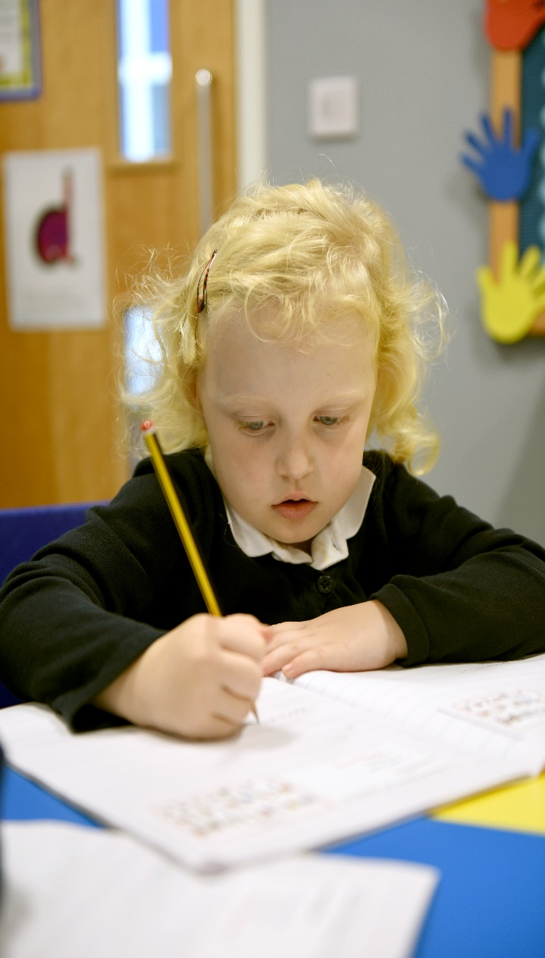


www.teaguesbridgeprimary.org



Marking & Presentation Policy
Written on: | September 2016
Reviewed on: | November 2025
Next review: | November 2026
Staff Responsibility | Mrs S. Abdulla
Governor responsibility | Stephen Reynolds

Policy Statement
The purpose of this policy is to make explicit how teachers mark children’s work and offer feedback. To be effective, this policy needs to be clear, manageable and consistently applied across the whole school.

Introduction
A good teacher describes marking as “… a cruel mirror to the teacher’s effectiveness.
Outstanding teachers recognise this and use such reflections when they need to; they also know that marking is their opportunity to promote and reflect the progress and learning that takes place in their classroom every day.
Children’s work, their standards and books are a direct reflection of our own teaching. Some children will always produce ‘good’ work. At Teagues Bridge Primary School we expect all children to do this.
Marking is one of the most crucial forms of assessment available. It is when we show children that we value their efforts, when we judge our own effectiveness as teachers, and it is when we make strategic decisions about the next steps they need to take. More than anything, it is a rare opportunity to have an individual dialogue with every child through quality feedback.
Why mark Pupils’ work?
- High-quality marking of pupils’ work makes a vital contribution to pupil progress.
- Marking provides children with clear and precise guide to how to improve their next piece of work and a clear expectation that they concentrate on improving this aspect as the next small step in making progress.
- In effect, marking is a short-term target setting for pupils, as well as an opportunity for teachers to make accurate assessments of pupil progress and needs.
Aims of Policy
- To raise standards of attainment by identifying examples of success in a child’s work and areas for development.
- To create a dialogue which will aid progression.
- To raise self-esteem by providing positive feedback and establishing an ‘I can…’ culture.
- To support the teacher in assessing a child’s progress and to inform future planning and interventions.
- To address any misconceptions and close the gap in the children’s learning.
- Where the child has met all the success criteria, a challenge comment can be written, allowing the child to be clear about the next steps in their progress.
- To encourage self-assessment, thereby developing the pupils’ understanding of the learning process and developing independence.
- Where appropriate, to encourage peer assessment as pupils have high regard for the thoughts of their peers. The language used to discuss the work is also at an appropriate level i.e. ‘child speak’.
- To provide a consistent and progressive approach to marking and feedback throughout the school.
- To encourage high standards of learning.
Principles of effective marking:
- Empower children to be more independent with what they are aiming to achieve by providing them with the relevant information or skills.
- points out technical errors, highlighting mistakes.
- Succinct
- Be manageable for staff.
- Be consistently followed by teachers and Tas across the school.
- Motivating and constructive for children.
- Encourage high standards of learning and presentation.
- Be written in handwriting that is legible and a model for the children.
- Allow specific time for the children to read, reflect and respond to marking.
- Infirm future planning.
- Give clearer understanding of pupil progress.
- Give clear strategies for improvement through modelling or scaffolding.
Marking and feedback should
- Inform the child about his/her progress and next steps.
- Find out what the children can do.
- Address any misconceptions.
- Add CH next to any errors (miscalculation error) and then check children have corrected.
- Place a green dot by any errors children then write the correct response next to or underneath/above the green dot. This is when there is clear error.
- Children should not rub out mistakes.
- Be manageable for teachers and accessible to children.
- Provide clear feedback relating to the learning objective and success criteria.
- Involve all adults working with children in the classroom.
- Give recognition and praise.
- Inform future planning and group target setting.
- Respond to individual learning needs e.g. marking face to face with some and at a distance with others.
- Show the children that their work is valued.
- Take place at the earliest opportunity, especially if the next lesson builds on what has been taught earlier.
- Marking should be live where possible.
- Allow children time to respond and address the comment.
- Remember to highlight up to three points in green for great (where they have been successful against the Success Criteria).
- All work in all books should be marked.
- Common misconception words spelt incorrectly should be highlighted in orange
- Handwriting, grammar and spelling need to be addressed daily. This needs to be ticked and any incorrect letter formation must be modelled by the teacher in pink and the children write a line of the letters beside the teacher’s letter.
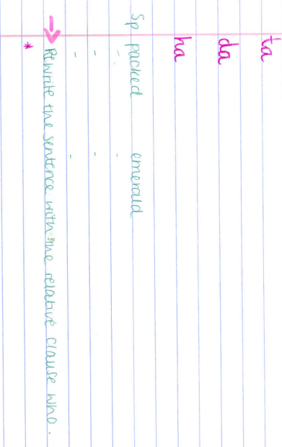
- When areas for development and misconceptions are identified the teacher will Write a pink arrow and then write one next step to improve/close the gap/correct the misconception. Write an * underneath the comment indicating where you want them to respond to the correction and an * by the sentence/paragraph they need to improve. This * can be written in pink.


- Responses must be marked to check accuracy and understanding. The teacher marks using a double tick
- Children who have achieved the learning objective with no misconceptions will be given a challenge. Write the word CHALLENGE, write a challenge for them to complete followed by an *, indicating where you want them to record their response to the challenge. Generic challenge label to be used when the whole group require the same challenge. The challenge should be checked and marked with double tick
- When working with the group, the teacher/TA will address improvements, next steps and errors using verbal feedback. VF is written next to the area for improvement and the children then show a response to the VF.
- Marking will take place during the lesson or as soon as practically possible. If this is the next day, it needs to be first thing before the learning is lost.
- All marking should be using a green pen.
- All adults should model neat handwriting when writing (Teacher/TA/HLTA).
- Use the agreed marking symbols.
- Provide children with the time to respond to marking and feedback given at the earliest possible opportunity.
- Where verbal feedback is given VF, children should show their response next to the VF, younger children could draw a picture to show the improvement.
- Highlight some good examples green and some areas for improvement in pink. Common exception words need to be highlighted orange when spelt incorrectly. Children must correct common exception words using their word card that should be accessible on their tables.
All written work will be marked for key literacy skills using the marking code.
All written work in any subject will be looked at and read by the teacher. A tick is written and marking code, dependent on the objective.
See appendix for marking code
OTHER METHODS OF MARKING
  - Verbal Feedback With the child- the best marking and feedback is without doubt the dialogue that takes place while the task is being completed.

  - Paired marking- this encourages proof reading by pairing the children up to check each other’s work. Pairings should be ability based, and ground rules may have to be shared with the class beforehand.

  - Self and Peer Assessment ~ children will be given opportunities to reflect upon their own work by assessing their work in line with the success criteria for the lesson. They will also mark their partner’s work.

  - Shared marking- teachers sometimes use one piece of work from an unnamed child to mark as a class on the interactive whiteboard. It allows the teacher to model the marking codes as well as reinforce the teaching points and success criteria.

  - AfL labels ~ children record what they have learnt in that lesson.

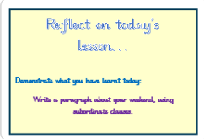

- Verbal feedback ~ Verbal feedback is a significant element of learning which is engaged in throughout every lesson. Such feedback allows the teacher to tackle misconceptions, develop a child’s understanding further or give positive praise. Such feedback is especially important for younger children, less able children or those with SEND. However, when undertaken with older children we encourage the children to record their response to the VF.
Regularity of marking:
- All handwriting should be marked daily with a tick.
- Spellings should be identified for errors and children respond.
- Chance to shine should be marked in detail (deep mark)
- Maths problems and reasoning should have a deep mark.
- AFL responses should be marked with a tick.
- Flash back should be marked daily with a tick.
- AFL grid in maths marked daily.
- Any writing at length (independent), should be marked with an improvement comment.
- Marking codes can be used for other aspects of writing and maths.
- Foundation subjects should also be marked using the marking code.
- Challenge can be used for extended writing/chance to shine/maths problem solving.
Spelling and letter formation errors:
- Spelling errors are persistent errors that the child has made or ones which the child is expected to be able to spell for their age. Subject specific words should also be identified.
- Words will be identified by:
  - Writing SP: in the margin and underline the wrong word with a green squiggly line, write the word for the children and then the children write it underneath 3X.
  - For year 5 and 6 just place a SP in the margin near to the spelling error. Children are expected to use a dictionary to find the correct spelling of the word. Some children may need the word identifying but can still look up the correct spelling of the word.
  - Children should be encouraged to always have dictionaries out when writing to support accurate spelling.
  - Spelling corrections should be acknowledged and marked with a double tick

Acknowledgement of good work:
When marking teachers are welcomed to use a small symbol to identify when something has gone well. A smiley face in the margin will be used to indicate what has gone well. Stamps or stickers will not be used. Children can be given a sticker, that says ‘Ask me why I got this today’.
Response time/Fix it time:
Children will be provided with focused time to allow them to respond to the marking at the next available session.
BOOKS:
Foundation Stage Requirements
Children should have:
- Phonics book
- Reading diary
- Learning journey book
- Handwriting book/pattern book
- Red word cards
- Communication book
- Floor book for music
- Floor book for enrichment

KS1 Requirements
Children should have a:
- Writing book;
- Maths book;
- Art Sketch book;
- Spelling book
- Read, Write, Inc. Phonics book;
- History/Geography book
- Science book
- RE/PSHE
- Floor books for Music
- Floor book for enrichment
- Reading record
- Communication book

KS2 requirements
Children should have
- Writing book;
- Maths book
- Reading journal
- Spelling book;
- Sketch book
- Science book;
- Reading Record
- History/Geography
- RE/PSHE
- DT/French
- Word catcher book
- Communication book
- Read, Write, Inc. Spelling book
- Read, Write, Inc. Spelling log.

Presentation guidelines
- All work should be dated.
- Staff put the date on the learning objective to avoid time wasted.
- If children need to colour a drawing etc. in their books, they should only use
Coloured pencils or wax crayons, not felt tips;
- When children set out maths work, each number should be in a separate square and they should be taught to space out their work appropriately;
- Children should avoid leaving blank pages in a book;
- When children are using blank paper, they should use line guides if at all necessary;
- Children should at all times be expected and encouraged to do their best work and not accept sloppy or careless work.
- A straight line should be drawn through mistakes using a ruler.
- The date should be underlined in pencil using a ruler if children are writing the date for a particular reason.
- Learning objectives and additional information sheets should be stuck in straight and central on the page (no overlapping into the margin.
- Children not secure with finger spaces should be given a card finger to help leave an appropriate space.
- A new page should be started for a new piece of work.
- Child friendly objectives (CATS) and (DOGS) should be should be stuck in the front of reading, writing and maths books
- Targets and Learning Objectives and titles for activities should be typed using the Nelson Font.
- Work for display should be the children’s best work, avoiding errors as far as possible.
- Children should be discouraged from using rubbers, but may be used at the teacher’s discretion—draw a single line through an error;
- Children should be encouraged to take responsibility for their work and return books to where they are kept and to keep them clean, tidy and safe;
- Children should be working in pencil in their books until awarded a pen;
- Use a pencil (only) in Maths books.
- Front covers should be stuck on all books with the name written neatly by the teacher and not the child.
- Place a number on the cover if they have more than one book.

Key Stage 1 and Foundation Stage:
- Marked in green pen;
- Reflection sheet to be used at least twice/three times a week.
- Verbal feedback
- Children respond to VF with pictures or symbols
- Chance to shine writing to be marked in detail
- Promote the use of the writing checklist
- Child friendly objectives in the front of books
- Moderation grids in the back of the books

Key Stage 1 and 2 Marking Guidelines:
- Mark in green pen
- Children should self-assess; peer assess and use reflection comments at least 3x a week.
- Pens stored centrally and given out/taken in each lesson.
- Teacher to use the marking code
- All children should have access to a whiteboard, pen and rubber.
- Pencils should be sharp and ready for the children; children do not sharpen pencils. If they require another pencil they do so from the spare pot.
- KS2 ~ spare pot for pens.
- Promote the use of the writing checklist
- Child friendly objectives in the front of books
- Moderation grids in the back of the books

Use green ink when marking

- A smiley face is used to acknowledgement a child has done a piece of work really well with no errors, this symbol is placed in the margin.
- If you have a child whose work you are particularly pleased with, please give them a sticker for their chart and a sticker to wear ‘Ask me why I got this today’. Any adult that sees this child should ask them why they received the sticker, and children should be able to comment.
- Children should be encouraged to complete corrections allowing time during the school day for these, as far as possible.
- Unfinished work should be marked, but it is important to establish why the work is unfinished and possibly comment on this.
- Spelling errors need to be addressed. Writing SP by the margin and a green wiggly line underneath the incorrect spelling. Children then write the correct word three times.
- Common misconception words spelt incorrectly should be highlighted in orange, children should then self-correct and write the correct word 3X.
- Handwriting needs to be addressed daily, highlight the word in pink and then children write the word or letter again, using the correct letter formation and correct joins. Children write a line of the letters or the joined word.

Examples of deep marking:

- Use a range of subordinating clauses in your writing to vary your sentences.

*(this is where the child will make the improvement)

MONITORING
Senior leaders will monitor work to evaluate the impact of the policy and give support and guidance to staff.

Presentation
Success Criteria
for Maths

Short date or date can be added to LO by the teacher.
Write 1 number or symbol per square.
Draw a line down the centre of the page (or fold the page).
Learning Objective stuck in neatly.
If you make a mistake, draw a small line through it e.g. 5 + 5 = using a ruler. KS1 use a bracet around the mistake (fjdksjf).

Presentation
Success Criteria
English
Long date or recorded on LO by the teacher.
Learning Objective stuck in neatly.
Always write on the lines given, using your best handwriting.
Start writing next to the margin but don’t write over the margin line.
If you make a mistake, draw a neat line through the word. e.g. school. KS1 use brackets around the mistake (fksfs).
Always check your work to make sure your presentation is the best it can be.

Examples of how the learning objective and Success Criteria should look.
Learning Objective for English

ENGLISH
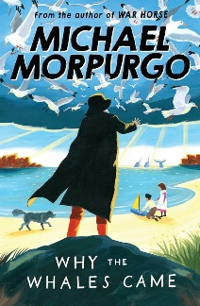  TEXT: | Vocabulary:  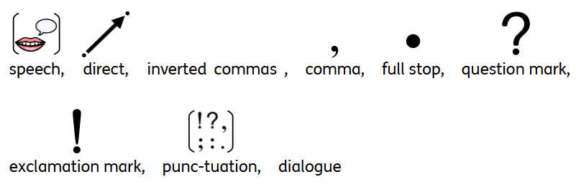
Date: 12th May 2025 | Purpose: To be able to use direct speech in my own writing.  Audience: Base 7 peers | CT, TA, I
Previous learning:
I already know.
- How to use inverted commas for direct speech.
Learning Outcome:
- To punctuate direct speech with inverted commas and other punctuation within the inverted commas.
Success Criteria:
By the end of today’s lesson:
I can (skill):
- Use inverted commas to indicate direct speech.
- Use full stops, commas and capital letters correctly when using direct speech.
- Use a new line for a new speaker.
I will know (knowledge):
- When I need to use inverted commas.
- What other punctuation I need to use.
- When I need to use a new line.
Writing Target
To use parenthesis my writing.

Daily Starter
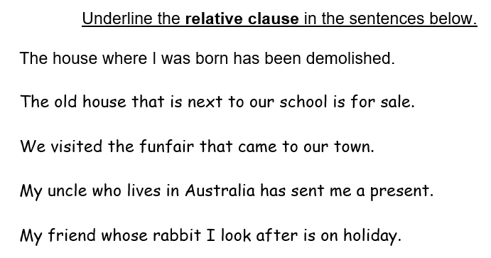
Learning Objective for maths:
MATHS

Assessment for learning: adding fractions |  |  | Vocabulary: 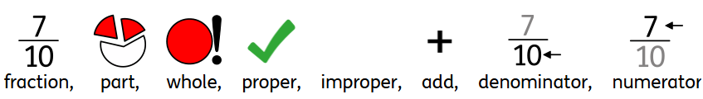
Date: 12.05.25 |  |  |  | CT TA I
Concrete | Pictorial |  |  | Abstract
Learning Outcome:
To add two fractions
Previous learning:
I already know:
- How to calculate fractions.
- What a numerator and denominator are.
Success Criteria:
By the end of today’s lesson:
I will know (knowledge):
- How to add the numerator.
I can skills:
- Keep the denominator the same.
- Add the numerator
Flash back 4
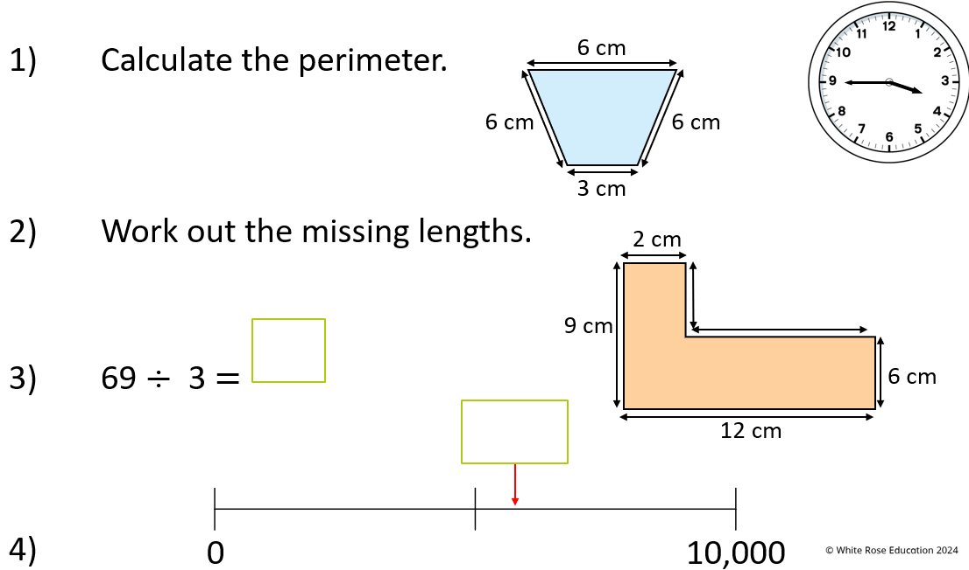

Chance to Shine Writing Label ~ Independent writing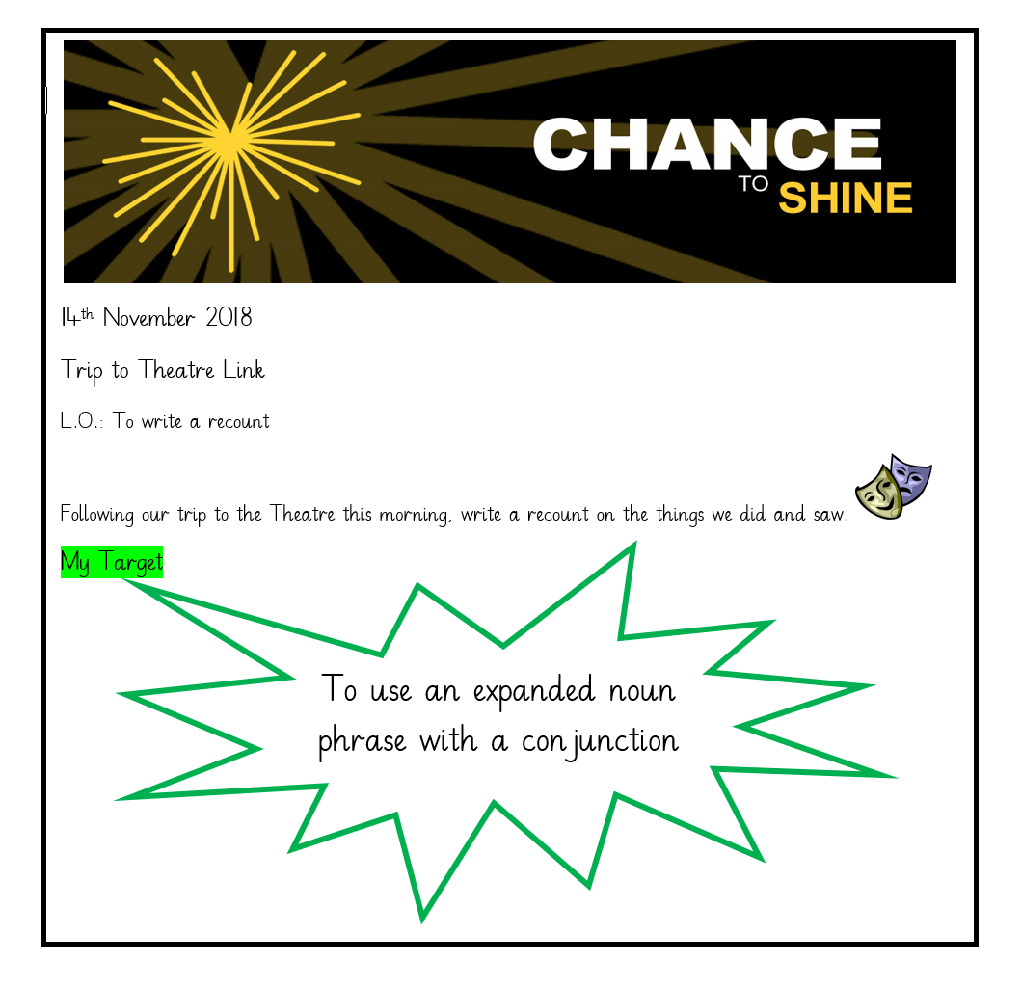

Learning Objectives and Success Criteria should also be evident in their cross-curricular books and science books.
Learning objectives should include handwriting S.C. and SPaG.
Don’t use I can in the L.O.is implies they can do it.

The following is an example of the L.O. used for RWI. Phonics:
Phonics
Week Commencing:
Previous learning:
- I already know the following sounds:
- I can read and write words from set __
Learning Outcome:
- To recognise the sounds…………..
- To read and spell words from set
- To read for meaning
Aa Bb Cc Dd Ee Ff Gg Hh Ii Jj Kk Ll Mm Nn Oo Pp Qq Rr Ss Tt Uu Vv Ww Xx Yy Zz

Foundation subjects LO:
Science
Vocabulary: 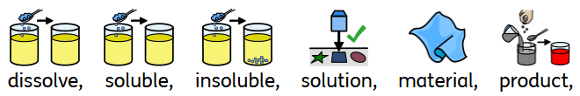
Date: 19th May 2025 | CT, TA, I, HLTA | 
Previous learning:
I already know:
- The names of some common materials
- How to sort materials by their properties.
- Why materials are chosen for a particular purpose.
Learning Outcome:
- To identify soluble and insoluble materials.
Assessment for learning: Dissolving true or false
Success Criteria:
By the end of today’s lesson:
I will know (knowledge):
- know that some materials dissolve in water and others do not and give examples of both
- know that a substance is still present in the solution when it has dissolved
I can (skill):
- Carry out a fair test.
- Investigate the solubility of materials.
Assessment for Learning
Statement | True | False
When materials dissolve, they disappear.
Only white powder materials will dissolve.
All materials dissolve

Assessment for learning label to be used twice or three times a week
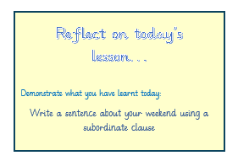
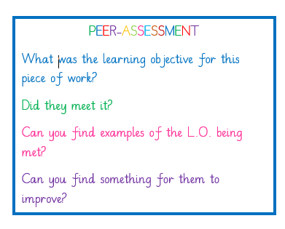
Examples of Peer assessment and Self-assessment

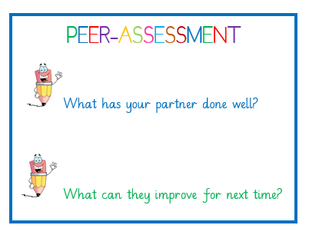

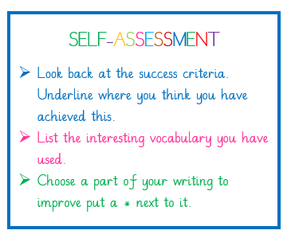

Writing checklist:
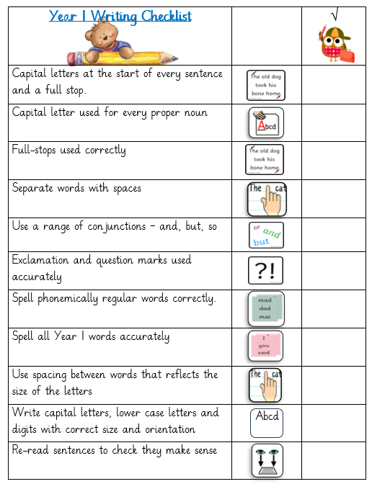

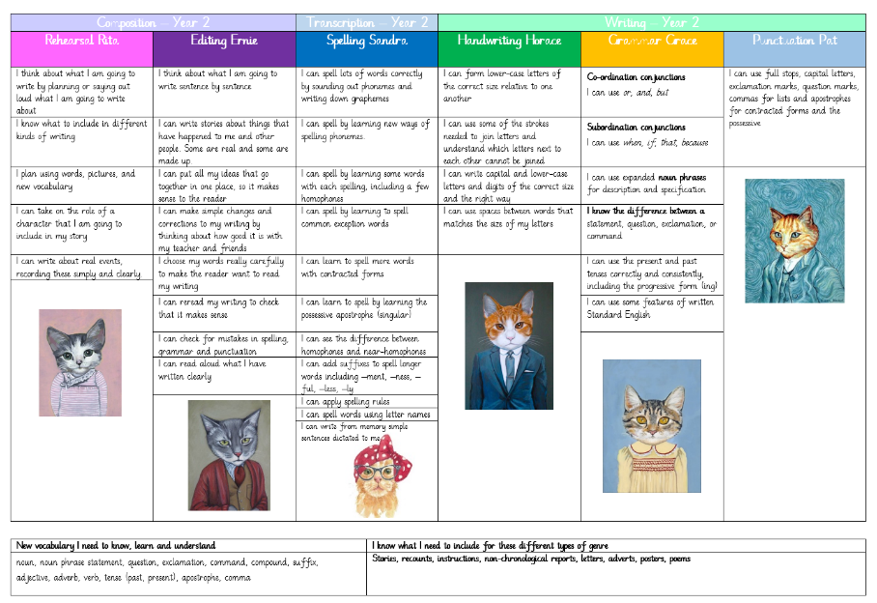
Child friendly objectives for writing, Maths and Reading

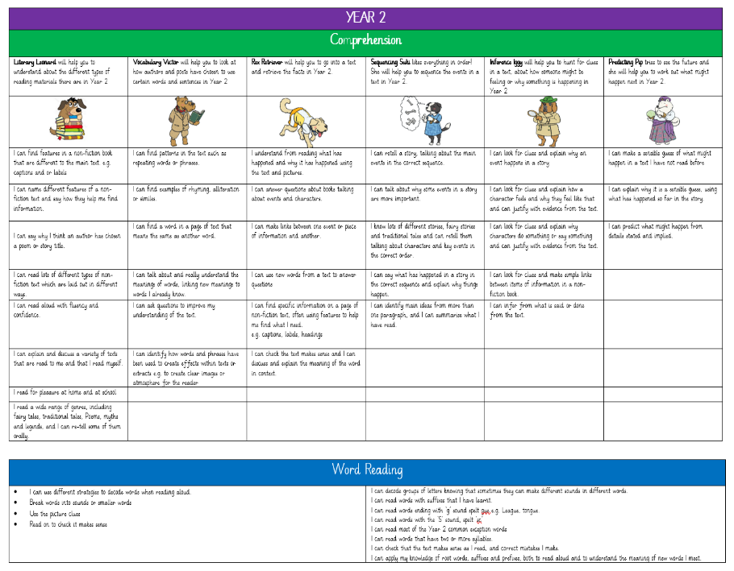

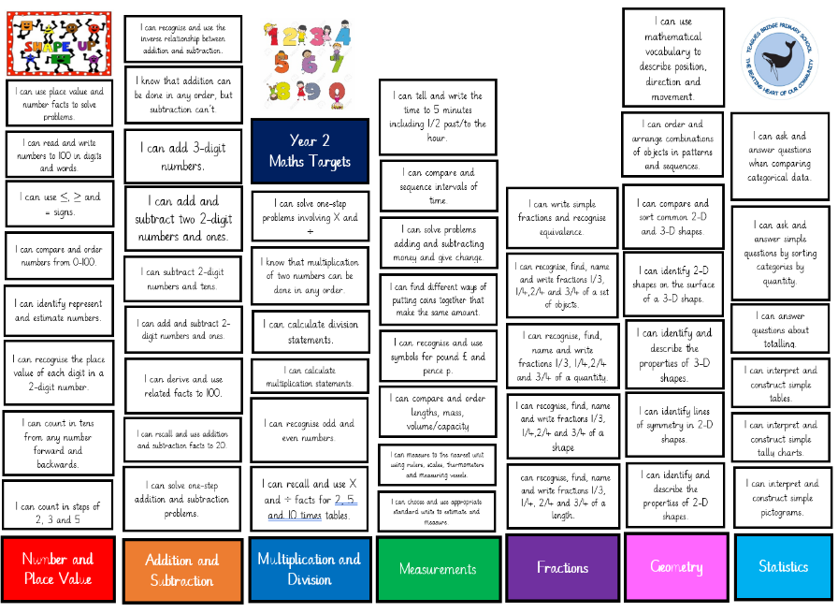

Feedback codes
Feedback Symbol | Meaning
 | Double tick ~ corrections seen and completed.
CH | Check answer/sentence/word  Check errors
SP | Spellings need correcting
// | New paragraph needed
VF | Verbal feedback
 | Finger space
 | Finger space too big
______ | Write on the line
 | Missing punctuation (commas, semi colon, full-stop, capital letter, ! and ?)
* | Improvement  Asterix for where the children write the response to the improvement.
 | Need to try harder
FF | Sound it out
 | Come and speak to the teacher
I | Independent
PG | Paired or group work
T | Worked with the teacher
TA | Worked with the TA
 | Everything achieved ~ good job.
 | Highlight green for great ~ achieved the SC/LO
CHALLENGE | A challenge should be used when children have done everything correctly.  If everything is correct then write the word CHALLENGE, write a challenge for them to complete followed by an *, indicating where you want them to record their response to the challenge.  A generic CHALLENGE label can be used if more than one group need this.
 | Highlight pink for think ~ not achieved the SC/LO

Effective marking and feedback
OUTSTANDING
- Strategies exist to acknowledge/celebrate the achievement of targets.
- Children are involved in setting targets for improvement.
- There is a very good level of response to teachers marking.
- Comments from the teacher are focused and diagnostic, revealing very good subject knowledge.
- Children demonstrate understanding of their LO.
GOOD
- All children are set relevant, accurate LO’s
- Self-assessment is a regular activity: children know what they are good at and what they need to do to improve.
- Children respond to prior learning.
- Children respond to comments/codes from the teacher
REQUIRES IMPROVEMENT
- There is sufficient work in the books to allow marking to have impact.
- Work is marked regularly.
- Children know how well they have done in relation to the LO.
- Marking builds confidence.
- The majority of marking is about recognising success.
- The teacher’s handwriting is readable.
- The teacher’s spelling and use of standard English is accurate.
INADEQUATE
- Marking does little to help children to improve.
- Work is not marked regularly.
- Children do not know how well they have done in relation to the LO.
- Marking does not celebrate learning.
- The majority of marking does not recognise success.
- The teacher’s handwriting is not easy to read.
- The teacher’s spelling and use of standard English are inaccurate.
- Work is marked incorrectly.
- The advice given to children is inaccurate.
- There is insufficient work in the children’s books to allow marking to have impact.

Marking prompt checklist
Marking | Colour/Symbol
Achieved success criteria | Highlight
Not achieved success criteria | Highlight
Green for great | Identify where the children have shown the SC/LO in their work and highlight these ‘green for great’.
Encouraging children to check their work when there is a mistake. | Put CH next to the error (miscalculation) and children try correct.
Verbal feedback | Give children verbal feedback to help them make an improvement ~ Write in green pen VF
Spelling | Sp: in the margin and underline the wrong word with a green squiggly line, write the word for the children and then they write it underneath 3X.
Letter/number formation | Pink, model how to write the letter/number forming it correctly, children then respond by copying the letter/number.
If success criteria not achieved | Put a pink arrow then next step.  Follow this with an Asterix to show the children where you would like them to respond. E.g.  Improvement: Rewrite the pink sentence, using the correct punctuation.
Marking Next step comments. | Response to marking needs to be marked with a double tick. Always mark in green.
Spelling mistake if it is a common exception word. | Highlight the word in orange and ask the children to find the correct word on their card and write this out 3x.
No errors or misconceptions | CHALLENGE

