Science Policy

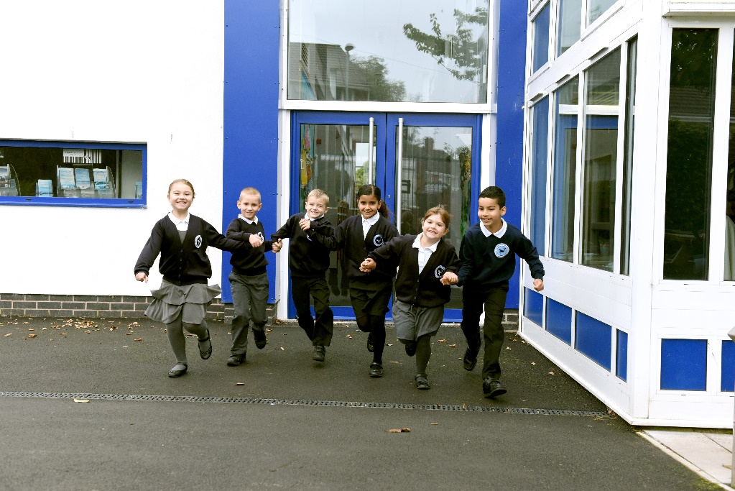
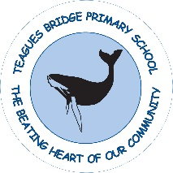
www.teaguesbridgeprimary.org
Teagues Bridge Primary School
Science Policy
Written on: | 15th July 2021
Reviewed on: | 21st August 2025
Next Review: | August 2026
Staff Responsibility | Natalie Woods & Sophie Wood
Governor responsibility | Drew White

Contents

- Aims and Objectives
- Principles of good science learning
- Teaching and learning
- Science curriculum planning
- Science in the Early Years Foundation Stage
- Science and inclusion
- Assessment
- Feedback and Marking
- Monitoring and Management

Aims and objectives
Science teaches an understanding of natural phenomena. It aims to stimulate a child’s curiosity in finding out why things happen in the way that they do. It teaches methods of enquiry and investigation to stimulate creative thought. Children learn to ask scientific questions and begin to appreciate the way in which science will affect the future on a personal, national and global level.
Our objectives in the teaching of science are to:
- ask and answer scientific questions
- plan and carry out scientific investigations
- know about life processes
- know about materials, electricity, light, sound, and natural forces
- know about the nature of the solar system, including Earth
- know how to evaluate evidence, and to present conclusions both clearly and accurately.

Principles of good science learning
At Teagues Bridge Primary School we believe that the 5 main principles of good science teaching and learning are:
- Prior learning is built on and planning is appropriate to children’s needs and levels.
- SC1 should lead through practical investigation. Children should gain scientific knowledge as well as skills.
- Teachers being enthusiastic and confident with own subject knowledge.
- Meaningful and engaging contexts should be used which allow learning to be driven from children’s interests / ideas / suggestions and questions.
- Pupils’ learning is enhanced by high quality resources, the application of skills from other areas and use of ICT.

Teaching and learning
At Teagues Bridge Primary School we use a variety of teaching styles in science lessons. Our principal aim is to develop children’s knowledge, skills, and understanding. We do this through engaging the children in enquiry-based research activities. We encourage the children to ask, as well as answer, scientific questions. The children have opportunities to use a variety of data, such as statistics, graphs, pictures and photographs and they also use ICT in science lessons where it enhances their learning. Children may also engage in role-play and discussion activities as well as presenting reports to the rest of the class. The children experience a wide variety of problem-solving activities. Wherever possible, teachers at Teagues Bridge Primary School involve the pupils in real-life scientific activities, such as investigating and carrying out a practical experiments and analysing the results.
At Teagues Bridge Primary school we recognise that in all classes, children have a wide range of scientific abilities, and we ensure that we provide suitable learning opportunities for all children by matching the challenge of the task to the ability of the child. We achieve this in a variety of ways:
- setting tasks which are open-ended and can have a variety of responses;
- sometimes grouping children by ability and setting different tasks for each ability group;
- providing resources of different complexity, matched to the ability of the child;
- with the support of teaching assistants to support the work of individual children or groups of children.

Science curriculum planning
Science is a core subject in the National Curriculum. The school uses the national programme of study for science as the basis of its curriculum planning adapting it to the local circumstances of our school. We use the engaging science planning to support enquiry-based learning in all classes.
The long-term planning across the school maps out the scientific topics studied in each term during each year group to ensure accurate and detailed coverage of the national curriculum. In this way, we ensure complete coverage of the National Curriculum, without repeating topics.
The class teacher is responsible for designing short-term plans for lessons using the school’s format of flipchart planning. These plans list the specific learning objectives and expected outcomes of each lesson.
We have planned the topics in science so that they build on prior learning. We ensure that there are opportunities for children of all abilities to develop their skills and knowledge in each unit, and we also build progression into the science scheme of work, so that the children are increasingly challenged as they move up through the school.
Wherever possible, teachers at Teagues Bridge Primary School make links to other subjects within science. For example, they will provide opportunities for the use of ICT; skills learnt in mathematics will be applied in science lessons; literacy skills are used and developed when writing reports on findings and speaking and listening will be encouraged. Teachers will also strive to ensure science links to the curriculum topic of the term.

The Early Years Foundation Stage
We teach science in reception classes as an integral part of the topic work covered during the year. The reception class is part of the Early Years Foundation Stage. We therefore relate the scientific aspects of the children’s work in the Understanding of the World area of learning to the objectives set out in the Foundation Stage Framework which underpin the curriculum planning for children aged three to five. Science makes a significant contribution to developing a child’s knowledge and understanding of the world, for example, through investigating what floats and what sinks when placed in water.

Science and inclusion
At our school, we teach science to all children, whatever their ability and individual needs. Science forms part of the school curriculum policy to provide a broad and balanced education to all children. Through our science teaching, we provide learning opportunities that enable all pupils to make good progress. We strive hard to meet the needs of those pupils with special educational needs, those with disabilities, those with special gifts and talents, and those learning English as an additional language, and we take all reasonable steps to achieve this.

Assessment
Teachers will assess children’s work in science by making ongoing judgements during lessons; this may be through observation, pupil discussions and marking of work. Written or verbal feedback is given to the child to help guide progress. Older children are encouraged to make judgements about how they can improve their own work. Assessment for learning is used to assess children’s starting points and lessons are adapted according to the outcome of this.
Teachers also assess children using the core concept grid for science and will assess progress against these each term to monitor progress over the year. This is tracked in the teacher’s assessment files using the assessment grids for science.

Monitoring and management
The coordination and planning of the science curriculum are the responsibility of the subject leader who also supports colleagues in their teaching, by keeping informed about current developments in science and providing a strategic lead and direction for this subject. The quality of teaching and learning in science is monitored and evaluated by the head teacher, senior leaders and the science coordinators as part of the school’s agreed cycle of monitoring and evaluation.

