Accessibility Audit & Action Plan
2023 - 2026
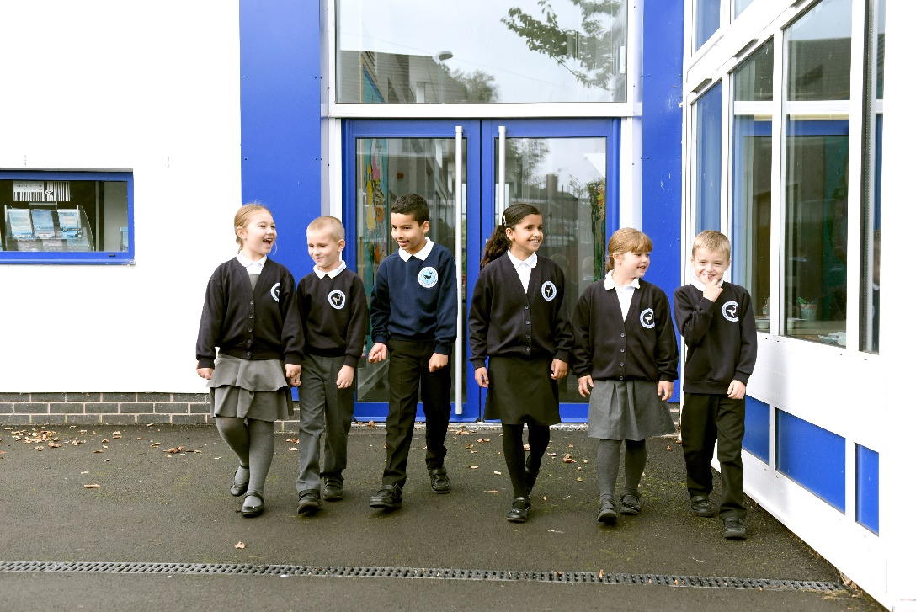

Audit Reviewed: July 2025
Accessibility Audit
Accessibility to the curriculum
Access to the curriculum | Current Position | Next steps
Do you ensure that teachers and teaching assistants have the necessary training to teach and support pupils who have a disability or additional needs? | The senior leaders and governors are forward thinking and reactive to need. All training is based on the needs of the staff and pupils and CPD is planned to ensure the all staff are well equipped to meet the needs of all pupils. | Continue to respond to need and if pupils with specific needs come onto roll, ensure all staff are trained in meeting their needs.
Are lessons suitably adapted enabling all children to achieve? | Lessons are adapted using a range of techniques. Teachers plan for the use of additional support and scaffolds to ensure all children have equal opportunities to achieve the LO. This now needs to be developed to ensure teachers plan the most effective way to scaffold a lesson. | Deliver CPD on how to choose the most effective scaffold for a lesson. This can be achieved through using the team teaching approach.
Are there sufficient adults within the classroom to support children? | Support staff in place in classes with additional adults where specific need has been identified and where possible. Most adults are effective in supporting pupils in the year group in which they work. | Ensure additional funding is applied for where there is a need and this additional funding is used to provide targeted support in a timely manner to those who require it.
Are support services accessed and used effectively? | Staff work effectively with outside agencies, acting on recommendations given. Support services have also been used to deliver specific CPD when need arises. | Continue to respond to need and if pupils with specific needs come onto roll, ensure all staff are trained in meeting their needs and ensure support services continue to be used to meet the needs of these pupils.
Are alternative communication methods used within lessons? | Visual prompts and diagrams are used to support learning in classes. Teachers explain diagrams and images and discuss written texts. | Staff to be trained on different communication methods that can be used within lessons such as Makaton.
Are all pupils encouraged to take part in music, drama and physical activities? | All pupils have the same access to all opportunities in school. PPG funding is also used to ensure children in receipt of this also have access to extra-curricular activities along with their peers.
Do staff recognise and allow for additional time required by some pupils to use equipment in practical work? | Staff respond to the needs of children, providing additional response time for those who require it. Provision maps detail additional support in class as well as additional interventions.
Do you provide access to appropriate computer technology? | A wide range of technology is available to all pupils and when specific needs arise, this technology is purchased to meet the needs. | Audit technology and programmes currently used is school, their effectiveness and identify any that may enhance our curriculum offer further.
Do staff provide alternative ways for children who cannot engage in particular activities? | Staff plan activities that are accessible to all and ensure adaptations are made as required so that all pupils have equal opportunities.
Are school visits made accessible to all pupils? | Staff plan activities that are accessible to all and ensure adaptations are made as required so that all pupils have equal opportunities, this is included on risk assessments for educational visits.

Access to the physical environment
Access to the physical environment | Current Position | Next steps
Can pupils who use wheelchairs/mobility aids move around the school without experiencing barriers to access such as those caused by doorways, steps, toilet facilities and showers? | There are 2 disabled toilet facilities in school, one with shower facilities.  Handrails on stairs are at the height for children.  Electronic ports for stair lifts in key stage 1 are in place ready to have one fitted if need arises.  Wheel chair access to key stage 1 is level from outside doors, the hall and lower key stage 2 class rooms can be accessed using the ramp at the far end of the playground. | If wheelchair access was required, a consultation meeting with the LA would be held as access to the key stage 2 classrooms is difficult due to stairs, also, access is mainly via outside routes which would need to be considered.
Can pupils with visual impairments move around school without experiencing barriers to access such as those caused by doorways, steps, toilet facilities and showers? | Walkways are clear and the majority of them are wide. Toilets are accessible and disabled toilet and shower facilities are accessible also. | If a child with visual impairment joined the school, narrower corridors would need to be considered to ensure the cupboards did not restrict walkways.  Coloured edging on steps outside and inside would make the steps clearer for visually impaired pupils and visitors.
Are emergency and evacuation systems set up to inform all pupils including alarms with both visual and auditory components? | Emergency pull cords are in place in disabled toilets.  Risk assessments, fire procedures and health and safety audits are carried out regularly.  Fire alarms are visual as well as auditory. | Emergency evacuation procedures are in place, but if a children with specific needs in this area joined the school, personal evacuation plans would be written and shared with staff to ensure their safety.
Are non-visual guides used to assist people to use the building including lifts with tactile buttons? | 3D door numbers are in place for classroom doors. | This would need to be considered if a child or parent with visual impairments joined the school.
Are areas well lit? | All areas are well lit and emergency lighting is installed and regularly tested.
Could any of the signage be considered confusing for pupils with specific needs? Is signage at a lower level for wheelchair users? | Signage is clear and not confusing. Signage is kept to a minimum to ensure only important signs are used and are accessible and not cluttered. | If a wheelchair user attended the school, signage in some areas of the school would need to be lowered to ensure they were able to access it.
Are steps made to reduce background noise for hearing impaired pupils such as considering the room’s acoustics and any noise equipment? |  | If a child with a hearing impairment joined the school, the school would work with outside agencies such as the sensory inclusion service to ensure the specific needs were met.
Is furniture and equipment selected and used appropriately? | Furniture and equipment is selected that is a suitable height, accessible for all and when specific equipment is needed, this is purchased and in place for the individual. | If a child with physical needs joined the school, we would work with OT and other agencies to ensure appropriate resources are in place.
Are toilets/urinals fitted with grab rails to assist those with disabilities? | There are 2 disabled toilet facilities in school, one with shower facilities. These have handrails and emergency pull cords. | Accessible toilets are in key stage 1, once the child reaches key stage 2, this would need to be considered with access arrangements being put into place through consultation with the LA.

Access to information
Access to information | Current Position | Next steps
Do you provide information in simple language, large print, on audiotape, in a range of languages or in braille for all pupils and parents to access? | Large print, coloured overlays and coloured backgrounds are used in class for specific children.  Sound buttons are used in some classes to aid instruction.  Large print is available for letters to parents, letters are also emailed out so parents with a visual impairment can have them read out by an app.  Translate website link on the school website so that parents can have letters and information translated. | Develop the use of translate software to provide key information for parents in a range of languages.
Do you ensure that information is presented to groups in a way in which is user friendly, eg by reading diagrams aloud to describe them when giving presentations? | Interactive white boards are used, visual prompts are used in all classes and teachers explain diagrams and what they show. This is the same for parent presentations and workshops that take place. | Develop the use of translate software to provide key information for parents in a range of languages.
Do you have the facilities such as ICT to produce written information in different formats? | ICT facilities are available to produce written information.
Do you ensure that staff are familiar with technology and practices developed to assist people with disabilities? | Staff are aware of and use different programmes across the school to support children in accessing the learning. | If future need arose, further facilities would be purchased and staff would be trained on how to use it.

Accessibility Action Plan
Increase access to the curriculum for pupils with a disability
Priority | Lead | Strategy | Resources | Timescale | Success Criteria
Training for staff on increasing access to the curriculum for all pupils | Head Teacher  SENCO | Epipen training  Talkboost Training  ASD training  Safeguarding Training  Learning & Behaviour Advisory Team support  Sensory Support team  Access to courses & CPD  Outreach support from local special school  Online resources for CPD shared with staff  Ongoing guidance from specialists e.g. Sensory Support Team for children with visual or hearing impairment, physiotherapists, OT, moving and handling advisors, continence nurse etc.  Training from EP  Makaton Training for staff | Training time  TA time allocated | Ongoing programme of high quality CPD that is reactive to the needs of the staff and pupils. | Increased access to the curriculum  Needs of all learners met  Staff will feel confident in supporting children.
Effective use of resources & specialised equipment to increase access to the curriculum for all pupils | SENCO  Class teacher | Strategic deployment of support staff/intervention staff.  Use of ICT, eg: widget and touch typing  Purchase and allocate other resources as needed, eg: sloping boards for writing, wobble cushions, reading rulers, coloured exercise books / overlays, pencil grips, adapted pens, chew/fiddle toys,  Ensure specialist equipment (eg: hearing aids) are checked daily and seek advice if needed (eg: from Sensory Support)  Set up and roll out SEND resources boxes into all classrooms for all children to access. | Specific apps to support learning on Ipads  Other resources as required for individual pupils  SEND resource boxes for all classes. | SEND resource boxes to be implemented 2023/2024  Ongoing review of needs and specialist equipment required to support pupils. | Needs of all learners met enabling positive outcomes for all pupils.  Increased access to the curriculum
All out of school activities and  after school clubs are planned to  ensure reasonable adjustments  are made to enable the  participation of the whole range  of pupils. | SLT  SENCo  Staff  leading  clubs  Head teacher Class teacher | Risk assessments will be undertaken where appropriate.  Pre visit completed before all visits  Risk assessments completed and take into account the additional needs of individual children  Needs of group shared with place of visit.  One page profiles shared with after school club leaders. | Any specialist  equipment needed to allow a child to access a club or trip. | Ongoing | Increased access to the  extra-curricular activities for Pupils with SEND.  All children will have equal opportunities.
Improve and maintain access to the physical environment
Priority | Lead | Strategy | Resources | Timescale | Success Criteria
School is aware of the access needs of disabled children, staff and parents/carers | Headteacher SENCO | Parents complete pupil information page about their child on entry to Teagues Bridge.  Appropriate staff training for those staff supporting pupils with a disability.  Care plans written in conjunction with medical staff and parents. | Time  Awareness folder | Ongoing as required. | School is fully accessible and inclusive for all pupils, staff and parent/carers.  Staff can safely support the needs of pupils with disabilities.
All staff and pupils can evacuate the building safely and in a timely manner in the event of an emergency. | Fire marshals  All staff | Health and safety audit.  Termly Fire drill | Time maintenance | Termly fire drill to ensure staff and children are able to evaluate the building safely. | All disabled pupils, staff, visitors and volunteers to have safe independent evacuation in emergency situations.
All areas of the school are accessible to all pupils and visitors. | Business manager  Head teacher  SENCo | Consultation with the local authority when needed as areas around the school are not accessible to those unable to use stairs. This will need to be considered alongside with LA when placing a child with additional needs. |  | When required | All children and visitors will be able to safely access all areas of the school building and outside areas.
Improve the delivery of written information to pupils, parents and visitors
Priority | Lead | Strategy | Resources | Timescale | Success Criteria
Availability of written material in alternative formats | Head teacher  SLT  Class teachers | Key content published on school website.  Provide translated documents where appropriate.  Communication through email enables parents to translate messages between home and school. | Contact details and cost of translation / adaptation | Ongoing | All parent/carers will be up to date and well informed of school information.
Ensure documents are accessible for pupils with visual impairment | Class teachers | Seek and act on advice from sensory support advisor on individual pupil requirements  Use of magnifier where appropriate  Ensure large, clear font used in documentation.  Access to large font texts to be ensured where needed. | Loan/purchase costs of magnifier or other specialist equipment | In place and ongoing. | Pupils able to access all school documentation
Translators provided for parents’ meetings, meetings with LSAT, annual reviews and any other external services as required. | All staff | Staff are aware of the language needs of their parents.  Translators are provided when necessary and where possible.  Use of an online translation app to be used when needed. | Translator | Ongoing | All parents can engage in their child’s learning and be fully included in supporting their learning needs.

