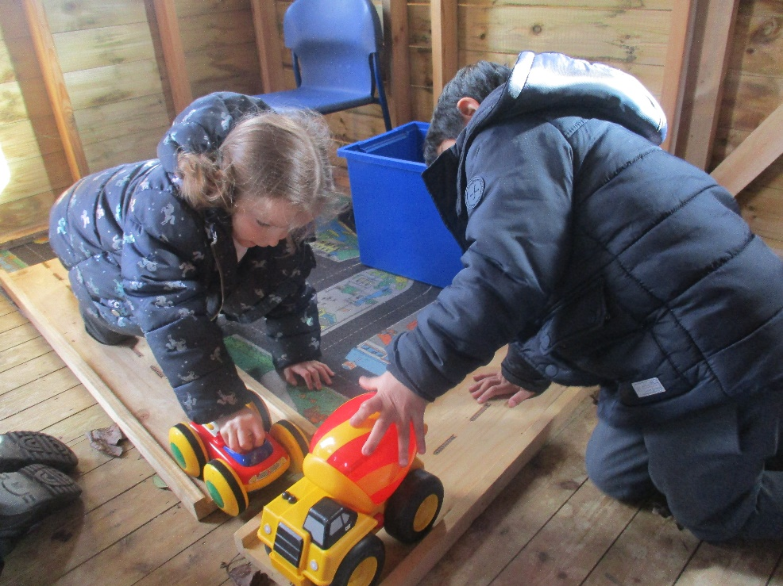

Accessibility Policy
2025 - 2026
www.teaguesbridgeprimary.org
Teagues Bridge Primary School
Accessibility Policy
Written on: | 1st March 2020
Reviewed on: | 14th August 2025
Next review: | August 2026
Staff Responsibility | Natalie Woods
Governor responsibility | Steve Reynolds

Contents

- Objectives of the policy
- Principles of the policy
- Definition of disability
- Definition of special educational needs
- Accessibility procedures in school
- The purpose of the accessibility plan
- What will the accessibility plan do?

Accessibility policy

Teagues Bridge Primary School aims to treat all people, including visitors to the school, pupils, prospective pupils, staff and governors favourably and, wherever possible, will take reasonable steps to avoid placing anyone at a substantial disadvantage. The school aims to work closely with disabled pupils, their families and any relevant outside agencies in order to remove or minimise any potential barriers to learning, which puts them at a disadvantage and to allow them to learn, achieve and participate fully in school life. The school is active in promoting positive attitudes to all people in the school.

This policy should be read in conjunction with the following school policies:
- • Behaviour Policy
- • Equal opportunities Policy
- • Health & Safety Policy
- • SEND Policy

Objective of this policy

To reduce and eliminate barriers to access to the curriculum and to full participation in the school community for pupils, and prospective pupils, with a disability.

Principles of this policy

Teagues Bridge Primary School recognises its duties under the Equality Act 2010:
- Not to discriminate against disabled pupils in their admission and exclusions, and provision of education and associated services;
- Not to treat disabled pupils less favourably;
- To take reasonable steps to avoid putting disabled pupils at a substantial disadvantage (the ‘reasonable adjustment’ duty) in matters of admission and education;
- To have and regularly to update an Accessibility Plan which meets the statutory requirements by being in writing and covering the three strands over time of: increased access to the curriculum for children with disabilities; improvements to the physical environment to increase access to education and associated services at school; improvements to the provision of information for disabled pupils where it is provided in writing for pupils who are not disabled.

Definition of Disability

A person has a disability if he or she has a physical or mental impairment that has a substantial and long-term adverse effect on his or her ability to carry out normal day- to - day activities

Definition of Special Educational Needs

The Special Educational Needs Code of Practice states ‘a child has special educational needs if they have a learning difficulty, which calls for special educational provision to be made for them.’
A child may be considered as having a learning difficulty if they:
(a) Have a significantly greater difficulty in learning than the majority of children of the same age; or
(b) Have a disability which prevents or hinders the child from making use of educational facilities of a kind generally provided for children of the same age in schools within the area of the local education authority
(c) Is under compulsory school age and falls within the definition at (a) or (b) above or would so do if special educational provision was not made for the child.

Accessibility procedures in school

Teaching and Learning
The school has:
- Appropriately trained staff who are equipped to deal with the range of learning needs experienced by children.
- A successful record of supporting children with a range of SEND needs by planning with parents and children, seeking advice from appropriate professionals and training staff with regard to any child’s specific needs.

Preadmission
The school has a procedure for dealing with accessibility in advance of a child’s arrival or, in the case of the emergence of a disability, the following procedures are in place:

A lot of planning will take place before the child arrives at school. This will include:
- Information gathering from parents, the child’s current school or nursery and relevant external agencies.
- Writing an individual accessibility plan tailored to the needs of the child. This will involve meeting with parents and meeting with the child to discuss their preferences. It may also involve meeting with external agencies who specialise in dealing with that particular disability, who can offer support to the school when planning the appropriate provision for the child.
- Providing adequate training for staff, who will be responsible for that child, so that they feel confident to carry out the care plan.
- Providing the correct resources for the child so that he/she has as much access to the curriculum as is reasonably practicable.

After admission
- Managing and recording the pastoral care of the child through the school’s pastoral system and fostering the child’s social and emotional development, with appropriate documentation.
- Reviewing the care plan with the parents and child at appropriate intervals so that planning can be put in place for the following term.
- Communicating with future schools with regard to the child’s needs.

If the onset of disability occurs during a child’s time with us, all of the above will be put in place.

The purpose of the Accessibility Plan

The purpose of the accessibility audit and plan is to show how Teagues Bridge Primary School intends, over time, to increase the accessibility of our school for disabled pupils. Under the Equality Act 2010 schools should have an Accessibility Plan. The Equality Act 2010 replaced all existing equality legislation, including the Disability Discrimination Act. The effect of the law means that “schools cannot unlawfully discriminate against pupils because of sex, race, disability, religion or belief and sexual orientation. The Accessibility Plan is listed as a statutory document of the Department for Education’s guidance on statutory policies for schools.

What will the Accessibility plan do?

Teagues Bridge Primary School is committed to providing an environment that enables full curriculum access that values and includes all pupils, staff, parents and visitors regardless of their educational, physical, sensory, social, spiritual, emotional and cultural needs. We are committed to taking positive action in the spirit of the Equality Act 2010 with regard to disability and to developing a culture of inclusion, support and awareness within the school. Therefore, the accessibility will:

- The Accessibility Plan is structured to complement and support the school’s Equality and Diversity Policy and the SEND Policy, both of which can be accessed via our website.
- The Accessibility Plan shows how access is to be improved for pupils, staff and visitors with additional needs to the school within a given timeframe and anticipating the need to make reasonable adjustments to accommodate their needs where practicable.
- The Accessibility Plan contains relevant and timely actions to increase access to the curriculum for pupils with a disability, expanding the curriculum as necessary to ensure that pupils with a disability are as prepared for life as are the able-bodied pupils. This encompasses teaching and learning and the wider curriculum of the school such as participation in after-school clubs, leisure and cultural activities or school visits. It also covers the provision of specialist or auxiliary aids and equipment, which may assist these pupils in accessing the curriculum within a reasonable timeframe.
- The plan contains actions to improve and maintain access to the physical environment of the school, adding specialist facilities as necessary – this covers improvements to the physical environment of the school and physical aids to access education within a reasonable timeframe.
- It includes actions to improve the delivery of written information to pupils, staff, parents and visitors with disabilities. The information should be made available in various preferred formats within a reasonable timeframe.
- Whole school training will recognise the need to continue raising awareness of equality issues for staff and governors to comply fully with the Equality Act 2010.
- The Accessibility Plan will be published on the school website.
- The Accessibility Plan will be monitored through Governing Body committees and reported to the Full Governing Body
- The school will work in partnership with the Local Authority in developing and implementing this Accessibility Plan.

Please see the Accessibility Audit and Action Plan for an audit of the current position of the school and for details of how the school plans to improve its accessibility.

